[](http://en.wikipedia.org/wiki/File:Australian_Sports_Commission_logo.svg)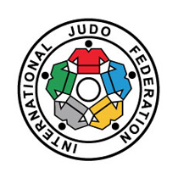[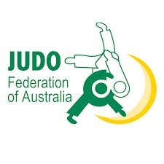](http://www.google.com.au/url?sa=i&rct=j&q=&esrc=s&source=images&cd=&docid=0m4PO9iwUEJUpM&tbnid=uPxjSGRdt50JdM:&ved=0CAUQjRw&url=http://en.wikipedia.org/wiki/Judo_Federation_of_Australia&ei=DZ_IU5P-NIr88QXtm4LQCA&bvm=bv.71198958,d.dGc&psig=AFQjCNGMEp5S5mr3xvr8BR6TGK9QStPtbw&ust=1405743057183924)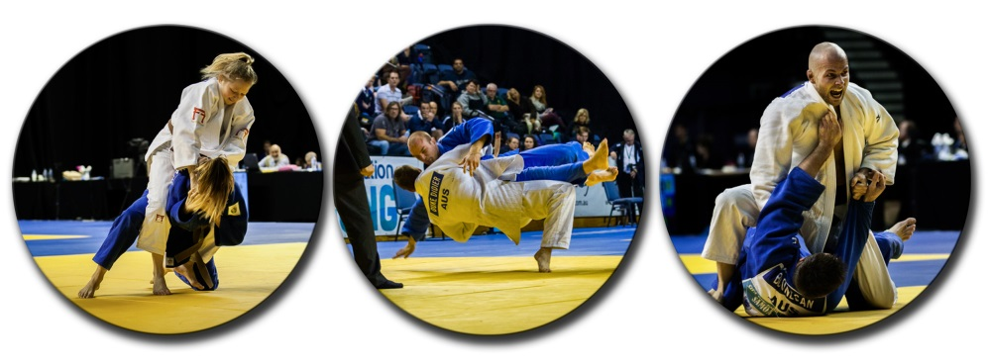

For the first time the **2014 OJU Continental Open** will be held in Australia.

The Judo Federation of Australia is proud to host this event in the warm, sunny and relaxed coastal city of Wollongong (84km south of Sydney).

The OJU Continental Open is an **Olympic qualification** event with **IJF World Ranking List points on offer** – so come to Australia to chase critical points before **proceeding to Asian qualification tournaments.**

Additional information including official hotels will be provided shortly.   
Teams staying in non-official hotels will pay an accreditation fee.

Visit [Destination Wollongong](http://visitwollongong.com.au/) for details regarding things to do in the area.

If you need additional information please contact Luis Val, JFA Sports Director [luisval@iinet.net.au](mailto:luisval@iinet.net.au)

**We hope to see you later in the year!**



http://intjudo.eu/images_2014/banners/logo_oju.jpg

**OJU CONTINENTAL OPEN**

**IJF World Ranking List   
scoring event**

**Competition dates**

Friday 14th November 2014

Saturday 15th November 2014

**Competition schedule**

Friday: 48kg, 52kg, 57kg, 63kg  
 60kg, 66kg, 73kg

Saturday: 70kg, 78kg, +78kg  
 81kg, 90kg, 100kg, +100kg

**Venue**

WIN Sports & Entertainment Centres  
Harbour St, Wollongong NSW

**Participant numbers**

We are expecting good entries  
Wollongong is easy to get to.