Stadium Masters
Announcing Stadium Masters!
In September we formally changed our club name from Stadium Snappers Masters Swimming Club to Stadium Masters Swimming Club. The idea came from our youngest member, who thought that Stadium Masters portrayed a more “professional” organisation. Since foundation in 1992 our club name has included the name of our training venue, originally the Superdrome, hence our club code was, and still is, WSU. When the venue became known as the Stadium, we changed our name accordingly. Now, in removing our nickname from our official name, we are consistent with other MSWA clubs, except for Bay View Saints and Superfins Masters.
As Christmas draws near, some of us are trying hard to finish our Endurance 1000 swims. Two swimmers were more than halfway through long swims this week when a chlorine gas leak was detected and the entire HBF Stadium was evacuated. The muster point under tall trees was a dubious choice since lightning was flashing and thunder booming at the time!
This year ends for us with our Christmas Picnic and Awards presentation in mid-December and the next year begins with a fresh Committee being elected at our AGM in January.
Inspired by the display of poppies at the Albany Anzac 100 Years commemoration in November, about ten of our members are busily knitting and crocheting poppies to be part of a much bigger display in Federation Square, Melbourne, on Anzac Day next year. Poppies were flowering in the spring of 1915 on the battlefields of Belgium, France and Gallipoli and now the poppy has become a symbol of both great loss in war and hope for those left behind. Anyone interested in contributing to this project can find details and patterns on the internet at 5000 Poppies.
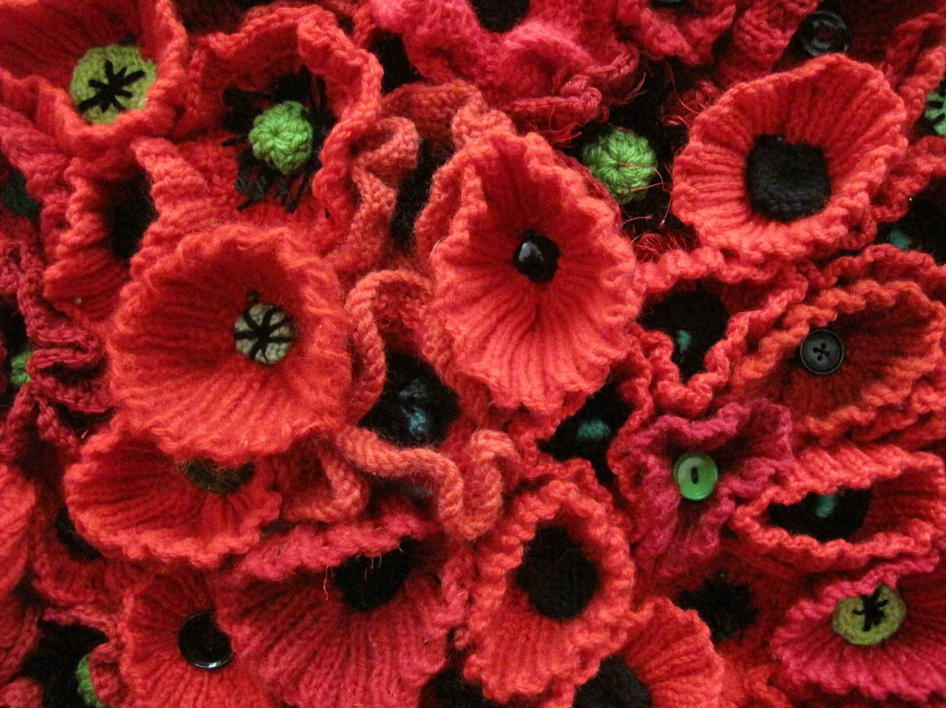

Poppies similar to the ones that Stadium Masters are knitting for a display in Melbourne on Anzac Day 2015

Our thanks to Wendy and Nadine for keeping the wheels turning at MSWA after the devastating fire and doing their best to make sure our swimming activities continue.

Westcoast Masters
Never a dull moment at Westcoast. We have ended the year with 132 members, most of those still swimming regularly.
We had a six of our men going over to Alice Springs for the Masters Games, they came back with a heap of medals and quite a few records amongst them. The stories of their trip over and back were rather amusing and amazing - although repair bills were not discussed. Gladly they all made it back in one piece.
Within our training programme, we have recently had an 8 week challenge. Everyone trying to improve their 500m time trial. Always good to see members training with a purpose. This has been in preparation for the open water season, which has got off to a good start. A regular contingent have been hitting the OW circuit. Special mention must be made of Brad Smith’s excellent results. We have at least 5 solo entries in for the Channel crossing, so plenty of long distance sessions coming up.
Our coaches have brushed up on their CPR qualifications, with 19 taking part in the club sponsored training. Fabulous to know that our swimmers are under the safe care of such keen coaches. We also had Paul Newsome come back to talk to our coaches about different training sessions and programmes. Hopefully, this will introduce some extra vitality to our sessions.
The social calendar has been full, with drinks and dinner in Joondalup, a breakfast sausage sizzle at Mullaloo and many Saturday morning coffees. We are looking forward to our Christmas Tea on 20th December, after training.
As usual, at this time of the year, we are preparing for our annual pilgrimage to Rottnest for the Swim Thru with 45 people staying over. The challenges are up, the training done and the fun is about to be had.
The President and Committee wish all of the Masters family a very safe and happy Festive Season.

Bunbury Stingers
Bunbury Stingers 25th Year Celebration
On Saturday November 1st past and present Stingers and their partners converged on Noovoh restaurant to celebrate the 25th anniversary of the Bunbury Stingers existence. It was a beautiful day and the setting, looking out over the Back Beach, was perfect given the origins of the club and the great affinity many of our members have for open water swimming. The room was decorated with club trophies and photos on display. This prompted much discussion of glory days gone by and the good times we have had over the last 25 years.
Those who turned out were treated to gourmet nibblies and a glass of bubbly to celebrate the occasion. It was great to see so many previous members of the club turn out to socialise and celebrate, with many being heard to say that the event enthused them to make a return to the water. I hope that feeling hasn’t left them and they do indeed act on those best intentions. A delicious cake was made especially for the event and was cut by founding members Marie Harris and Sandra Swain. Those who attended received a commemorative edition of the Stingers newsletter and a 25 year swimming cap
Much thanks must go to Tanya and Pam for organising the event and to Erica for producing the excellent 25 year newsletter. Their hard work was much appreciated by all of us who attended the event.
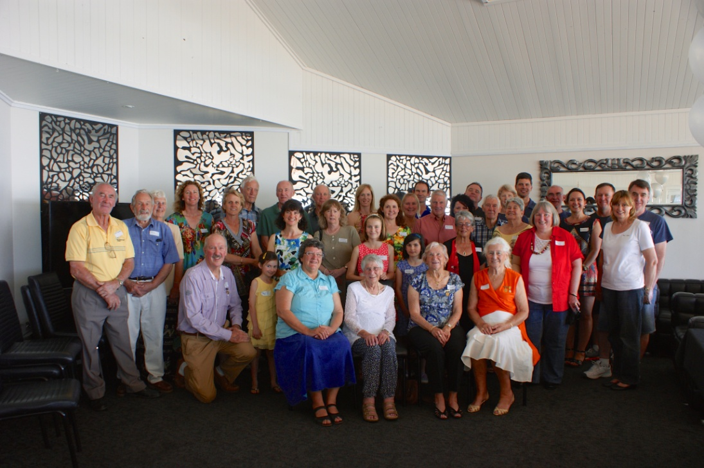

Carine Masters
We attended the popular Beatty Park LiveLighter Club challenge. We always enjoy the short course format which allows for a few exciting “splash and dash” events. Our team of eight swimmers managed to gain 80 points placing us 6th amongst the 12 clubs present. We think our relay team did very well too so we came home happy with our results. However, it is the camaraderie and catching up will all our swimming friends that we enjoy most. There was a certain amount of sadness amongst swimmers that day as we remembered the lovely Kerensa Allason, one of Beatty Park’s most active members who sadly passed away shortly before the carnival.
We are very pleased with the fact that we have gained four new members in the past couple of months. They are all keen swimmers and very pleased with the progress made under the watchful eye of Kerry Hodson who has been kind enough to coach us on Wednesday nights this year.
Our Christmas function was lunch at local restaurant, Spinnackers at Hillarys Boat Harbour. We had an enjoyable and amusing time and the food was delicious. We included the presentation our Alan Blake Memorial Trophy for “Most Improved Swimmer” which was awarded to Jane Laws who was both surprised and delighted to receive it. The trophy is named after one of our long serving member who passed away in the early 1990s. Alan was such a keen and enthusiastic member the club felt it appropriate to name the trophy after him. We also presented Kerry Hodson with a gift of appreciation for all the time and effort she has put in to our training sessions. Lois Fleming did a great job organising the lunch and a Christmas raffle. The recipients were very pleased with their early Christmas gifts.
President, David Laws and the Carine committee wish all Masters swimmers a happy festive season and we hope you enjoy your swimming in 2015.
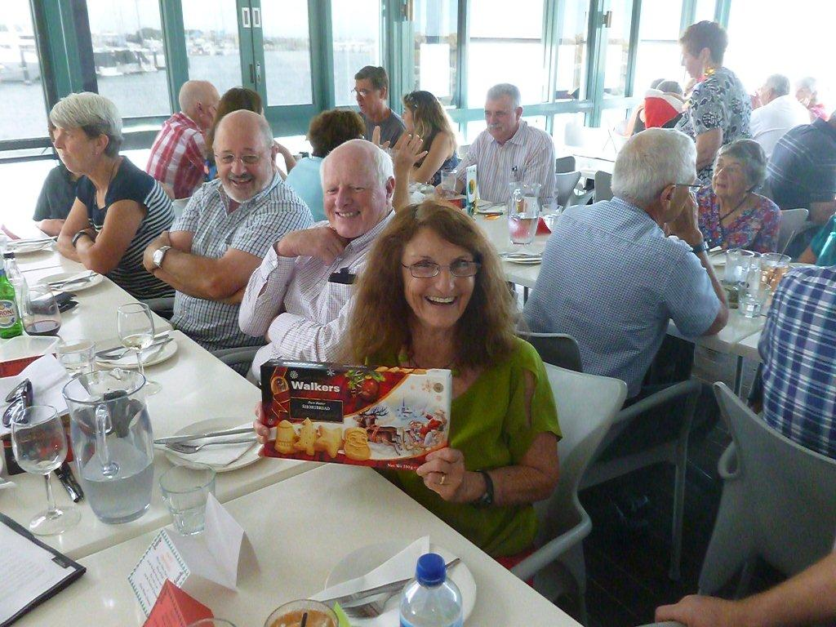
Club Patron, Kay Cox, very happy with her raffle prize
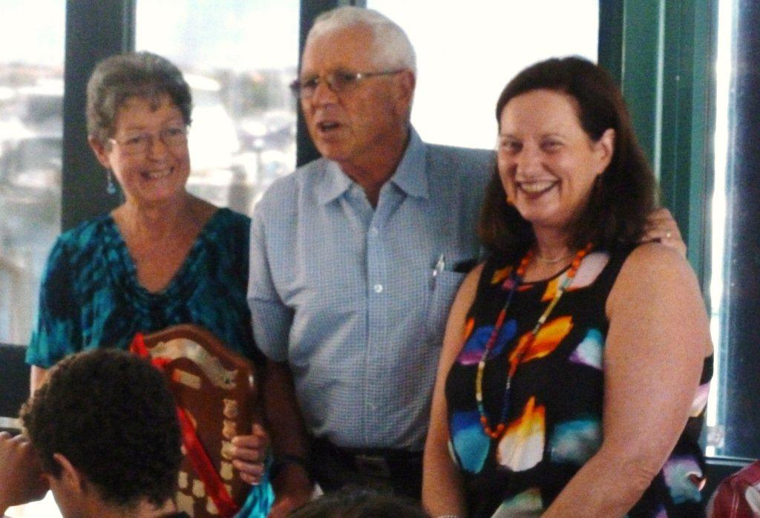
L-R Jane Laws, David Laws, Kerry Hodson at presentation for Most Improved Swimmer 2014
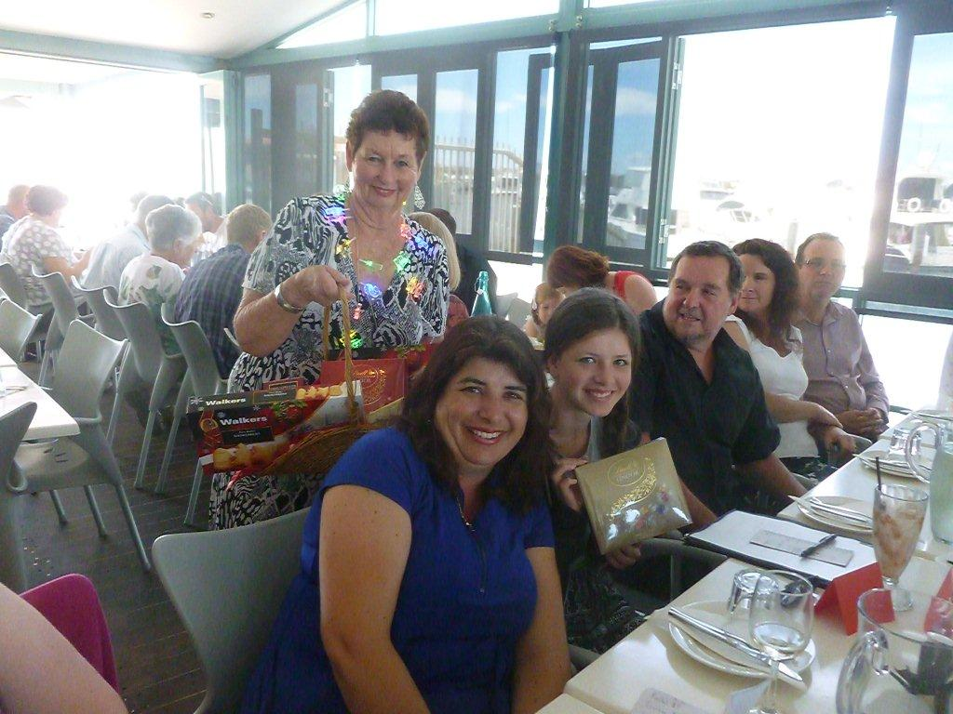
Standing Lois Flemming with Rachel Wright and daughter Courtney who both won raffle prizes

