Presentation Dinner
Leichhardt Hotel, Rockhampton
Saturday, 26th April 2014
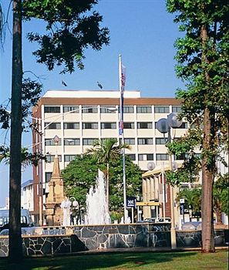
We would like members nominating for the Championships’ event to consider booking their places at the Presentation Dinner as soon as possible.
This will serve to assist us in determining the number of people who would like to attend the dinner. Numbers are limited.
Please tick the relevant box below. You may pay now or tick to indicate your intention of attending, but paying for the dinner at the same time as your events’ payments.
I would like to book for the dinner. My payment of $50 per person is included.
I would like to book for the dinner. My payment will be made with my entry fees.

Payment:

Cheque made out to the account name below, for the amount of $________ (Total)

Direct Debit payment with code (Name)dinner e.g. TBrowndinner

Mastercard/Visa card payment: Account Name:_______________________

Account Number: _______________________________________Expiry Date:____________

Payment Details
Address for the Cheque and Form:
Masters Swimming Queensland
PO Box 1279
CAPALABA BC 4157

Email:
nationals2014@mastersswimmingqld.org.au

Direct Debit Details:
Account Name: Masters Swimming Queensland,
Nationals 2014
BSB: 064 107
Account Number: 10327819

Number of people booked: _______________
Names:
____________________________________________________ Club Code: _______________________
____________________________________________________
____________________________________________________ ____________________________________________________

