FLAC OFFICIALS RULES OF COMPETITION 2019-20
Your Role as an Official
Primarily, your role as an Official is to:
- Facilitate the opportunity for children to compete, have a go and enjoy athletics.
- Ensure that all children are safe.
- Help all children improve.
- Create a fun environment to which children will want to return.
Officiating junior sport is not the same as officiating senior sport. This is an important distinction. Children are not little adults. The differences are:
- The child comes first, not the rules.
- Officials at junior sport need to apply the rules to match the skill levels of the child and the activity.
- The simpler the skill level, the simpler and more relaxed are the rules and their interpretations.
- Be consistent, fair and objective when making decisions, giving the benefit of the doubt to the child.
- Be courteous when making decisions, use it is a learning experience for the child. If they have done something the wrong way, show them the right way and give them another attempt.
- Compliment and encourage all participants - officials are role models and a source of confidence building for a child.
- Ensure that the activity is conducted within "the spirit of the game" and that sportsmanship underpins all actions.
- Always remember that officials in junior sport have a big responsibility. As a child’s first foray into organised sport, a positive experience will help set in place a lifetime of involvement. Likewise, a negative experience can severely impact on that child’s involvement in any future physical activity.
- Understand your obligations and responsibilities with regards to Child Safety and your conduct as an official.

TRACK UMPIRING
Safety tips
- Check the track conditions. In wet conditions, tracks can become very slippery, which can make hurdles a very dangerous event for the athletes. Safety is paramount in all events.
For Laned Events
An athlete can be disqualified for the following:
- Running out of their designated lane
- Running off track (either infield or outside)
- Interfering with another athlete such as, jostling, pushing, tripping, cutting off, obstructing, locking or waving arms
For Hurdles, the following additional actions may also lead to disqualification:
- Arms/legs protruding into adjoining lanes.
- Legs passing outside of hurdles (lanes 1 & 8).
- Lead/Trail leg passing below the hurdle in the case of 200 / 300m hurdles where some of the hurdles are staggered.
- Falling into adjoining lane (as in laned).
For Unlaned Events
An athlete can be disqualified for the following:
- Interfering with another athlete such as, jostling, pushing, tripping, cutting off, obstructing, locking or waving arms.
- Running off track (either infield or outside).
Hurdles Set Up:
Ensure adequate numbers of Hurdles (flights) are on the track at the correct distance apart
and at the correct height for the age group, (according to specifications).
Race Distance & Colour track mark | No. Hurdles | Age Group | Height of Hurdles | Distance to First Hurdle | Spacing between Hurdles | Distance to finish line
60m  (Orange) | 6 | U8 Girls & Boys  U9 Girls & Boys  U10 Girls & Boys | 45cm  60cm | 12m | 7m | 13m
80m  (Black) | 9 | U11 Girls & Boys  U12 Girls & Boys  U13 Girls & Boys  U14 Girls | 68cm  76cm | 12m | 7m | 12m
90m  (White) | 9 | U14 Boys  U15 & U16 Girls | 76cm | 13m | 8m | 13m
100m  (Yellow) | 10 | U15 & U16 Boys | 76cm | 13m | 8.5m | 10.5m
200m  (Green) | 5 | U8 Girls & Boys  U11 Girls & Boys | 68cm  76cm | 20m | 35m | 40m
300m  (Green) | 7 | U15-U16 Girls & Boys | 76cm | 50m | 35m | 40m
Equipment
The feet of the hurdle will be at right angles to the crossbar and will be placed on the track, so that the edge of the crossbar nearest the approaching athlete coincides with the track marking the nearest athlete.
- In order for the athletes to check their start and hurdle clearance, athletes are normally permitted a practice trial over the first two hurdle flights.
- All races will be run in lanes and each athlete must keep to their own lane throughout the race.
- An athlete who trails a foot or leg below the horizontal place of the top of any hurdle at the instant of clearance will be disqualified.
- If an athlete jumps any hurdle not in their own lane they will be disqualified.
- If in the opinion of the Referee or Chief Official, an athlete deliberately knocks down any hurdle, they will be disqualified.
- The unintentional knocking down of hurdles will not result in disqualification, nor prevent a record being set.
- It is recommended that officials allow athletes a practice run of two flights before each heat. For older athletes, best/safe practice is to lower the third flight of hurdles so the athletes travelling at the higher speed don’t run into them. Officials required Officials/Umpires are required to observe from directly down the track for any lane infringements, or to notice any interference with other athletes. Additionally, Officials/Umpires adjacent to the hurdle flights are required to observe athletes when they are attempting to clear the hurdles for infringements.
TRACK STARTING PROCEDURE
The Starter indicates the race is about to start by blowing a whistle, then the start commands are as follows:
For laned events: “On Your Marks”, “Set”, “Start Signal (gun or horn)”
For unlaned events (inc. 800m started in lanes): “On Your Marks”, “Start Signal (gun or horn)”
All athletes will be allowed to perform a Standing Start for all track events, from U6-U16.
U11-U16 athletes may use starting blocks if performing a crouch start. However, while U11 athletes can use blocks, most athletes struggle with performing correct crouch starts using blocks, until their U13 or U14 year.
Please note, it is recommended that athletes perform a standing start until they are proficient at a crouch start and then move to the use of blocks.
The start signal is not given until the Starter is satisfied that all athletes are steady. If the waiting time
for athletes to be steady becomes excessive the command "Stand Up" may be given, this command cancels the start procedure.
Additionally, obstructions on the track or issues with the starting gun may require the command "Stand up" to be given.
- If a false start occurs, i.e., one or more athletes gain an advantage ("break" or "fly") a second "Start Signal" is fired to abort the start ("false start" or "recall" signal).
- The athletes who committed the false start are warned by the Starter and/or Recall Starter, a second false start by any previously warned athlete shall lead to their disqualification. Note: The number of false starts that leads to disqualification for U7-U9 is 3 false starts.

AGE GROUP MANAGERS (AGM’s)
Age Group Managers play an important role in supporting our athlete’s experience and enjoyment of little athletics. Each year we are fortunate to have a dedicated and experienced group of parents who volunteer for this role. Age Group Managers (AGMs) have the support of other parents and the FLAC Committee and are key to the smooth running of the weekly program and the development of our kids.
How do I become an Age Group Manager?
To become an AGM you must obtain a Working With Children Check and preferably have completed the Introduction to Officiating Course. WWCC is free because you are a volunteer and the LAVic courses are free to FLAC members.
Our AGMs are not expected to be coaches. At FLAC we have access to qualified coaches to help athletes and parents understand the events and how to develop the skills to perform the event successfully. The role of the AGM is to:
- Support the age group, ensuring the program is followed and the kids get the best out of their participation
- Engage & communicate with parents regarding programs and events throughout the season
- Provide athletes with Personal Best recognition
- Provide feedback to the Age Group Coordinator regarding concerns, questions or program improvements
Our Age Group Manager Coordinator is Mandy McDonald

Will I be any good at this?
It can be daunting taking on a new role when especially when you don’t know what to expect, but FLAC takes your commitment to Little Athletics seriously and we understand that without volunteers to take up these roles, there would be no Little Athletics for anyone. So, whatever issue you are facing, you have the support of the FLAC committee and the Age Group Manager Coordinator and we are available to speak to at any time.
What if I don't have enough parent helpers?
We use SignUp Genius for duty allocation at FLAC. Parents are required to perform at least 4 duties per family for the season and they can sign up to a duty using SignUp Genius. In addition to this there are sheets located in the pavilion where parents can sign up on the day. If you are short of helpers on the day, let the Arena Announcer know and they will put out a call asking parents to help you. If you regularly find yourself short of helpers, contact the Age Group Manager Coordinator and we will encourage more parent to be helpers.
What do I do if I can't make it on a Saturday?
If you are aware that you can't attend please let the Age Group Manager Coordinator know as soon as you can. They will see if someone may be able to fill in for you. If you are not able to do this, please email us and we will seek a replacement on the morning of competition.
Can I share this role?
Absolutely. We have AGM’s making use of the arrangement and it works well. We would encourage this as it shares the workload around.
What equipment do I need?
FLAC will provide you with everything you need to perform your role. There is no uniform, but we require all AGM’s to wear the fluoro vest provided with your age group pinned to the back. This makes you easy to see on the field and with the number attached to the back, easy to identify as the AGM. You need the folder that contains sheets to record each athletes result and a radio to communicate with the Arena Manager.
How do I run field events for my group?
In order to run the field events, it’s important that AGM’s understand the rules regarding those events in your age group (noting that not all age groups compete in all events). For Little Athletics, there are not a great deal of highly technical rules for events. The most important things to remember are:
1. Correct weight for throws - its important the athletes throw the correct weight shot, discus and javelin for their age and gender. All caddies at throws have these listed for your reference.
2. Correct hurdle height and distance - hurdle heights do change by age. Senior athletes run a longer distance also.
3. Correct measurement for long jump and triple jump - measuring can be from the foot or the front of the board.
4. Recognising foul jumps and throws.
AGM’s will have the opportunity to participate in Officials training, a free event run by LAVic. We have also created an event quick reference guide that is located with the equipment for each event, so there is nothing you need to commit to memory.
How do I record Results?
Each Saturday morning your folder will include record sheets for each event your age group is competing in that day. These sheets have all athletes' names, as well as technical information for that event (weights etc), Centre records and each athlete's PB in that event.
How do results get recorded?
Our Results Manager enters all the field event results from the sheets into the online results database each week. To make this process as accurate and quick as possible, we ask you to make sure you record the BEST RESULT for all field events on the record sheet. For throws, this is easy as we only measure once. For Jumps, please ensure you fill in the Best performance column after the conclusion of the third jump. Try and write the numbers as clearly as you can.
How to I let the Arena Manager know my age group has finished an event?
Each AGM has the use of a radio set to frequency 21. These are located with the fluoro vests and the folder with the record sheets on the table inside the pavilion. At the end of each event, use the radio to let the Arena Manager know you have finished.
How can I support the kids?
Encourage them to focus on PB’s not who comes first or last. Encourage them to support their fellow athletes. Other than that, just have fun. We take the approach that Little Athletics should be fun. This is not the Olympics. We hope they will learn skills they can apply to other areas of their lives such as confidence, resiliency, determination, fairness and a general love of health and fitness.
How do I deal with difficult parents?
Encountering difficult parents is extremely rare. You do not need to deal with this situation yourself. If you ever find yourself in this scenario, please contact a member of the FLAC committee and they will deal with the situation. If you need someone urgently, contact the Arena Manager.
Who are the FLAC committee members?
The current FLAC committee members are listed on the FLAC website. They also have name tags which will help you identify them.
Who are the other FLAC officials?
Aside from AGM’s the other officials are Starters and Timers. We have a front straight timer & starter, a back straight timer & starter and a circular timer & starter.
How will FLAC communicate with me?
Apart from email, we use various social media tools to communicate with our members, namely TeamApp, Instagram and Facebook. There instructions on how to install and configure TeamApp on the FLAC website. You can like or follow Frankston Little Athletics on Facebook or @17FLAC on Instagram.
What if I have safety concerns?
Extreme Weather – We have no control over the weather but where possible FLAC will put in place measures such as misting fans, extra shelter, sunblock, extra water for hot weather. Wet weather is trickier. Once the track is really wet then slipping and sliding become issues that are not as easy to address. If witness something that concerns you report it to your AGM Co-ordinator, the Arena Manager or a FLAC committee member. We also have 2 child safety officers (Ian & Rebecca) who you can report any other concerns to.
How do I know what program we are running each week?
The FLAC competition program is created before the season begins and works around the state and regional events. It is published on the FLAC website and you can also view it in TeamApp. In the first few rounds there are no PB’s as it is the first time that athletes are competing in an event.
COMPETITION - TRACK & FIELD
The Board
The event board is located near the pavilion on the inside of the track. This is where the Arena Manager is located. They will make their announcements from here and update the event board as you advise them that your age group has completed an event. If you are unsure as to what event your age group has next or where you should be, check out the board. TeamApp will also list the events for the day. | 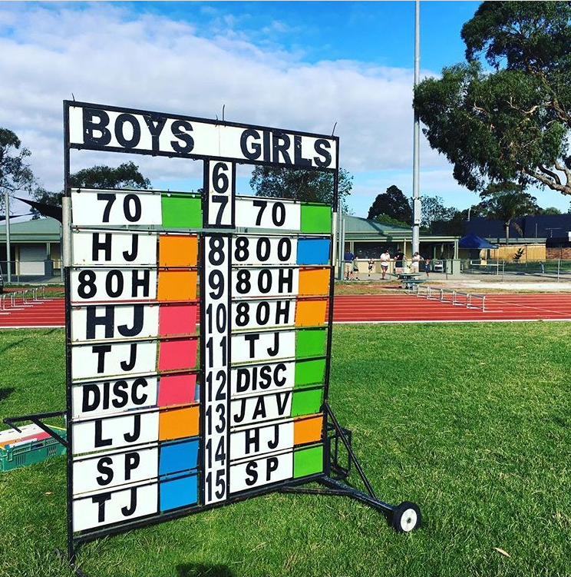
Map of Ballam Park
Your age group will be called to a coloured flag for an event. The flags are located below.
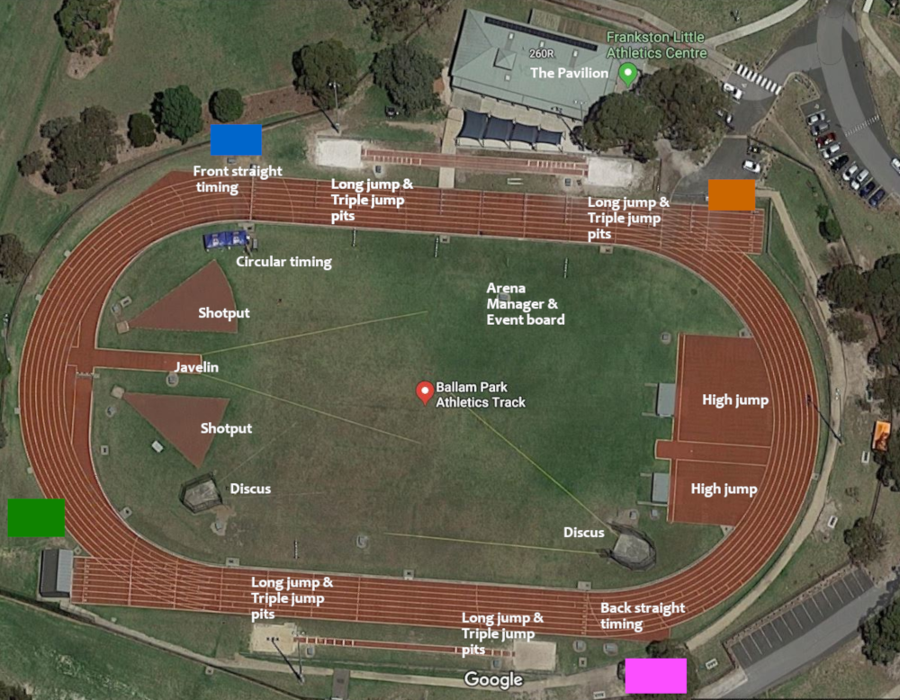

What else do I need to know?
We want our AGM’s to feel informed and empowered to perform their roles, so If you feel like you are missing something, don’t hesitate to ask a committee member or the AGM Co-ordinator a question. The FLAC website also has loads of information.

Note: The information in this document assumes that you have a general understanding of how Little Athletics runs e.g. how athletes can register for little athletics, what uniform they must wear, their tag, shoes/spikes, trial athletes, and much more. If not, you can find out more on the FLAC website (http://www.frankstonlittleathletics.com.au) or on the Little Athletics Victoria Website (http://www.lavic.com.au).

