LONG JUMP QUICK REFERENCE GUIDE
Safety tips
- Make sure all helpers and other athletes not standing to the side of or behind the athlete while a jump is in progress.

Equipment Needed | SETUP – Officials
- Take-off mat covered with damp sand  - Measuring tape (Min 20 meters)  - Watering can  - Spike for marking impression in pit  - Rake, broom & shovel | - One parent to rake and on measuring spike  - One parent to measure distance and check for foul jumps  - One parent to marshal athletes and record measurements
Take Off Mat / Board
Age Group | Take Off Area | Surface
U6-U8 Girls & Boys | 1.22m x 1.0m | Mat with thin layer of sand
U9-U10 Girls & Boys | 1.22m x 0.5m | Mat with thin layer of sand
U11 and above | 1.22m x 0.2m | Board
Getting Started
- Smooth the take-off mat and rake the pit for the first competitor.
- For each jump, ensure the take-off is from one foot.
- Athlete must place the take-off foot on or behind the mat/board.
- If any part of the foot is over the front edge of mat/board, then it is a foul.
- The athlete must exit the pit forward of the landing area. If the athlete walks back
- Through the landing area, it is a no jump.
Number of Jumps
- Each athlete will have 3 jumps, one at a time (Not in a row)
- Allow athletes a practice jump to check their run-up (if possible)
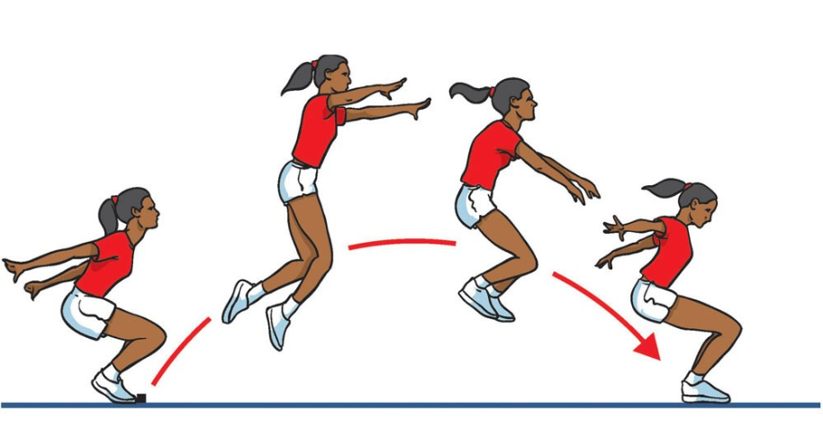

Measuring the Jump
- All jumps must be measured from the nearest break in the landing area made by any part of the body to the front edge of the imprint made by the take-off foot (U6-U10) or to the take-off line or its extension (U11 and above). The selected point is marked by the spike and the zero end of the tape is held at the spike.
- In the case of an (U6-U10) athlete taking off before reaching the take-off area, the jump is measured from the nearest break in the landing area made by any part of the body to the back edge of the take-off area. The measurement must be taken perpendicular to the back of the take-off area or its extension.
- The tape is drawn tight and the distance is measured to the nearest centimetre below the distance jumped unless the reading is a whole centimetre.
Recording
- Best performances should be circled or highlighted.
- Τhe athlete who has the longest measured distance from all jumps recorded is the winner.
- Ties are broken by referring to the next best jump
Athlete | 1st Trial | 2nd Trial | 3rd Trial | Best | Place
A | 4.75 | X | 4.62 | 4.75 | 3
B | 5.35 | 4.92 | 5.87 | 5.87 | 1
C | 4.65 | 4.35 | 4.75 | 4.75 | 2
D | X | X | X | NM | NM
- X should be used to indicate an invalid trial
- Results will always show “NM” when an athlete fails to record a measurable trial

