JAVELIN QUICK REFERENCE GUIDE
Safety tips
- Javelins can become dangerous when throwing in windy conditions.
- Make sure all helpers stand to the side or behind the athlete while a throw is in progress.
- The javelin should be carried back to the runway in a vertical position, tip down – never thrown.

Equipment Needed | SETUP – Officials
- Tape measure  - Assorted javelins  - Spike for marking | - One parent on measuring spike  - One parent to measure distance and check for foul throws  - One parent to marshal athletes & record measurements

Javelin Weights
Age Group | Javelin Type | Weight (grams)
U9-U10 Girls & Boys | Turbo Javelin | 300
U11-U12 Boys  U11-U14 Girls | Javelin | 400
U15-U16 Girls | Javelin | 500
U13-U14 Boys | Javelin | 600
U15-U16 Boys | Javelin | 700

Number of Throws
- Each athlete will have 3 throws, one at a time (Not in a row)
- Allow athletes a practice throw to check their run-up if possible
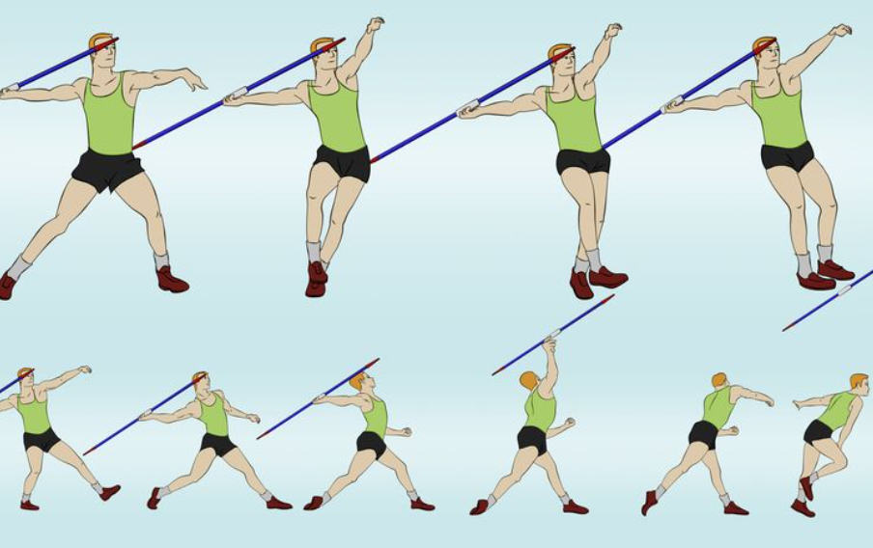
Valid Throw
- The javelin must be held at the grip. It should be thrown over the shoulder or upper part of the throwing arm and must never be slung or hurled.
- At no time during the throw, until the javelin has been launched into the air, may the athlete turn completely around, so that their back is toward the throwing arc. The athlete cannot turn their back to the throwing arc until the javelin has been launched into the air
- A throw shall be valid only if the tip of the metal head strikes the ground before any other part of the javelin. The javelin does not have to stick in, but the tip must make an imprint in the grass.
- When a javelin descends at a low angle to the ground it may bounce shortly before producing what looks like a fair landing. This must be carefully watched to see where the tip impacts first.
- The athlete must not leave the runway until the javelin has impacted the ground.
- When leaving the runway, the athlete must not move forward into the throwing arc.
- The athlete may stop and place the javelin down inside or outside the runway, leave the runway, then return to begin a fresh trial, providing that no other infringement has occurred.

Method of Measurement
The measurement of each throw shall be made from where the tip of the metal head first strikes the ground to the inside edge of the arc along a line from the point of landing to the centre of the circle of which the arc is part.

The spike marks the selected point and the zero end of the tape is held at the spike. The tape is drawn tight through the center of the circle of which the arc is a part (8mts from the arc). The distance is measured at the point where the tape crosses the inner edge of the runway arc. Each measurement is to the nearest cm below the distance thrown.

Recording
X should be used to indicate an Invalid Throw
Athlete | 1st Throw | 2nd Throw | 3rd Throw | Best | Place
A | 24.75 | NT | 24.62 | 24.75 | 4
B | 25.35 | 24.92 | 25.87 | 25.87 | 2
C | 24.65 | 24.35 | 24.75 | 24.75 | 3
D | 25.87 | 25.35 | 25.05 | 25.87 | 1

- D beat B on countback to 3rd Best Throw
- C beats A on countback to 2nd Best Throw

