|  |  |
| --- | --- |
| Club house stretch | Edithvale Bowls News |

**EDITOR – Kevin Breen November/December 2016**

If you have any Items of Interest

Please E-mail  *[kevinbreen1097@gmail.com](mailto:kevinbreen1097@g-mail.com)* or Phone 9772 2824

**MERRY CHRISTMAS**

**to All & Your Families**

**& A Happy New Year**

**What’s on**

**Twilight Bowls**

Wednesday, 14th December

Play starts at 5pm,

to be followed by a BBQ (meat and salad)

$10 per head

The list will be available shortly

March 20th 2017

**Cruise from Tooradin** (I have been on it GREAT trip ED.)

Cost $50pp

More details to follow

**Casino** Monday April 21st, 2017

More details to follow

**Trivia Night**

April 7th, 2017 More details to follow

**New Members** Please make welcome all new members by introducing yourself to them.

**From the Executive Director**

The Board has been very busy over the past few weeks. So, just a short report on some of the activities -

* Now that the business plan has been finalised discussions with officers of the Kingston City Council (KCC) are underway and numerous documents have had to be, and are continuing to be, prepared as we work to implement the first stage of the plan – the resurfacing of the Frank and Isabel Baguley green. Information to keep the three KCC South Ward Councillors informed is also being prepared and will be sent to them soon.
* The review and renewal of the club’s insurance policy is an annual event in November and that has been done.
* Maintenance issues have been dealt with as required.
* Contact has been maintained with the club’s sponsors.
* Now that Bowls Victoria has placed the responsibility for any necessary applications for exemption from VCAT rulings re single gender events onto individual clubs, the Board, together with the Bowling Committee, is working to decide what actions the club needs to take.
* Longer range planning has also been the focus of the Board’s attention recently. An application for grant assistance for the installation of lights over the John Clark green in 2018 is in the process of being finalised and will be lodged shortly.

2018 is, of course, the club’s 50th Anniversary Year and, as many of you will know, steps have already been taken to set up a group of members to help with the planning and implementation of some special, commemorative, activities for that year.

Please support your Board members by talking with any one of us if you have ideas or concerns.

With every good wish to each and every club member this Christmas.

Peace be with you.

***Ian Wilding***

21st November 2016

**WELFARE**

**Men’s welfare report**

8 NOV 16 - *A couple of weeks ago* ***Stan Holland*** *spent some time in hospital having blood transfusions but now is back on his feet at home and getting stronger by the day. Stan and Lyn won’t be bowling anymore however we look forward to seeing them at the club from time to time as social members.*

*Earlier in the year* ***Bob Baird*** *had a knee replacement followed by four months of rehab. He and Paula then decided to avoid our rains and follow the sun up north. They have just arrived home and Bob's knee has fully recovered so they should be bowling again soon.*

**STOP PRESS** Extra

"16 Nov 16” – **Bob Hasler** has had a recent operation which went well. Bob is on the mend and is likely to be home by the time you read this.

**STOP PRESS** Extra (Cont)

"22 Nov 16 - **Jim Gumbleton** had an operation last Friday and is now on the mend. He hopes to be home Thursday 24 Nov and looks forward to bowling again in the new year.

*If there are any club members missing bowls due to ill health, please let me know on* 9774 2997.

**Doug Rafter, Men’s Welfare officer**

**Ladies Welfare Report**.

Thankfully most of our ladies are well as I haven't heard otherwise. We wish Kay well pending her surgery and our thoughts are with Eric.

I'll take this opportunity to wish all members a Merry Christmas and a healthy and happy New Year.

Regards

**Margaret Burke, Ladies Welfare Officer**

**The True Spirit of Edithvale Bowling Club.**

* Edithvale Bowling Club offers its members a wide variety of bowling activities in which members can participate. These include several variations of social bowls, pennant bowls both mid-week and Saturday to suit bowlers of all capabilities and a wide range of club championship events in which all members are invited and encouraged to participate.
* Of necessity, all of these bowling events have their own set of rules and conditions of play in order to for them to be conducted successfully for all participants, and importantly, make it an enjoyable experience for everyone regardless of the outcome of the game.
* I am becoming increasingly concerned that members of our club are approaching me, at times visibly upset, because someone in our club has been openly critical of something that the member has or hasn’t done, and that member has been criticised and/or ostracised by another member of the club. Unfortunately, the member being critical is usually a member who has no position of authority in regard to the event being played, and as often happens, the critical member ‘s opinion or ruling which they are trying to impose on another member, is incorrect or a misinterpretation.
* I think if we all stop for a minute and reflect on just how upsetting a confrontation like this would be if we were new to the sport of lawn bowls and new to our club. A situation like this can still be upsetting even if we are experienced bowlers and longer term members of our club.
* **Such confrontations are unnecessary and unwanted in our club!**
* So I would ask all members of Edithvale Bowling Club to consider this; if you are in a position where there is some doubt over a ruling or you believe that another member is stepping outside the rules or the conditions of play, please **DO NOT** take it upon yourself to be the sole arbitrator in the situation and try to assert your interpretation of what should and shouldn’t apply. Rather, the matter should be referred to the person within the club who is conducting the event or to a member of the EBC Bowling Let us all do whatever we can to keep Edithvale as the “Friendly Bowling Club”.

Bob Steele, Chairman, Bowling Committee

Edithvale Bowling Club

5th October 2016.

**November Birthdays**

3/11 HelenThomson/Pauline Cousens/Phil Westmore

11/11 Bill Newman

12/11 Helen Robinson

13/11 Ian McPherson (A Special Birthday)/Judith Abbott

15/11 John Cracknell

21/11 Lyn Steele

22/11 Betty Gaunt

28/11 Ray Weston (A Special Birthday)

Happy Anniversary to:

14/11 Phil and Nancy Westmore

**Jokes / Stories / Gossip** *by Fibber ‘*What’s the difference between a Jeweller & Jailer?’ ‘One sells watches, the other watches cells’. (Thanks grandchildren Ed.)

***SPONSORS***

**Important Message.**

Andrew Tomlinson from Ray White in Chelsea has been and remains a very good supporter of Edithvale Bowling Club. Andrew is offering a donation of $1,000 to our club for any property that he sells that belongs to a member of our club or a property sold as a result of a referral to Andrew from a member of our club. HOWEVER, in order for the club to receive the $1,000 from Andrew, the property for sale must be directed to Andrew and no-one else. Any property offered to a Ray White agency will not receive the donation. So please, if you have a property for sale, or you know someone who does, would you please contact Andrew directly. His details are shown below.

|  |
| --- |
| **CHELMC900016541[1]EA**  **CRUISE & TRAVEL**   * + - PERSONAL SERVICE     - CORPORATE & HOLIDAY TRAVEL     - CRUISING SPECIALISTS     - INTERNATIONAL & DOMESTIC TRAVEL     - TRAVEL VOUCHERS, BRIDAL / GIFT   REGISTRY   * + - WE SELL LUGGAGE & TRAVEL   PRODUCTS  **Phone 9773 1900**  396 Nepean Highway  Chelsea Vic 3196  Email: travel@chelsea-travel.com.au |

Andrew Tomlinson

Senior Sales Consultant

Ray White, Chelsea

T: 03 9772 6333

M: 0429 234 341

Email: Andrew.tomlinson@raywhite.com



***ASPENDALE GARDENS cHARCOAL CHICKENS***

The succulent chickens come with a great range of delicious salads, which are freshly prepared each day. Gluten free mayonnaise is used.

Aspendale Gardens Charcoal Chicken is a valued sponsor of Edithvale Bowling Club. Please make yourself known to the staff. They look forward to serving you. Phone 9588 1616

**MICHAELANGELO’S**

Address:

4 Springvale Road, Aspendale Gardens

Victoria 3195

Phone: 03 9772 6999

Cuisine: Italian

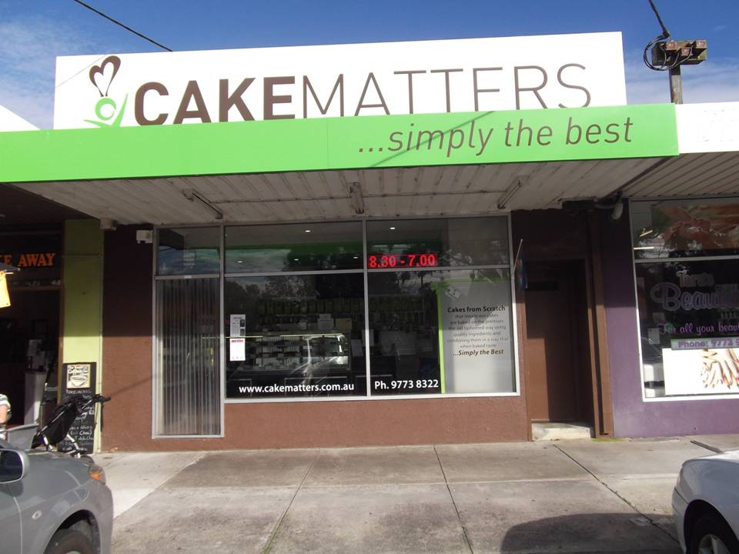**CAKEMATTERS**

Cake & Pastry Shop

236 Wells Rd, Chelsea Heights, VIC 3196

*Phone 9773 8322*

**LAKEVIEW MEATS** at Patterson Lakes. Pop in and see Craig

Address: Lakeview Shopping Centre, Gladesville Blv, Patterson Lakes Victoria 3197

Phone: 03 9772 0669

Support your Sponsors please

and

don't be shy to tell them

you are from Edithvale Bowling Club