[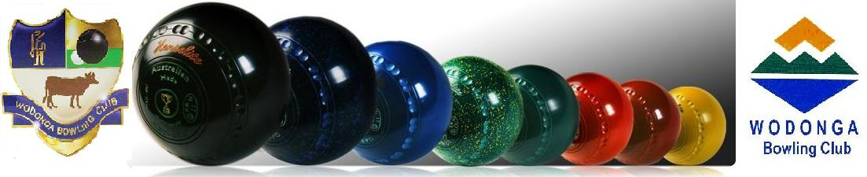](http://www.wodonga.bowls.com.au/site/index.cfm?fuseaction=display_main&OrgID=18224)

**NEWSLETTER**

**ISSUE 1 – SEPTEMBER SEASON 2017-18**

**WEBSITE – www.wodonga.bowls.com.au**

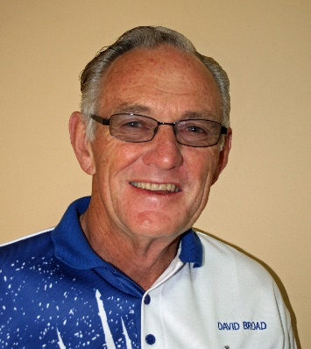

**FROM CHAIRMAN DAVID**

***A warm welcome back to all members, particularly to the grey nomads back from their time in the sun and a very warm welcome to all our new members.***

***After the usual cold winter and a number of washouts and low numbers which in turn seriously affected revenue, we hopefully can now look forward to a great season of bowling and friendship commencing with OPENING DAY and the HILDA HAWKINS MIXED PAIRS set down for the weekend of 10th September – with the event a challenging lead into the Pennant season.***

***WELCOME BACK EVERYONE!!***

**MEMBERSHIP:**

At this stage membership is down on expectation due to the continuing ageing and illness of our friends. Also, some are still enjoying the sunshine, and obviously have not checked for their email “account”. However, they will return and some prospective new members have already made enquiries and we look forward to welcoming them to Wodonga. As a result, at this stage, we will have only 76 positions available for weekend pennant and one less team playing mid-week. Please make it known to selectors immediately if you wish to play pennant.

In an attempt to bring more balance to the ageing demographic of our membership, a direct approach is to be made to all secondary school students to come and try our wonderful game of bowls during “Come Try Bowls” days scheduled for the 8th, 15th and 22nd of October, between 10:15am and 12:15pm followed by a sausage sizzle. We have never seriously approached this event with any success, but hopefully we can expect a good roll up of students, parents and teachers along with others in the community, so volunteers to help new bowlers and to man the BBQ will be essential. Because we registered early with Bowls Vic. the event will also appear in the Council’s Seniors Week Program.

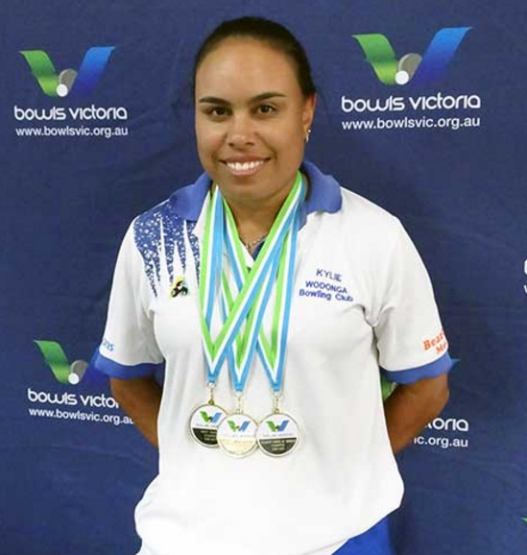

\***OUR YOUNG STATE CHAMPION - 3 TIMES OVER**:

Since our last Newsletter back in April, Kylie Whitehead has gone on to proudly represent herself and the Wodonga Bowling Club by winning the Victorian State Singles Championship, the under 25 State Singles, and was also part of the Ovens & Murray team that took out the State Fours Championship. Added to past efforts, truly a Wodonga Legend! ‘

From Bowls Vic. -“Couldn’t happen to a nicer person – one of the nicest people you’ll meet,” was the comment made by pretty much everyone who’s had anything to do with Kylie, as the news of her third victory spread around Bendigo East’ back in April.

\***STRATEGIC PLANNING PROCESS:**

The Wodonga Bowling Club has recently received a grant of $4000 from the City of Wodonga to appoint a Consultant to assist with the development of a Strategic Business Plan to guide the Club over the next two - five years, without ignoring longer term goals. Michelle Hudson from “The Communications Dept.” will work with the Board, Members and Bowls Australia Regional Manager, Josh Thornton, over the next two - three months targeting: - Financial Stability; Marketing and Improvement of Facilities; Promoting Bowls as a Sport to Recruit New Members; Governance and Management Practices; Board Structure; Sponsorship and Involvement of Volunteers in the Club’s operation.

The Development of a Strategic Plan has been commenced on numerous occasions over recent years, but has never been completed to provide a detailed document to guide the Club forward, which then should be reviewed regularly, in conjunction with a much more formal annual budgeting process.

Members are invited to bring relevant issues and ideas to the attention of Board Members or Josh Thornton at any time.

PLEASE NOTE: THERE WILL BE A CONSULTATION SESSION WITH MEMBERS ON PROGRESS AND DEVELOPMENT OF THE STRATEGIC PLAN, TO BE HELD AT 6.30 PM ON MONDAY EVENING THE 2ND OCTOBER. – *ALL MEMBERS ARE REQUESTED TO PLEASE MAKE A SPECIAL EFFORT TO ATTEND.*

**SPECIAL BOARD FINANCE MEETING:**

The high cost structure of the Club’s operation was discussed at length, with particular reference to the high cost of wages which currently account for 45% of overall expenses, which is clearly unsustainable without change, such as more volunteer participation behind the bar. Measures generally agreed to were improved purchase controls and the requirement for deposits on function bookings, but more should emerge from the Strategic Planning Process. However, pie charts were presented that illustrated that whilst the winter period created a lean time for the Club, current trends were consistent with recent years, albeit that the Club’s overall position is disproportionately held up by Bingo, Sponsorship and the Christmas Raffle, the first two of which are a credit to a very small group of volunteers. One weighty item looming in the immediate future, is the need for a replacement greens roller which could cost as much as $8,000.

\***RECENT BREAK-INS TO CLUB HOUSE**:

On two occasions recently there have been break-ins to the clubhouse. The only loss was an aging computer and there was some damage to the mechanism of one of our double doors. On the first occasion one of the alarms failed and security firm back up was poor, so rectification on both fronts is now in place thanks to John Harding’s contacts with “Security 1”, which hopefully will see the Club obtain better service in the future. However, further expenditure is clearly needed with the installation of both internal and external security cameras, which have been under consideration by the Board for some time.

# **David .**

# 

**Mid-Week Selection Committee:**

Marlene Ellis

Dawn Fraser

Deanne Gardiner

Hellen Harrison (C)

Pat Polly

**Weekend Selection Committee:**

Mike Bodman

Col Dwyer

John Evans

John Hodgson

Gary King

Josh Rudd (C)

**OFFICE BEARERS SEASON 2017-18**

**OFFICE BEARERS SEASON 2016-17**

**FFICE BEARERS SEASON 2016-17**

**OFFICE BEARERS SEASON 2016-17**

**Men’s Match Committee:**

Ashley Bates (C)

Alec Green

David King

Rob Taylor

**Ladies’ Match Committee:**

Lesley Duncan

Louise Farrar (C)

Julie Jones

Lyn Retallick

Lyn Winter

# 

**President Ladies:**

Pat Jackaman

**Deputy President Ladies:**

Dawn Fraser

**President Men’s:**

Murray Lawn

**Deputy President Men’s:**

Tony Smedley

**Chairman:**

David Broad

**Director of Administration:**

John Evans

**Director of Finance:**

John Harding

**“General” Directors:**

Mike Bodman

Hellen Harrison

David Jackaman

Peter McLarty

**Delegates to O&M Bowls:**

Jean Barber

Paul Davies

COMING EVENTS

|  |  |  |
| --- | --- | --- |
|  | |  |
|  | |  |
|  | |  |
|  | |  |
|  |  |
|  |  |
|  |  |
|  |  |
|  |  |

**MEMBERS MEETING – 6:30pm MONDAY 2nd OCTOBER.**

To provide all members the opportunity to have an input in the development of and receive a report on the progress thus far of the Club’s strategic plan **ALL** Club members are invited to a workshop/consultation session to be held at the Club at the above time and date. It is essential that as many views as possible of members are heard regarding the future of **YOUR CLUB.**

**MEN’S CLUB EVENTS**

Club Triples Sat 17 March

Club Singles Sun 5 November

Club Pairs Sun 11 February

Club Handicap Singles Sun 5 March

Dunstan Day Men’s Fours Mon 13 March

**LADIES CLUB EVENTS**

Generation’s Ladies Fours Fri 15 September

Club Consistency Thu 21 September

Club Singles Thu 2 November

Club Mixed Pairs Sat 14 January

Club Pairs Fri 25 January

McHarg Ladies’ Medley Fri 23 February

Club Triples Thu 8 March

Ladies Invitation Triples Fri 23 March

92nd OPENING DAY

**&**

**BORDER**

**CARPETS**

**HILDA HAWKINS**

**MIXED PAIRS**

**SUN. 10th SEPTEMBER**

**12:15pm**

**OPEN CLUB EVENTS**

Australia Day Major/Minor Pairs Thu 26 January

Ratcliffe Open Pairs Sun 25 March

“Westmont” Open Pairs Fri 30 March

“Conways” Open Pairs Fri 30 March

**STATE EVENTS**

Men & Women Fours Sun 24 September

Men & Women Over 60’s Singles Thu 28 September

Men & Women Novice Singles Sun 8 October

Men & Women Over 60’s Pairs Thu 8 October

Men & Women Triples Sun 22 October

Men & Women Singles Sun 12 November

Men & Women Pairs Sun 26 November

Men & Women Under 25 Singles Sun 17 December

Men & Women Mixed Pairs Sun 14 January

**SEPTEMBER DATES TO HIGHLIGHT**

Mon 5 Ladies’ Meeting

Thu 7 McRae Motors Men’s Triples

Sun 10 Opening Day / Hilda Hawkins Mixed Pairs

Fri 15 “GENERATIONS” Wodonga Ladies’ Fours

Sat 16 Weekend Pennant Practice Vs Cobram

Sun 17 Weekend Pennant Practice Vs Cobram

Thu 21 Ladies’ Consistency Rnds 1 & 2

Sun 24 Men’s & Women’s State Fours

Thu 28 Men’s & Women’s Over 60 State Singles

**LADIES’ MEETINGS:**

In past years lady members met once a month with these meetings proving very popular, well attended and a great means of communication. The Ladies will again conduct similar meetings on the first Monday of the month with the first one being held on:

Monday 4th September.

LADIES FOURS

FRI. 15th SETEMBER

10:00am

LADIES’ MATCH COMMITTEE:

As I write this report the sun is shining outside giving us a taste of what is just around the corner. So, it’s time to dust off the bowling gear, shine up the bowls and get down onto the green for a loosen up before all the competitions start.

We have had a steady group of bowlers who have braved the weather and regularly turned up to Tuesday Social but we are now looking to build our numbers so come along and join in the fun.

Our Generations Tournament is just around the corner on 15th September. Entries are slowly coming in from other clubs but not many names on our own list – please put yours down if only so I don’t worry that we won’t be well represented at our own tournament.

Our Club Opening Day which is a mixed event is on Sunday 10th. Haven’t got a partner? – not a problem, I’ll get you one. Let’s make this day one to remember – list is on the board.

Haven’t paid your fees yet? Ooooh that’s naughty but I won’t tell if you don’t. Just pop down to the club and get them paid so you can play.

Entries for a number of State events are open and on the board. If you wish to play you need to get your name down.

We have lots (probably 10 or more) tournament brochures from other clubs on our board. It would be great if we could send at least one team to each of them. Don’t worry if you haven’t got a team, if you would like to play put your name down so others can see you’re interested and we can get some more teams to go. We can’t expect clubs to come to us if we are not willing to support them.

Well, that’s it for now. Let’s make this year one to remember!!

Louise

STRATEGIC PLAN MEETING:

The first meeting for our Club’s business plan / strategic plan was completed recently to formulate key action areas.   
  
All club members are welcome and invited to a workshop planned for Monday 2nd October 2017 – 6:30pm.   
  
We as a club require as many people as possible to attend to ensure your thoughts, ideas and suggestions are heard.  
  
A plan that unites members, where all can share and work towards an agreed direction for sustainable growth, development and a successful and happy future.

Please start thinking about;

* Our future and what it looks like (Vision)
* How we can achieve this vision (Actions)
* What role if any you might play in ensuring our club has a long and successful, prosperous future.

This conversation with your peers should commence now. We need ideas and solutions.

Please note that this isn’t about the price of beer or the colour of the walls, membership fees, and pace of the greens or other day to day issues.

Think big and about exciting things for our futures.

Peter McLarty

Director: Strategic Planning/Recruitment

COME & TRY / BAREFOOT BOWLS:

**NOTICE TO ALL MEMBERS**

To assist the Club keep track of expenses and prevent any nasty surprises all members are requested, on no account, purchase or order goods on the Club’s behalf without first obtaining a purchase order number from Club Manager Bob or Club Finance Manager Caroline.

All members are reminded that if they use any of the Club computers they are responsible for their own backups.

Wodonga Bowling Club has begun the new season with a bang and a few whistles, and has high hopes of showing as many people as possible how to have fun and find enjoyment from the game of lawn bowls.

With the re-introduction of bowls viewing on SBS TV, an influx of people has shown an interest in the game which has led the club in opening their facilities to anyone who wants to ‘Come & Try’ the sport.

‘Come and Try’ Bowls begins on Sunday October 8th 10.00am to noon for three consecutive Sunday mornings and is an ideal opportunity for those interested to find out more about the game.

A recent Bowls Victoria survey revealed that over 60% of new bowlers started playing because of an invite from playing bowlers, and a further 15% started after being introduced the game by family.

So, members, please encourage other family members and friends to come down to the Club on Sunday mornings in October to learn more about the sport of bowls and enjoy the hospitality and friendship of our Club.

Barefoot bowls is the social format for new bowlers, whether they be workmates looking for some social entertainment, family and friends seeking a fun idea that is different to the norm, school age children that are looking for a non-contact sport that can enable them to represent their state and even country, or those people looking for a new sport that need only keep them occupied for a few hours each week.

The new season of Barefoot Bowls begins the first Thursday of November and continues each Thursday of that month. Just go on down to the Club any Thursday evening after 6.00pm, give the game a try and see what it is like. There will be no requirements to fill in nomination forms, no membership payments, only a nominal nightly fee to cover costs. What more could anyone ask for!

For those wishing to play the game on a more serious note, they can participate in the “Business House” social competition in November, a competition that has been running for over 15 years. Non-Members predominate this competition, with the majority either workmates that put a team together, a group of families and friends that want a social night out, or families and children having a cheap night out

.

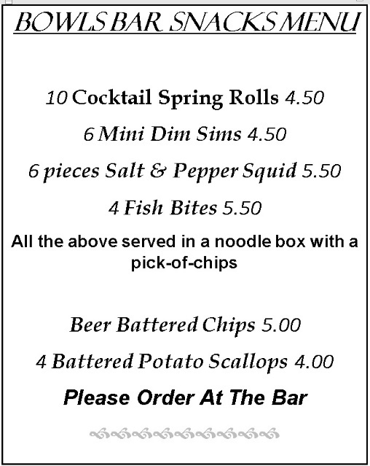

**PENNANT PRACTICE:**

The weekend selection committee has arranged to hold practice sessions/matches over the weekend 16th – 17th September against Cobram Bowls Club at Cobram. Twenty-four players from Wodonga are required for these sessions to proceed.

Selectors hope this event will be fully supported in order reciprocation from Cobram next year can be achieved and in future become an annual event.

All details regarding this event are on the notice board with provision to add your name if interested.

Further enquiries can be directed to:

**Josh Rudd: 0447 114 750**



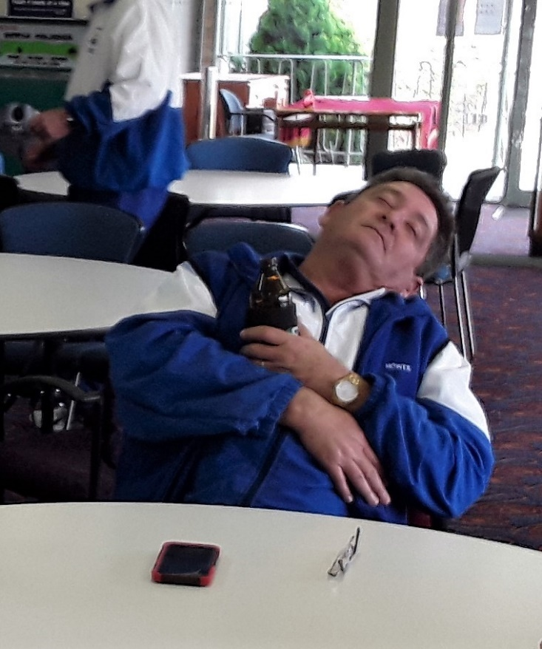

**Above:**

The life of the party on the West Coburg trip – just relaxing after a hard day!

.

**WEST COBURG BOWLING CLUB VISIT**

Wodonga members frequently mention they support events conducted by other clubs and these clubs don’t always reciprocate by entering in our events. With this in mind a group of our bowlers, last week, visited West Coburg Bowling Club to reciprocate for members of West Coburg supporting our Easter events.

***Peter McLarty presented this report:***

A great weekend of socialisation, hospitality with a little bit of lawn bowls throw in.

WCBC hosted 13 Wodonga bowlers over the weekend.

What a great bunch of the West Coburg members are, we were made to feel welcome and at home.

I would recommend all bowlers make the effort to visit WCBC. Their greens (carpet) are great, their beer cold and their meals like eating at Mums on a Sunday arvo.

Thanks to the WCBC for a fantastic weekend. Also, big thanks to Bob Ellwood and Brett Barton for driving the bus.

The Wodonga boys are a great bunch who enjoyed each other’s company.

