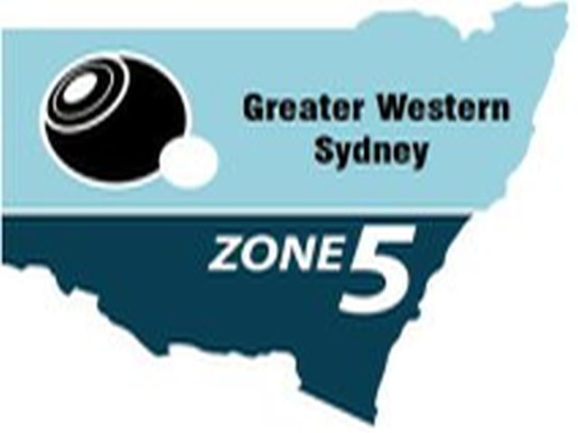
2017 Bowls NSW Inter Zone
Sides Championships
Westport Bowling Club
9-11 September 2017

CONGRATULATIONS TO THE BOWLERS BELOW
SELECTED TO REPRESENT ZONE 5 AT THE ABOVE EVENT

Full details including dates for further
training days will be released soon

UNAVAILABLE PROCEDURE:

If unavailable, please contact the Zone Secretary at:

Col Crossingham Mobile: 0414 196 635 or
zone5secretary@gmail.com

