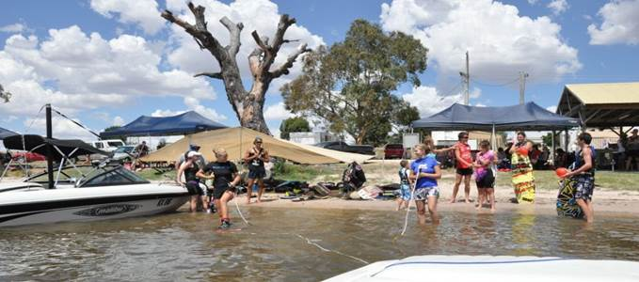

Secretary,

The AWWF is the governing body for waterskiing in Australia and covers 6 disciplines, Barefoot, Wakeboard, Show Ski, Tournament, Disabled and Cable Wakeboarding. With over 1.3 million Social Skiers on the water and over 3,500 involved with competition we have a key role in administering a strong sport across the nation. We are also recognised for Water Skiing with the  Australian Sports Commission.

One of our key roles is that of support to the  General Water Ski Clubs across Australia from the  hard core completion clubs to the  social clubs. Some of the services that we offer the clubs can include.

* Basic affiliation and support through communication and  web site information.
* Come and Try days  for introductory clubs.
* Several Insurance options to suit the club structure.
* Coaching opportunities.
* Coaching accreditation courses.
* Environment and local council support
* Boat Insurance for affiliated club members.
* Listing of your club and details on the AWWF web site.

For a water ski club to become affiliated with the AWWF then the following must occur. Once the base affiliation has been completed then the club has the choice on different “packages” available to them more so for Insurance purposes.

***The club needs to be formed by conducting a General Meeting  adhering to the following.***

* Minutes of meeting recorded
* An Executive appointed to manage the club. Minimum President, Secretary and Treasurer.
* The name of the club needs to  formalised and noted in meeting minutes.
* Bank Account of the club to be opened with signatories eg Executive.
* Club needs to be “Incorporated” in the State Government. (Look up State Government Consumer Affairs)

***Once the club has been formed then you have the opportunity to take up one of the AWWF affiliation packages including Insurance options.***

**Introductory package.**

* In effect support for the club  as above with no Insurance.

**Club Package**

* Full options above and includes Insurance coverage for the club including the following.
* Full 24/7 Public Liability on and off water.
* Professional Liability
* Association Liability
* Boat Insurance for members.

The cost  to the club for this package is $3000 per annum.

**Premium Package**

* Includes all of the Club package however is free to the club if all members of the club are full members of the AWWF.

In summary the offer from the AWWF is beneficial and tailor made to suit each club. We are happy to discuss further by calling Gary or Sue on 0260 212223 or e mailing us on [admin@awwf.com.au](mailto:admin@awwf.com.au)

The attached files give more detail on the points listed  above.

**Gary Humphrey**

**Executive Officer**

**Australian Waterski and Wakeboard Federation.**

0260212223

0428 494359

[executive@awwf.com.au](mailto:executive@awwf.com.au)

<http://www.awwf.com.au>

