Club News Autumn 2013

Bold Park

Last Saturday morning, some 50 people turned out at City Beach for the Anne Donkin Memorial Open Water Swim and breakfast barbecue. Anne was an inspirational and much loved member of Bold Park Masters who, after a tough and courageous battle, finally succumbed to her illness a few short months ago. It was fitting that this year's open water swim should be held in her honour.

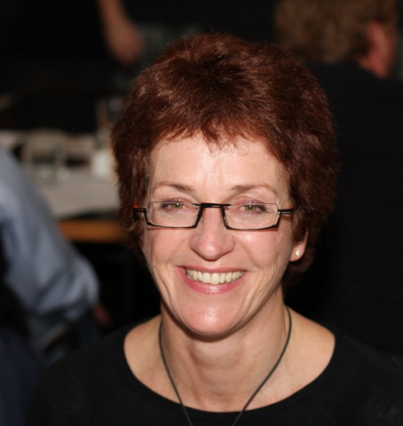

While husband Russell and kids were overseas it was wonderful that Anne's mother Dot, sisters Lyn and Rae and a number of other Donkin family members could join us for the occasion (indeed some even participated in the swim!).

After a few words of remembrance and swim briefing from President Grayam, swimmers took to the waters for an 8am start for a 1km social swim, commencing south of the southern City Beach groyne to Floreat groyne and return. While choppy south westerly conditions prevailed, all swimmers were 'present and accounted for' at conclusion of the event.

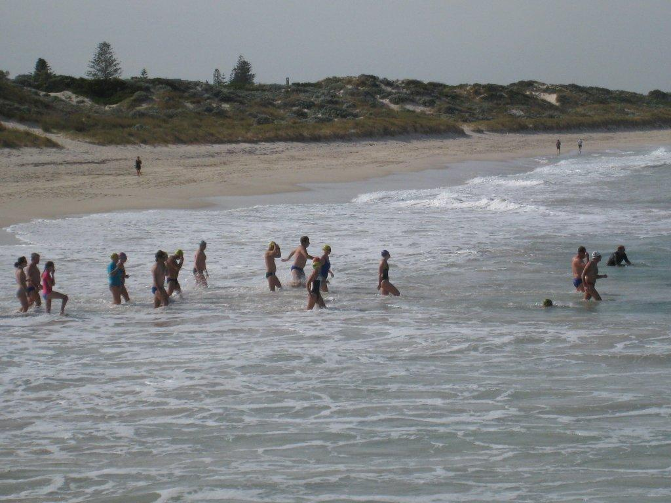

Then followed a very enjoyable gourmet breakfast barbecue with head chefs Bryan and Richard being tong masters for the day and Gale's home baked Christmas muffins hitting the spot. Many thanks to Gale Martin, Richard Press and Roy Colum for arranging the breakfast offerings.

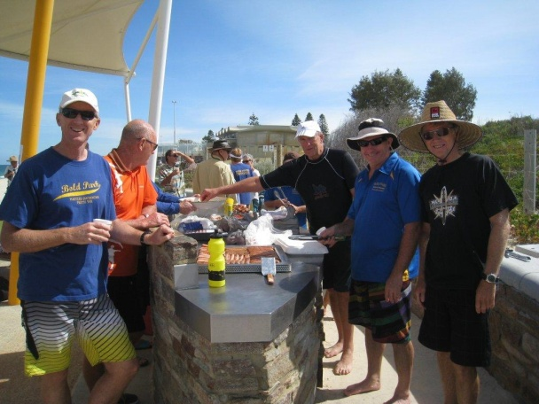

In an act of selfless defiance it was good to see Roy wearing an electronic shark protection device during the swim. It obviously worked as Floreat Beach was closed at 10.30am due to a shark sighting. Too close for comfort or food for thought......??? Roy assures us he wore the device to protect all swimmers, not just himself!

Stadium Snappers

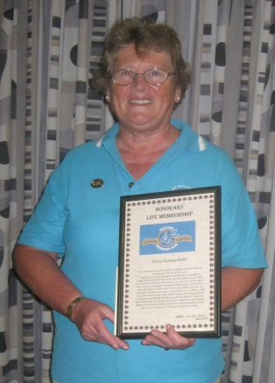
Life Membership was awarded to ’Tricia Summerfield in January:
‘Tricia Summerfield has been an active member of Stadium Snappers Masters Swimming Club Inc for 18 years. During this time she has been conscientiously committed to supporting this club through its development phases in the 1990s, as a President, Secretary, and Coach. As a club coach for the past 15 years, 'Tricia is the longest serving accredited coach with the club to date. Over these 18 years when 'Tricia was working full time she contributed extensively to many club activities as a swimmer, swim meet official and in many other administrative and technical duties to maintain an efficient and effective club. In addition, 'Tricia has held Directorships for Development and Coaching on the Board of Masters Swimming Western Australia Inc and been recognised for her services to Masters Swimming in Western Australia.
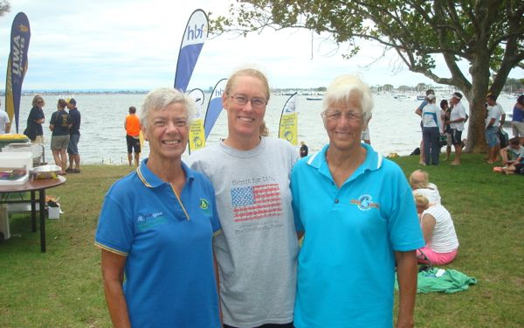
Snappers have enjoyed participating in the Open Water Swim series and thank each of the Masters Clubs who organised the events. Lake Leschenaultia, Fremantle Ports Swim Thru, Swim Thru Perth, Australia Day at Scarborough and Mandurah were well attended by swimmers. One of our swimmers, newly arrived from Texas, is enjoying her first experience of OWS in our lovely Perth waters!

Mandurah Mannas

Just a quick update as our club welcomes the return of our wandering Mannas.They have variously been tackling the tortuous FINA World Masters Swimming Competition in Italy, entered Asian marathon swims, attended FINA conferences in Germany, completed an English Channel Crossing, enjoyed American and European tours, dusted off after some 4x4 outback driving, peddled through a 300km cycle ridefor charity, and competed in the South West marathon circuit.Now, with varying degrees of fitness, we have begun the OWSseason.Welcome tosummer!

The summer started well with our trip to Narrogin. This club hosts a very special weekend with awell-organised swimming competition andthe wonderful Dragon Dance. The venue is lovely, the band terrific, and the food “to-die-for”. Thankyou Narrogin; we had a BALL.

The Sunday following Narrogin, we gathered for our “bubbly & BBQ” Christmas Party andthoroughly enjoyed Santa’s left-right game. Apparently, not all of us can tell our left from our right! OOPS!

The photos below are offered as proof that we do swim sometimes.
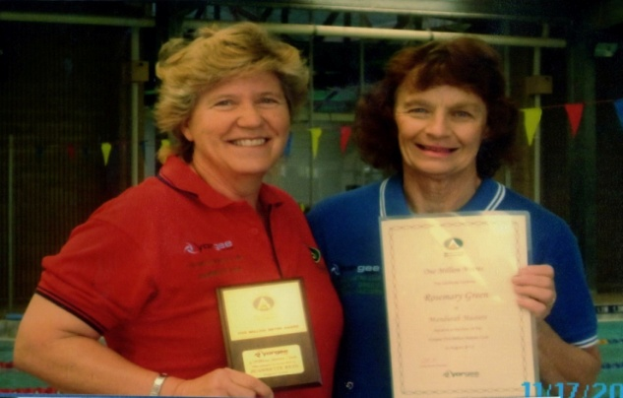
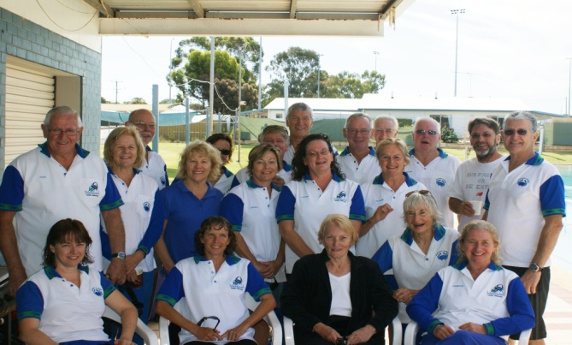

The Team at Narrogin Jeannette Rein 5 million metres Trophy(l)
Rosemary Green 1 million metres certificate (r)

A group of 20 to 30 more swimmers meet regularly to swim in the ocean at Doddi'sBeach. This has become a good test of fitness with a few extending themselves out to 10 km. It is amazing how the profile of this beach changes with the weather, from steep cutaway and exposed reef, to smooth white sand,with periods of weed in between. Ocean swimming is never dull.

Twenty-three members completed the 2013 Busselton Jetty Swim, seven for the first time.Rod Baker and Pauline Wingate won their respective age groups.The Mannas hosted the Mandurah Masters Ocean Swim on 17 February. An enthusiastic group of swimmers braved cooler weather to swim either 1 500m or 3 000m. Six Mannas won their respective age groups. Several of our members are preparing for the Rottnest Channel Swim withthree doing it solo, includingJeannette Rein who will be attempting her first solo.

Have a wonderful 2013!

WESTCOAST

Westcoast held their AGM and Awards presentation on 19 January. This was well attended. There were a few changed made to the committee, which is always good – bringing in some fresh blood with new ideas. Lane Awards were presented to Ina Simson, Mark Richards, Steve Gale, John Bryan and Frank van Rooyen. Swimmer of the Year Award went to Shaun Harrison, with Club Person of the Year going to Viki Shelver. As this was the first official function of our 30th year, members were treated to a cup of tea and a slice of birthday cake at the end of the meeting.

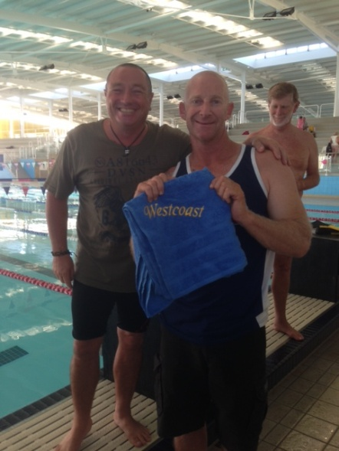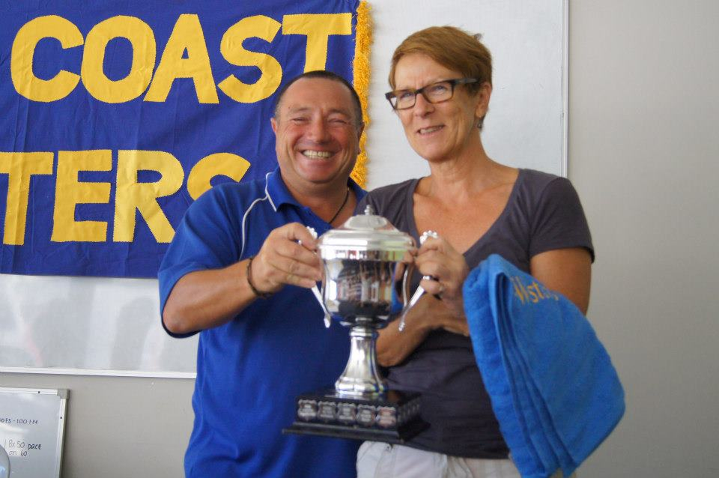

Swimmer of the Year Shaun Harrison Club Person of the Year Viki Shelver

There are great plans afoot to ensure that all members, present and past, have the opportunity to celebrate our 30 years of success, with plenty of social activities on the cards.
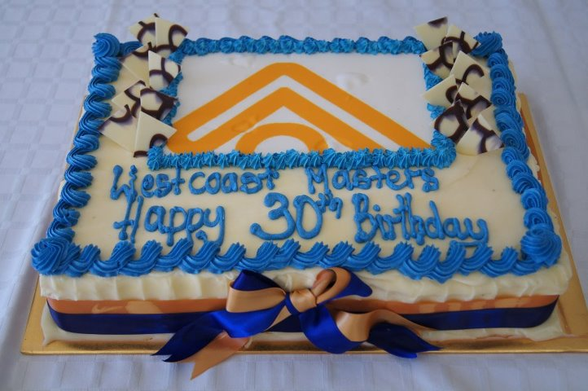

We have started the year with 94 financial members, a few pending payment and even some newies giving us a try out before making a commitment.

Our head coach, Alan Power, put out the challenge to all members to commit to an 8 week period of serious committed swimming. The 8 Week Challenge started in the first week of February with a 400m time trial and heart rate recording. This will be done again at the end of the 8 weeks in order to see what improvements have been made to fitness levels. It was great to see more than half of the club signing up for this activity. We have also been fortunate to have Caryn Keillor (Masters National Coach of the Year for 2004) giving of her term to provide technique sessions to each of the lanes. What a wonderful start to the year, everyone is fired up with enthusiasm.

Our Club Captains, Peta Batorfi and Paul Kannemeyer, are busy encouraging participation in the State Open Water Championships and numbers are looking very promising. After that, our focus turns to the hosting of our LiveLighter Club Carnival to be held mid-April. We once again look forward to hosting many clubs and giving our members the opportunity to show off the results of our 8 Week Challenge.

