There are NO ongoing fees to pay! The registration fees are all inclusive!!
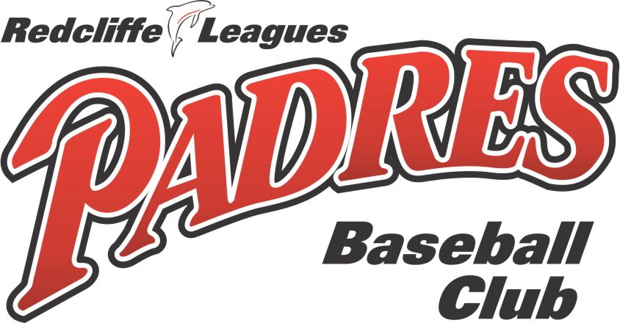

Where do my fees go?

We understand that playing baseball can be an expensive sport. Below is a breakdown of the expenses that the club budgets for. Please understand that we are a not-for-profit club, and all funds are spent on getting the players on the field, running the club and maintaining this great facility.
 | $ 400.00 | $ 400.00 | $ 440.00 | $ 470.00 | $ 490.00 | $ 560.00 | $ 670.00 | $ 560.00
 | Tball | Rookie | U13 (LL) | U15 (JL) | U17 (SL) | U20 | Snrs | Masters
Baseball Queensland Fee | 15% | 15% | 17% | 16% | 19% | 22% | 19% | 14%
Baseball Australia Fee (insurance) | 8% | 8% | 11% | 10% | 10% | 11% | 9% | 11%
Brisbane North Region Fee | 4% | 4% | 3% | 3% | 3% | 3% | 0% | 0%
GBL Competition Fee | 0% | 0% | 2% | 1% | 1% | 1% | 2% | 2%
Club Membership Fee | 2% | 2% | 2% | 2% | 2% | 2% | 2% | 2%
Equipment Fee | 21% | 22% | 16% | 15% | 8% | 7% | 10% | 10%
Umpiring Expenses | 5% | 5% | 9% | 13% | 13% | 11% | 12% | 23%
Scoring Expenses | 4% | 4% | 7% | 7% | 6% | 5% | 5% | 5%
Sinking Funds (Major Works) | 7% | 7% | 7% | 7% | 7% | 7% | 7% | 7%
Lights (Electricity) | 10% | 10% | 5% | 5% | 10% | 10% | 23% | 15%
Batting Shed Maintenance | 1% | 1% | 1% | 1% | 1% | 1% | 1% | 1%
Club Operation Costs | 22% | 22% | 20% | 20% | 20% | 20% | 10% | 10%
 | 100% | 100% | 100% | 100% | 100% | 100% | 100% | 100%

