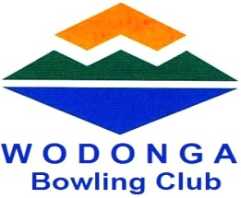



and our sponsors

**invite entries to the 55th running of the**

**DUNSTAN DAY MENS FOURS**

***$1800 Prize Money***

### WINNERS $760 2ND $380 3RD $200 4th $160 5th $100 6th $100

Best Last Game $100 (excludes major prize winners)

**Monday 13th March 2017**

#### Commencing at - **9:30am**

#### 4 Games of 10 Ends (Play off for Winners if necessary)

Entry fee $100 per team (includes lunch)

***Entries Close Thursday 9th March 2017 at 5pm***

**Postal Entries:-** Wodonga Bowling Club Cnr Hovell & Osbourn Sts. Wodonga Vic 3690

**Phone Entries:-** 02 6024 1554

**For Information:** Bob Ellwood 02 6024 1554 0r David King 0407 261 188



**ENTRY FORM**

**DUNSTAN DAY MENS FOURS**

**Mon 13th March 2017**

**$1800 IN PRIZE MONEY Winners $760 2nd $380 3rd $200 4th $160 5th $100 6th $100**

**Best Last Game Winners excluding major winners $100**

Team entered by…………………………………………….. Club……………………………………..

Home address……………………………………………….. Telephone………………………………

Amount enclosed $100.00 (Cheques to be made payable to Wodonga Bowling Club)

Please reply to: **Wodonga Bowling Club** Cnr Hovell & Osbourn Sts. Wodonga Vic 3689

or

**Phone Entries**: **02 6024 1554**