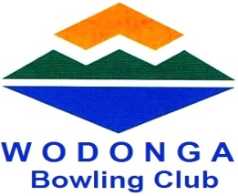
WODONGA

Lady members are pleased to invite
your ladies to enter our
Fours Medley Tournament
Proudly sponsored by
McHargs
Solicitors

on Friday 24th February 2017

commencing at 10.00am
Morning tea and Lunch provided

Entry Fee : $54.00 per team
with Single Entries welcome

TOTAL PRIZE MONEY $400

Entries Close :
Tuesday 21st February 2017 at 5.00pm
Games Format:
1 game 4’s x 12 ends; 2 games 2 bowl pairs x 12 ends

To enter your team OR single entry please contact:

POSTAL ENTRIES:
Ladies Match Committee Maxine Bounader
Wodonga Bowling Club Inc Phone: 0402 311 927
PO Box 215 or 64 Hovell Street Email: maxichick@iprimus.com.au
Wodonga Vic 3690

