MARYBOROUGH & DISTRICT HOCKEY ASSOCIATION

Come and Play Indoor Hockey

Fun Fast and Exciting
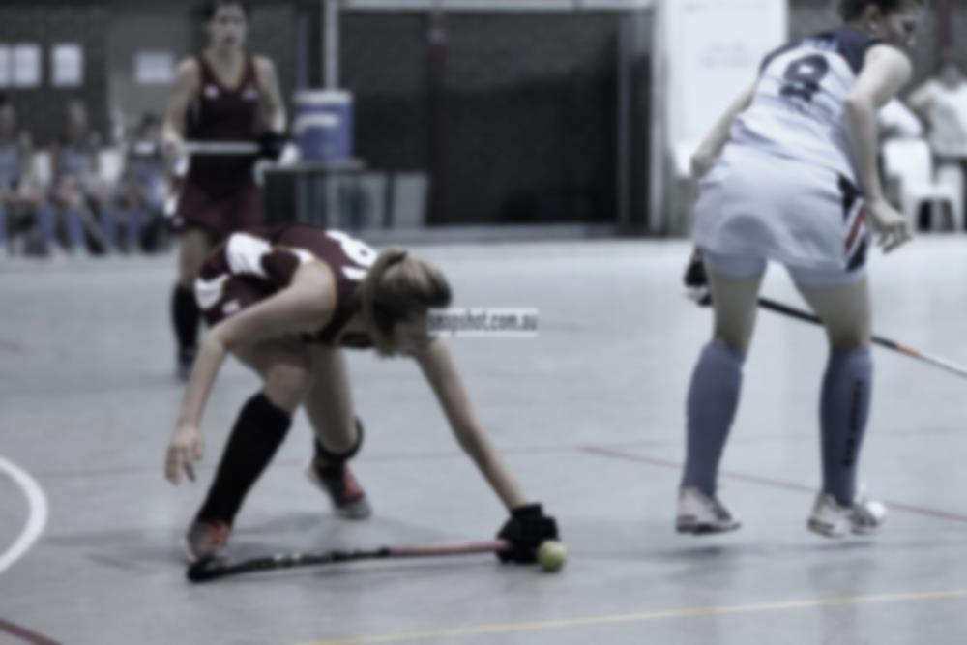
When: Monday, Thursday & Friday afternoons

From: 02/10 to 1/12/17 (see age groups below)

Where: Maryborough Showgrounds – Main Hall

More Information: Contact Shane Palmer on 0414 591616 or
visit our website: www.maryboroughhockey.asn.au

Monday: 4pm to 5pm 15yrs & Under Girls
5pm to 6pm 15yrs & Under Boys
6pm to 7pm U18 & Open Women
7pm to 8pm U18 & Open Men

Thursday: 4pm to 5.00pm 7 to 10 year old Girls & Boys
5.00 to 6.15pm 11 to 13 year old Boys
6.15 to 7.30pm 11 to 13 year old Girls

Friday: Social Competition for anyone 13yrs old plus 6 to 8pm

MARYBOROUGH & DISTRICT HOCKEY ASSOCIATION

Come and Play Indoor Hockey

Fun Fast and Exciting
When: Monday, Thursday & Friday afternoons

From: 02/10 to 1/12/17 (see age groups below)

Where: Maryborough Showgrounds – Main Hall

More Information: Contact Shane Palmer on 0414 591616 or
visit our website: www.maryboroughhockey.asn.au

Monday: 4pm to 5pm 15yrs & Under Girls
5pm to 6pm 15yrs & Under Boys
6pm to 7pm U18 & Open Women
7pm to 8pm U18 & Open Men

Thursday: 4pm to 5.00pm 7 to 10 year old Girls & Boys
5.00 to 6.15pm 11 to 13 year old Boys
6.15 to 7.30pm 11 to 13 year old Girls

Friday: Social Competition for anyone 13yrs old plus 6 to 8pm

