On Sunday 23rd October 2016 the Box Hill Little Athletics Club will host their Invitation Relay Day.

This event is not to be missed, as it’s well organised, not too far away to travel and it’s a great team event for our CLAC athletes to enter into and compete against other centres. Note that last year the Centre had registered 27 teams for the event.

Note that the Box Hill Relay Day is a great precursor event leading into the (EMR) Eastern Metropolitan Regional Relays to be held on 19th November at the Doncaster track and it’s a great way for our athletes to try out their competitive relay skills against other clubs beforehand.

U8 – U16 Team Registrations must be into CLAC by No Later Than 12th October for each age group with a nominated team manager (Parent) responsible for the team submitted and listed for the event.

Please use the attached CLAC Team Submission Form.

2016 LAVic relay rules will apply at the event and EMR starter will be present.

Events:
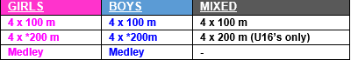

Note that the U8 & U16 age groups are subject to pre-registration interest and are at the discretion of Box Hill Little Athletics Club if they run or not based upon interest gained.

