Gwen Green

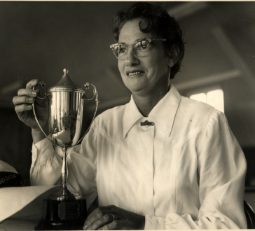

Started bowling at Wodonga 195

The first Wodonga player to achieve the honour of playing for Victoria was Gwen Green who was selected to represent the state in 1962. Gwen’s achievements on the green support the view held by many long-time members that she was the finest bowler ever to play for the club. Taking up the game in 1950, having previously played women’s cricket for Collingwood, netball and golf, from the beginning Gwen displayed a natural talent.

Just four years later she won the Victorian Country Pairs with Sibyl Baines.

In 1974, this time partnered by Hilda Pochan, she won the Victorian State Pairs. But without doubt the highlight of her career came six years later when she won the 1960-61 Women’s Victorian Singles title; the first country bowler to achieve this success. Before Wodonga ladies became affiliated with the North East District Ladies Bowling Association Gwen won the Champion of Champion title in the Ovens and Murray Association three times. She later won the NEDLBA Singles and also the Association Pairs and Fours titles.

Over her career Gwen, won the Ladies Club Singles a record number of 16 times as well as numerous tournament events.

Gwen’s introduction to bowls came when she assisted her husband, Alby, to cart and spread loam, when he and other members of the club, were constructing a new green (now known as the Mahony Green).

Club President 1952 - 54, 1961 - 63, 1985 - 87

Victorian State Singles 1961

Club Singles 1955, 56, 57, 58, 59 60, 62, 65, 66, 69, 73, 75, 77, 82, 84, 87

