HARBORD BOWLING & RECREATION CLUB LTD
GREENS & SURROUNDS SMOKING POLICY
Policy No 003 V1

- Purpose
It is the policy of Harbord Bowling & Recreation Club Ltd to protect the health and sporting performance of all its members and guests.
- Scope
This policy is in place to ensure all members and guests are aware of the “Designed Outdoor Smoking Area’s” of the Club. Smoking will only be permitted in the designated “Smoking Area’s” as shown on the map.
- The Policy
It is the policy of Harbord Bowling & Recreation Club Ltd to protect the health and sporting performance of all its members and guests by adopting a “Smoke Free Greens and Surrounds” policy.
The greens and banks of all 4 greens are now designated to be smoke free. Harbord Bowling & Recreation Club Ltd acknowledges the Smoke-Free Environment Act 2000 (The Act), which applies penalties for smoking in spectator areas during sporting events, such as bowls.
Patrons may be issued with an on the spot fine of $300.00 for non-compliance.
Areas have been allocated for smoking are known as “Designated Outdoor Smoking Areas (DOSA)” and are marked on the below map for your information.

DESIGNATED OUTDOOR SMOKING AREAS (DOSA)
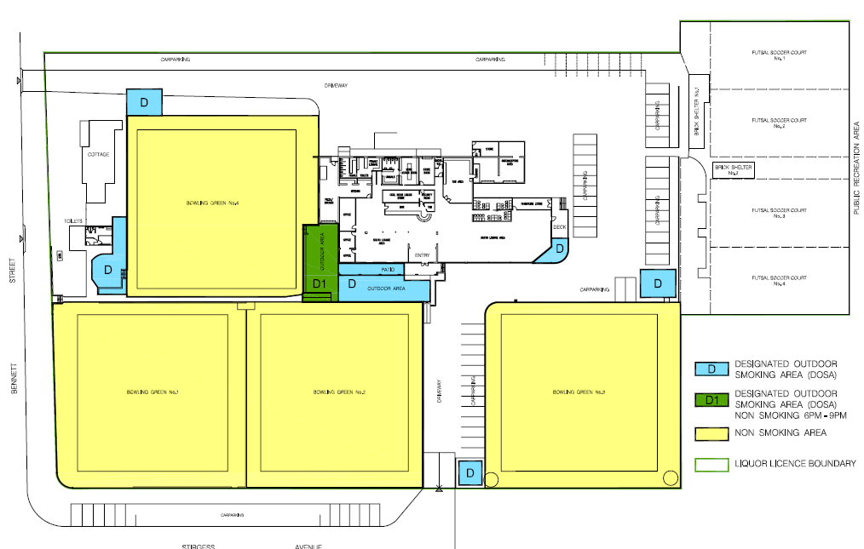

The nominated contact person responsible for the Harbord Bowling & Recreation Club Ltd is the Secretary Manager, email hbrcl@ozemail.com.au or phone 02 9905 4849 during normal business hours

