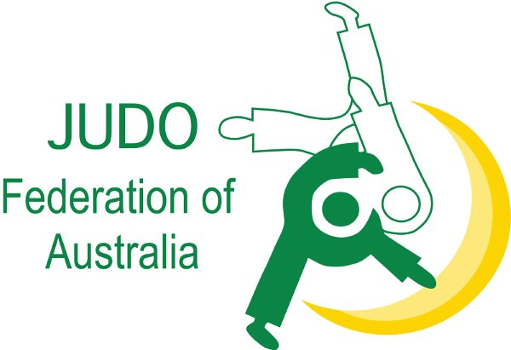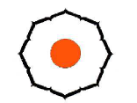

JFA Inc. Kodokan Committee

The JFA Inc. Kodokan Committee is sanctioned by the Kodokan Judo Institute Japan and the Judo Federation of Australia Inc. to recommend and authorize Kodokan Dan Grades, across Australia.
This means that the JFA Kodokan Committee has the authority to put forward recommendations on behalf of JFA Dan Grades for approval by the Kodokan Judo Institute.

The JFA Inc. Kodokan Committee can make recommendations up to and including 6th Dan.

The 1st Dan to 3rd Dan process is relatively straight forward, as the JFA Inc. criteria and the Kodokan criteria, is very similar. In the majority of cases the JFA Inc. Kodokan Committee’s recommendations are accepted and endorsed by the Kodokan Judo Institute.

However, from 4th Dan to 6th Dan the criteria, is more stringent.
The Kodokan places strong emphasis on an individual’s contest history, continued contribution to Judo, and the personal pursuit of self-improvement in Judo. It is not unusual for candidates at this level to be offered grades lower than their JFA Inc. grade.

JFA Inc. endorsed 7th Dan and above applications are forwarded directly to the Kodokan for consideration under their deliberation system.

As you would understand, the Kodokan criteria, is the main reference in this application and assessment process.

This is a great opportunity to have your successful Judo career endorsed by the world recognized Centre of Judo Excellence, the Kodokan Judo Institute.
I look forward to your interest in this opportunity.

Yours in Judo,

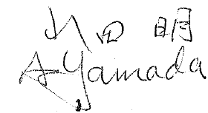

Akira Yamada Kodokan 7th Dan
Chairman JFA Kodokan Committee

The Process:

- Grade Application Form:

The first step is to complete the Kodokan Grading Application Form, with passport size photo and Judo Biography.
Cover in detail your;
- Contest record
- Grading record
- Contribution to Judo
- Your future contribution and personal pursuit of knowledge in the art.

Please note:
      - That if you are not a Kodokan Judo Institute member, a one off joining fee will need to be paid, currently Y8000.
      - All applications are to be forwarded electronically using the .xls form below.

The Kodokan Grading Application Form is available by clicking on this link:
http://assets.imgstg.com/assets/console/document/documents/20160412021003KDK_Dan_Grade_Application_Form.xls

- Send to JFA Office:

The second step is to forward your digital application to the JFA Office to:

cathy.potter@ausjudo.com.au

The office will forward applications to the Kodokan Committee.

- Kodokan Committee Assessment and Kodokan process:

The third step involves the following:

- JFA Kodokan Committee receives applications, approves as is, or adjusts to a level of Grade they feel complies with the Kodokan standard, or rejects the application.

- Recommended applications are sent to the Kodokan “Kokusai Bu” International Department who will vet the suitability of the recommendations.

- The Kodokan Kokusai Bu will present applications to the Kodokan Board for review, validation or rejection. They meet once per month to assess applications.

- On validation, the Kodokan Board will advise the Kokusai Bu who will then inform the JFA Kodokan Committee of the Board’s decision. 4. Payment and Certification Process:
- The successful candidates will then be asked to deposit the appropriate fees via the JFA Inc. office invoice process.
- The JFA Inc. will then transfer the payment to the Kodokan bank account.

The fee and payment schedule is available by clinking on this link:
http://assets.imgstg.com/assets/console/document/documents/20160412021116FEES_AND_PAYMENT_METHOD_KDK.xls

- Kodokan certificates will be sent to the JFA Inc. office for forwarding to the successful candidate.

