|  |  |
| --- | --- |
| Club house stretch | Edithvale Bowls News |

**March 2016**

**EDITOR – Kevin Breen**

(If you have any Items of Interest please E-mail [*kevinbreen1097@gmail.com*](mailto:kevinbreen1097@gmail.com) or

Phone 9772 2824)

**What’s** (been) **on**

Trip to the Sandown Dogs WOW!!!! They WON!!! A $1,000 for the CLUB. See Directors Report.

B.B.Q. At Bunnings (Thanks to Mary Weston & helpers.)

**New Members**

**Saturday Section** January 2016

**Ian Wilding (President Saturday Section)**

**FROM the BOARD – March 2016**

Welcome to the end of the Club Year – **Sunday April 10th is the Club’s AGM** and a you are all invited! This year sees the introduction of some major changes to the way the Club will operate. Soon after the AGM, Members will vote for positions on the new **Bowling Committee**. There are 9 places up for nomination: Men’s President, Ladies President, Secretary, Treasurer, 5 Committee Members (with a gender limit imposed – no more than 3 can be of the same gender). There will also be the usual vote for Selectors ( 5 for Mid-week and 5 for Saturday). And, of course the Match Committee which requires 10 members.

AND don’t forget we have **Board positions up for nomination** and possible election if there are more nominations than positions. Finishing their 2 year terms are the Executive Director, the Finance Officer and 1 Director position. It goes without saying that the Exec Director and Finance Officer roles are VITAL to the administration of the Club. Don’t all rush to fill these positions, take your time, come and speak to a Board Member to find out more and then NOMINATE.

At the AGM, Members will also be asked to **vote for a Life Member**. The Board received a nomination from the Members for Barbara Overson to be awarded the honour of being an Edithvale Bowling Club Life Member. The Board has a set of criteria which assist the assessment process and maintain a line of continuity. In accordance with the process, nominations for Life Members are received and assessed by the Board. If the Board agrees then the Board’s recommendation is put to the Members as a Special Resolution at the AGM. If 75% of Members present agree with the nomination then Barbara is accepted as a Life Member.

The Board has considered and agreed that Barbara is a worthy nomination deserving of the honour of being a Life Member and we will offer our recommendation to the Members for a secret ballot at the AGM.

**BUNINGS BBQ** – thanks especially to Mary Weston and all the helpers at the recent Sausage Sizzle we held at Bunnings Keysborough. We only get a chance at being offered a BBQ slot once a year and it is an opportunity too good to miss. We made approximately $1,000 which is much appreciated.

**Kingston Council & our Irrigation System** – the saga continues. The Council arranged a quote for the repair/replacement of our sprinkler system which required EBC to pay some $15,000 for the work. The KCC refused to pay for another quote so the Board agreed to get another assessment to assess what the KCC was recommending. The latest report is being currently reviewed by the Board and the KCC. To further complicate matters we have a “neighbour complaint” about the noise caused by the pump and the coolroom motor – the reason behind KCC’s plan to move the pump to the other side of the property – something which further impacts directly on our irrigation system plans.

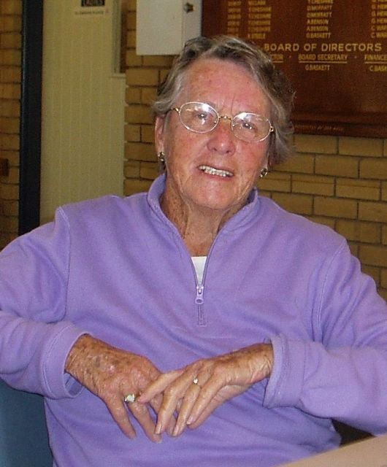**Sandown Dogs** – the Social Committee had a very profitable time at the race track last week. The Sandown Races have a promotional scheme whereby they invite Groups and Clubs to bring along a bus-load of punters – there are free nibbles, a $10 betting voucher and a lively atmosphere as the dogs run past as you sit in comfort behind a huge glass window. For a selected race each Club attending gets a dog – if that dog wins the Club gets the $... - EBC won! $1,000! A big thanks to Robbie Leitch and the Social Committee.

**VALE Avriel Darby** – heartfelt condolences to Bob and his Family. At times like these the Club is a there, with friends for company and offers of support if we are needed.

Ian Thomas,

Executive Director Thanks Barb / Pam I took the photo from the Web Site (Ed.)

**Saturday Section**

Following the forthcoming Annual General Meeting of the Club on April 10th the Saturday Section Committee will be discontinued, being replaced by the new Bowling Committee. Throughout the past two years I have valued the many contributions made by all the members of the Saturday Section Committee and I have appreciated their support. Thank you.

**Tournaments**

The weekend of the 19th and 20th March will be a busy one with the Men's Classic 3 Bowls Pairs and the Armed Bowlers tournaments being played. It would be good to get some more entries for the Baguley Men's Fours (2nd April) and there are 5 spots left for the Mixed Medley (16th April). Entries to date are posted on the notice board at the Club.

**Marking**

As mentioned in a previous newsletter Secretary Glen Baskett has kindly prepared some up to date 'guidelines for markers'. Copies of these are now available at the Club for those interested.

Finally, I encourage members to take a turn in helping to run the Club by standing for election to one of the positions on the Bowling Committee.

With every good wish for the 2016-2017 year.

Ian Wilding

President Saturday Section

15/03/2016

**Men’s Welfare** Report**.**

**.** **.** Last week Max King spent 5 days in hospital with cardiac problems. Max is home again now and will soon have an ecocardiogram which hopefully will identify the cause/s.

**.** Stan Holland is continuing chemo treatment for the next three weeks and he tells me at this point everything is on track. He may then be placed on a course of tablets. At the end of April Lyn and Stan are planning a trip to Echuca, Yarrawonga and Albury.

**.** In the last week Wayne Clarke has been back in hospital after an adverse reaction to medication and is now back home. Wayne may take phone calls when not resting but please call first if you intend to visit.

**.** Last Wednesday Bob Baird had a knee replacement at Peninsula Private and after a tough first couple of days is doing well. At the time of writing Bob is walking around and hopes to be driving again by May.

**.** Peter Brain is still suffering the effects of gout and also has been diagnosed with whooping cough which have kept him at home. Peter advised there are signs of improvement and we should see him at the club in the near future.

**.** It's good to see our Saturday committee President Ian Wilding back at the club and he should be bowling again in a couple of weeks.

**.** Last Thursday John Cracknell was admitted to hospital with arterial problems but after some treatment and many tests John is back home in the care of nurse Shirley. John may miss a couple of weeks of bowling but is looking forward to another season.

**NB:** Recently we have had two members staying away from the club due to whooping cough. hopefully no other members have whooping cough which may be spread by coughing or sneezing and is highly infectious. Incubation period is between six and twenty days.

If I have left out anyone missing bowls due to ill health or if anyone has any information - please call me on 9774 2997.

**Doug Rafter –(MENS WELFARE)**

**Ladies Welfare** Report. March 2016

Pleased to say no Ladies have been reported sick to me this month.

**Rae Gibbs. (Ladies Welfare)**

**Happy March Birthdays to:**

2/3 Pat Sherriff 4/3 Julie Bennett 6/3 Andrew Perkins

10/3 Bob Davies 11/3 Phil Westmore 12/3 Ian Thomas

15/3 Graeme Hewitt, Di Cameron 17/3 Peter Howell

22/3 Rae Gibbs 23/3 Glenys Gionis 25/3 David Costelloe

29/3 Walter Trupke 31/3 Greg Kelly

Happy Anniversaries to:

Judith and Harry Thacker

STOP PRESS from Suzanne Webber

Membership Committee.  
A strong membership is essential for the financial, social and competition success of our club.  
A large membership base also ensures diversity within our club.  
In order to continue to achieve this,  EBC is forming a "Membership Committee" .  
If you are interested in helping to achieve these goals, please put your name on the list in the  
"notice board area"  near the "lounge".  
Any questions,  please see Suzanne.   Thankyou.

**SPONSORSHIP.**

***LAKEVIEW MEATS*** *at Patterson Lakes. Pop in and see* ***Craig***

***SHARPEDGE Window cleaners*** *Darren has done a lot of work around this area and has 30 years’ experience. Ring him for a quote Phone 0400391211. His prices are very reasonable, an average house $60 - $80”*

**MAKE SURE YOU MENTION THAT YOU”RE FROM EDITHVALE BOWLING CLUB**

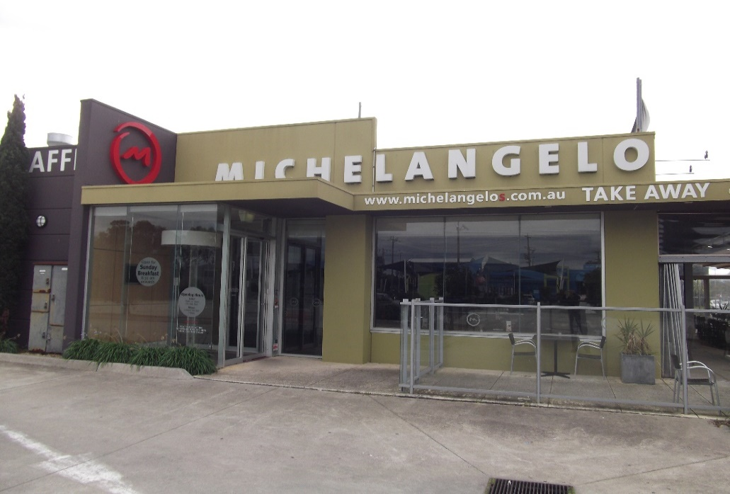

|  |
| --- |
| LastScan.bmp**CHELMC900016541[1]EA**  **CRUISE & TRAVEL**   * + - PERSONAL SERVICE     - CORPORATE & HOLIDAY TRAVEL     - CRUISING SPECIALISTS     - INTERNATIONAL & DOMESTIC TRAVEL     - TRAVEL VOUCHERS, BRIDAL / GIFT   REGISTRY   * + - WE SELL LUGGAGE & TRAVEL   PRODUCTS  **Phone 9773 1900**  396 Nepean Highway  Chelsea Vic 3196  C:\Users\LynRob\Pictures\Bendigo Bank Ad.jpgEmail: travel@chelsea-travel.com.au |

[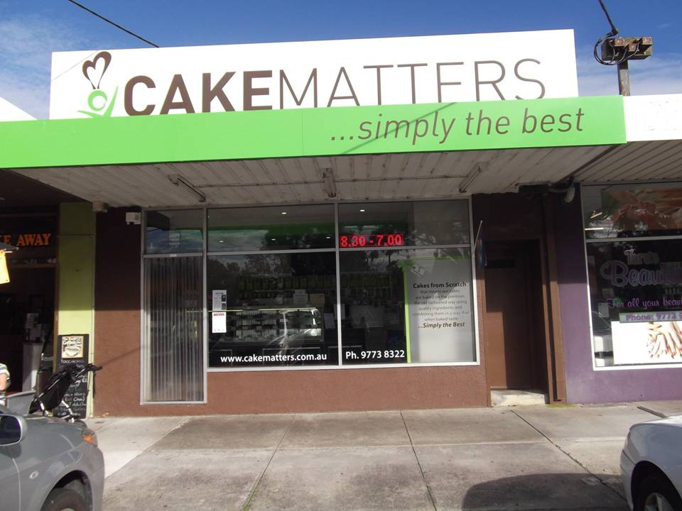](http://www.edithvale.bowls.com.au/sponsors/index.cfm?fuseaction=display_main&SponsorID=9965&OrgID=18279)***ASPENDALE GARDENS***

***CHARCOAL CHICKENS***

The succulent chickens come with a great range of delicious salads, which are freshly prepared each day.

***Aspendale Gardens Charcoal Chicken*** is a valued sponsor of Edithvale Bowling Club. Please make yourself known to the staff. They look forward to serving you.

Phone 9588 1616

Support your Sponsors please

And d on't be shy to tell them

You are from Edithvale