Westcoast Masters Autumn Report 2016
The year has started well, we already have a membership of 111. Training sessions are being well attended and we have many swimmers enjoying the open water season.
Our AGM was held after training on 30 January and was well attend. We welcomed in our new committee and handed out awards for our swimmers who had made significant progress or impact in the lanes.

Congratulations to State Award Winners:
• Open Water Age Group Winner: Frank van Rooyen
• Top 10 in MSA Series : Adrian Hirsch
• State Records: Viki Shelver, Vince Walsh and Mike Gittings

Lane Awards:
• Lane 1: Rhonda Sales
• Lane 2: Frank Prchal
• Lane 3: Charlie Gale
• Lane 4: Debbie Hart
• Lane 5: AeRee Mills
• Swimmer of the Year: Lex Robertson

Club Persons of the Year: Social Committee of Sue Finney, Jeff Ernst, Peter Kerman and Chris Wippl.
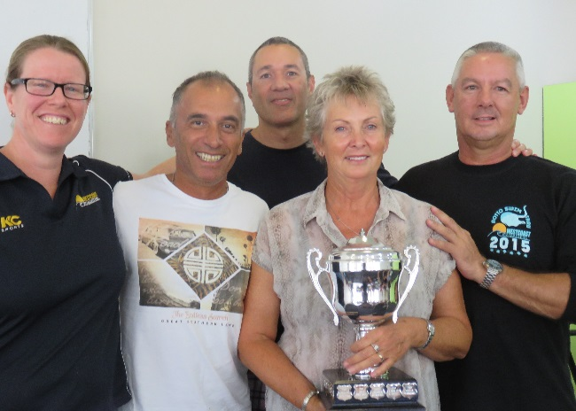

Rottnest Crossing was a successful event for all our solo swimmers. Great Effort by Lex and Cameron Robertson, Charlie Gale and Shaun Harrison. All swimmers involved with teams also had successful results and those who helped as support crew were happy to have a day out in superb conditions.
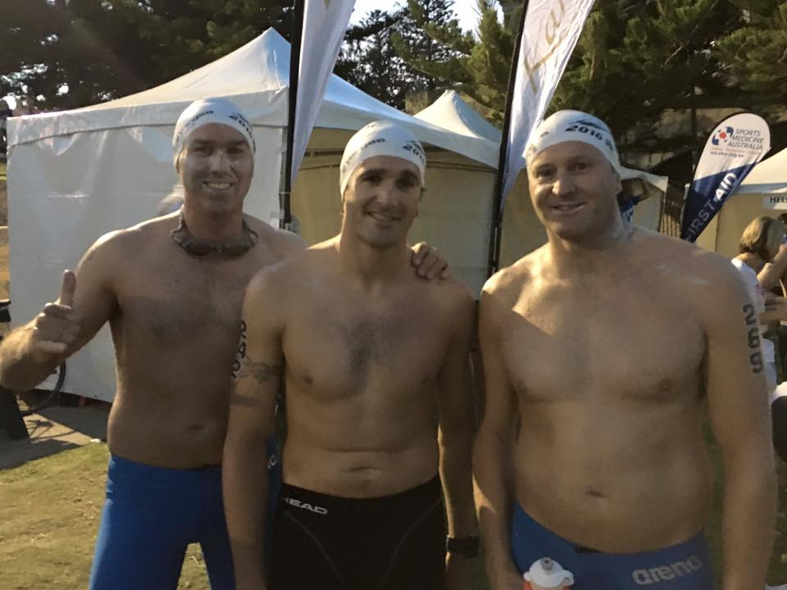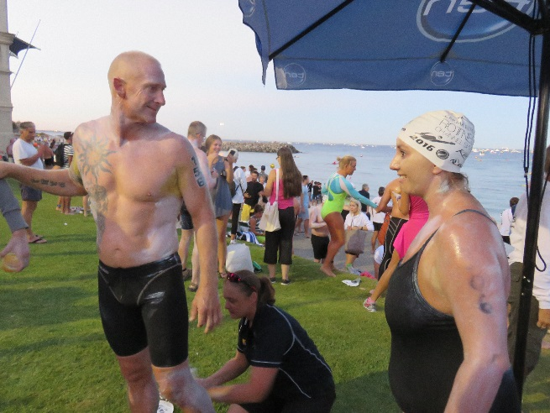

One of our long time members and a living legend, Les Stewart, celebrated his 80th birthday on 23rd February. He had a fabulous party organised by Anthea Warnes and Sue Oldham, this was attended by many friends and family. The celebrations continued during the week, with more tea and cake shared at the beach with his regular ocean swimming crew.
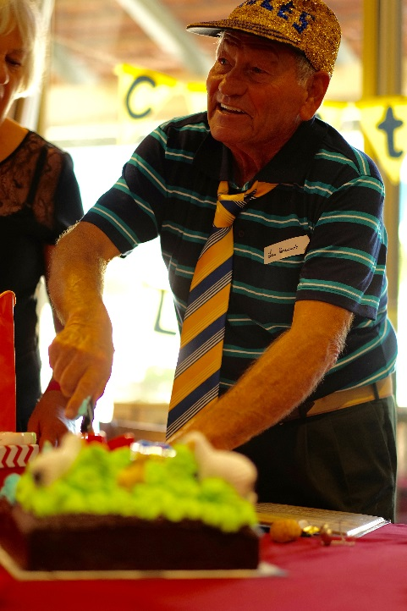
Swimmers are getting ready for the State Open Water Swim and gearing up for the LiveLighter Carnivals coming up! Lots of social activities in line as well, starting with a few drinks and dinners lined up already.

