|  |  |
| --- | --- |
| Club house stretch | Edithvale Bowls News |

**February 2016**

**EDITOR – Kevin Breen**

(If you have any Items of Interest please E-mail [*kevinbreen1097@gmail.com*](mailto:kevinbreen1097@gmail.com) or

Phone 9772 2824)

**What’s** (been) **on**

Trip to the Casino, no report of anyone coming home RICH I believe but everyone had no complaints. Thanks to the Organisers!!!

**New Members**

**Saturday Section** January 2016

No report

Ian would like more entries for our “*SPECIAL EVENTS*” look under the TV for entry forms

**Ian Wilding (President Saturday Section)**

**FROM the BOARD – February 2016**

Just a short one this month. The Board is starting to prepare for the coming AGM in April – it promises to be a very busy day – AGM, Presentations and a match against Richfield! Keep your Calendar free.

**Photocopier** – We received a Grant from KCC in last year’s allocations – provided for a photocopier. After much deliberation and delays we have finally made the purchase. It is a Fuji Xerox. The Fuji Xerox Company were kind enough to save us some $250 by providing free delivery and set-up – so a big thank-you from the Club. The copier should appear in the next week or so. We have tried to keep it simple and a quick run through is all you need to start.

After a month of **things breaking down** we are finally get on top of things. The water boiling unit has been fixed. The Coolroom is a goer and we have a new replacement vacuum cleaner at a very discount price courtesy of John Lyons. Thanks John – or should we call you Godfrey?

**Irrigation System** – the Club and the Council have been busy planning and preparing a renovated irrigation system – providing necessary water to our Greens. This is a big project and is intended to start in June or July. Eventually the main water pump will be moved to the other side of the grounds, extra sprinkler heads will be added and a reconditioned pump will provide adequate pressure to the system.

**Attempted break-in** – A week or so ago we had an attempted break-in. The prospective thieves jumped the fence just before 3:00am and tried and tested each of our windows. They managed to push in the Match Room window – which set –off our alarm – which is VERY LOUD. I got there about 3:10am and no-one in sight. The police came the next day and took fingerprints from the windows... so if you get a knock on the door?

**Bunnings BBQ** – Sunday March 6th – get your name on the Roster to help out. Mary Weston is once again kindly coordinating the day. It is a big $ raiser for the Club so try and put in for a 2-hour slot.

Ian Thomas

**"**Happy February Birthdays to:

1/2 Bob Hasler 2/2 Barbara Cheshire

4/2 Wayne Clarke, Margaret Clark, Gail Hamilton

8/2 Ray Lambert 10/2 Di Scown 12/2 Diane McFarlane

13/2 Lynne Flemming 15/2 Irene Trupke

22/2 Norm Overson ***Special Birthday Boy got his OBE welcome to the Club Ed.***

24/2 Shirley Simpson28/2 Denis Meadows

**Men’s Welfare** Report**.**

**.** Very good news from the Clarke family is Wayne has overcome some early setbacks and is coming home from hospital today. Waynes' immune system is still weak and therefore he cannot have visitors at this early stage and will not be able to take phone calls for at least a couple of weeks.

**.** Stan Holland is buoyed by positive results obtained from CT scans and blood tests and commences lighter prescription chemo next week. Stan has commenced a rehab program and is looking forward to stepping out on a bowling green about mid year.

**.** Chris Wardle has been receiving treatment for a respitory ailment and is still short of breath after any energetic movement. Good news is Chris is improving daily and hopes to be back bowling in a months time.

If I have left out anyone missing bowls due to ill health or if anyone has informations - please call me on 9774 2997.

**Doug Rafter –(MENS WELFARE)**

**Ladies Welfare** Report. February 2016

**Di Scown** had a fall a few weeks ago while shopping in Springvale, she cracked some ribs and is feeling very sore and sorry for herself, we wont see Di on the green for a few weeks.

**Lynne Fleming** had a a very bad fall, Lynne was  at the Casino on the clubs bus trip on the 15th February  she spent 24 hours in Dandenong Hospital. Lynne also as cracked ribs and as badly bruised her arm and knees. Talked to Lynne a few days ago she is still very sore but she hopes to be back bowling soon.

No more cracked ribs that l know about.

**Rae Gibbs. (Ladies Welfare)**

**SPONSORSHIP.**

***LAKEVIEW MEATS*** *at Patterson Lakes. Pop in and see* ***Craig***

***SHARPEDGE Window cleaners*** *Darren has done a lot of work around this area and has 30 years’ experience. Ring him for a quote Phone 0400391211. His prices are very reasonable, an average house $60 - $80”*

**MAKE SURE YOU MENTION THAT YOU”RE FROM EDITHVALE BOWLING CLUB**

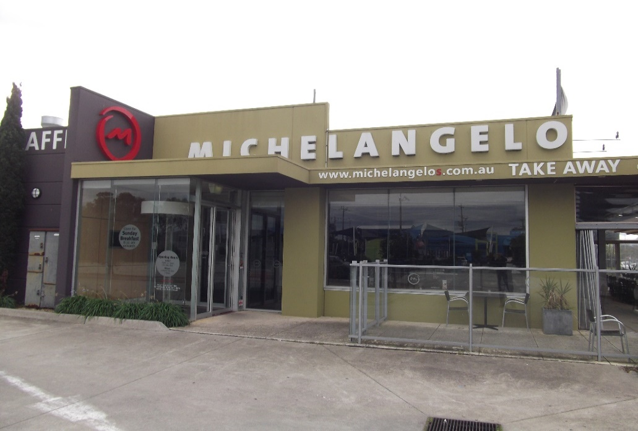

|  |
| --- |
| LastScan.bmp**CHELMC900016541[1]EA**  **CRUISE & TRAVEL**   * + - PERSONAL SERVICE     - CORPORATE & HOLIDAY TRAVEL     - CRUISING SPECIALISTS     - INTERNATIONAL & DOMESTIC TRAVEL     - TRAVEL VOUCHERS, BRIDAL / GIFT   REGISTRY   * + - WE SELL LUGGAGE & TRAVEL   PRODUCTS  **Phone 9773 1900**  396 Nepean Highway  Chelsea Vic 3196  C:\Users\LynRob\Pictures\Bendigo Bank Ad.jpgEmail: travel@chelsea-travel.com.au |

***ASPENDALE GARDENS***

***CHARCOAL CHICKENS***

The succulent chickens come with a great range of delicious salads, which are freshly prepared each day.

[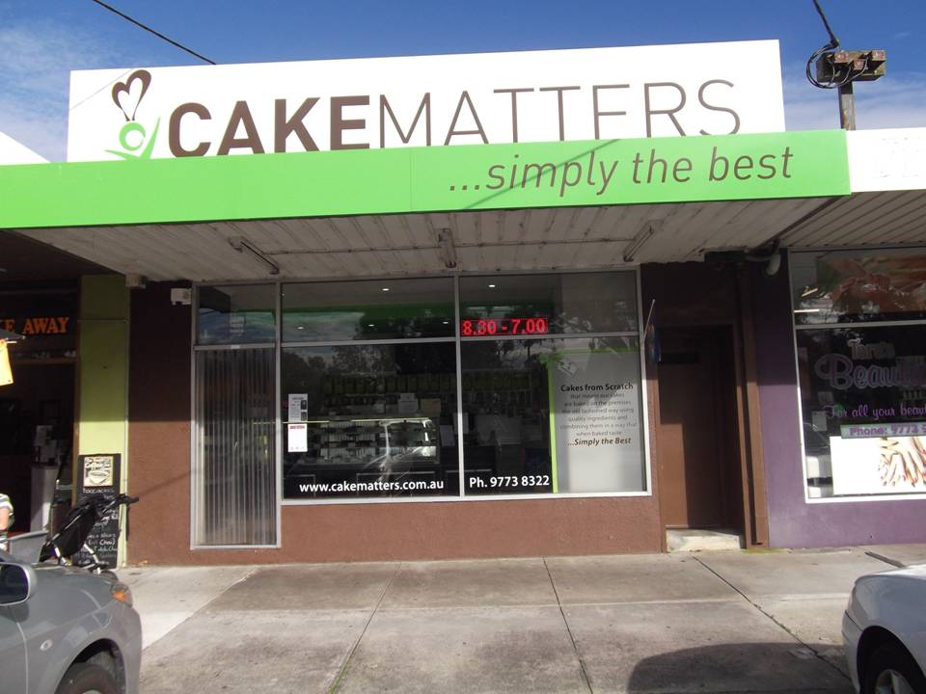](http://www.edithvale.bowls.com.au/sponsors/index.cfm?fuseaction=display_main&SponsorID=9965&OrgID=18279)***Aspendale Gardens Charcoal Chicken*** is a valued sponsor of Edithvale Bowling Club. Please make yourself known to the staff. They look forward to serving you.

Phone 9588 1616

Support your Sponsors please

And d on't be shy to tell them

You are from Edithvale