|  |  |
| --- | --- |
| Club house stretch | Edithvale Bowls News |

**August 2015**

**EDITOR – Kevin Breen**

(If you have any Items of Interest please E-mail [breenkp@optusnet.com.au](mailto:breenkp@optusnet.com.au) or

Phone 9772 2824)

ANOTHER SEASON & Another Reason to produce this NEWSLETTER, I wish all to have an enjoyable and successful time on the **GREENS** I must apologise for my tardiest in issuing but someone has been playing “Ducks & Drakes” with the @$@^(@!&^% **COMPUTER (sorry about the BAD LANGUAGE)** but I do get frustrated.

**What’s** (been) **on**

[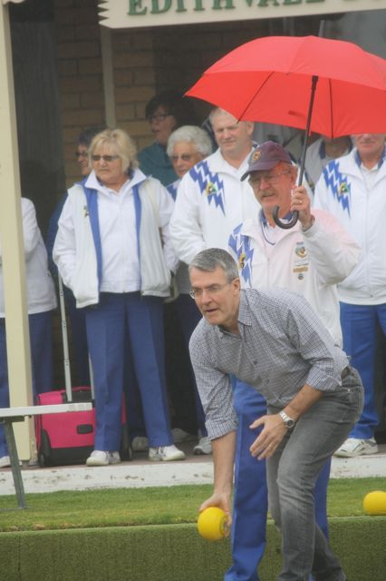](http://www.edithvale.bowls.com.au/news/index.cfm?fuseaction=display_main&NewsID=54729&OrgID=18279)**OPENING DAY**  Weren’t we lucky, the rain held off until, the official opening was completed. Thanks to our SPONSOR Mark Dreyfus QC MP. Federal Member for Isaacsfor completing his official duties

**New Members**

Welcome to all New Members, I hope to have a list for the NEXT ISSUE

**Saturday Section**

Over the winter the Saturday Section Committee has been running the Wednesdays' open club selection and Fridays' open nominated triples as well as doing the necessary preparatory work for the forthcoming summer season.

A number of Wednesdays were lost due to inclement weather and some had to be canceled because of poor attendances. However, Fridays' bowls fared much better - with no weather cancellations and good numbers of bowlers (including 8 to 12 visitors at times) throughout. I acknowledge with appreciation the work done, and continuing to be done by all members on Match Committee duties.

In the forthcoming Saturday Metropolitan Pennant competition Edithvale will have 5 sides, all open, selected on merit.

Division 1 - A 16 player side

Division 2 - A 16 player side

Division 4 - A 16 player side

Division 6 - A 16 player side and

Division 8 - A 6 player side. This Division is a new competition - 2 rinks playing 2-bowls triples, 25 ends.

Accordingly we shall be fielding 70 bowlers each Saturday. I encourage all to respect the decisions of the selection committee. Should you have suggestions or concerns about selection please go directly to the selectors.

In the words of that song "Don't worry...Be happy"

A happy club will produce happy results.

Good bowling and happy bowling.

**FROM the BOARD – September 2015**

**Welcome back everyone** from their Winter travels – hopefully the Sun will be following you back to Melbourne.

We have had a few important changes around the Club.

**Terry Cheshire** has tendered his resignation from the Board. Terry was part way through his first term and contributed significantly to the Board’s running of the Club – most notably as replacement Finance Officer whilst Claire was away recently touring Australia. Thanks Terry.

**Stan Holland** has been our Men’s Welfare Officer for a number of years now and has done a fantastic job keeping us connected, letting our members know that they are part of a Club that cares. Stan has just tendered his resignation, reluctantly. A big thanks Stan from the whole Club. It has been a “busy” year so far for you and we’ve appreciated your kind concern, and commitment to keeping us up to date with each other’s aches and pains, sorrows and woes, recovery and return.

More thanks – this time to the **City of Kingston** (which includes all of us) for awarding us a **$1,500 grant** to purchase a new photocopier. The Board is finalising quotes for a model and Service contract at this time.

**Neil Lewis**, has officially regained the reigns as our **Club Secretary** after a holiday break so all is go as far as the Board is concerned. **THANKS to Walter Trupke** for filling in by extending his term as Secretary until Neil returned. It kept everything running smoothly. Walter is now busy both as Men’s Vice President and Men’s Uniforms Coordinator – no rest for the wicked ☺.

**Suzanne Webber** has agreed to coordinate a **Membership Committee** and will be looking for a few willing volunteers – don’t wait for Suzanne to ask, put up your hand and see how you can help. Membership numbers are vital to our future.

Talking about the future – **the following is IMPORTANT** - The Board is progressing with the proposed formation of a **BOWLING COMMITTEE** (which would replace/merge the present Men’s and Ladies Sections). I talked about it at the last AGM and there was general agreement. The formation of a Bowling Committee is proposed to be introduced at the next AGM in 2016. There is an **Organsation Chart (see Page 7)** which sets out the proposed new structure. The chart gives a graphical summary of the change. The Board will display the chart and a more detailed written explanation on the Club Noticeboard. We need members to provide feedback over the next few months so that the Board can revisit any amendments and then finalise the administrative paperwork before taking it back to members for approval.

Ian Thomas,

Executive Director.

**Happy “September” Birthday’s to:**

3/9 Max King

8/9 Jason Costolloe

11/9 Kay Cramond

13/9 John Coassin

17/9 Lesley Mulder

20/9 Bob Baird/Stan Holland

21/9 Deb Sherry

26/9 Kay Sellars

27/9 Judy Munn

29/9 Ray Guthrie

Happy Anniversary to Alan and Marie Seddon

MEN’S WELFARE SEPTEMBER 2015:

The 2015/16 Bowling Season Practice Matches have commenced. Those lucky enough to escape the Melbourne winter are now home. The warmer Spring weather is being well received after a very cold winter and those bowlers that participated in winter bowls this year all deserve a medal for surviving the cold winds that swept across the Edithvale Greens.

Sick Report.

1) Bernie Turnbull is back bowling after his hip replacement.

2) Kevin Breen is recovering from his operation and it is hoped he will be back bowling soon.

3) Denis Meadows has a back injury that is going to put him out of action and we all wish him a speedy recovery so he can get back and enjoy a game of bowls.

4) Robert Rook has recovered and back bowling and would you believe the first club members he had contact with after many months was our Touring Groupies in the main street of Broom WA.

5) Jim Exton has responded well to his latest treatment and is looking forward to bowling this coming season.

6) Wayne Clarke. I have good news, Wayne is now on the Lung Transplant waiting list at the Alfred Hospital and he could receive that vital phone call at any time now once a suitable donor is found. This will be life changing for Wayne and we at Edithvale wish him well and speedy recovery once he has this procedure.

7) Klaus Ulmar has had an operation and is well on the road to recovery and should be back bowling soon.

Vale:

The winter season has been a sad time in the clubs history with passing of three members from the Men’s Section.

Bob Moloney, a foundation member of our club. Will be sadly missed by all.

Gordon Vallance, a former member in his 94 year.

Ken Bright, a former member and partner of Lisa Williams. VALE

Glenis Kent Passed away 7/9/15 Respected member of Edithvale Bowling Club (This was a late Addition Sorry Ed.)

**RIP**

To all our Pennant Teams good bowling in the upcoming 2015/16 season.

Stan Holland (Men’s Welfare)

Ladies Welfare Report.

Pat Sherriff is recovering after her accident in Queensland while on holidays. Pat is doing well with her rehabilitation and hopefully she will be back bowling very soon.

Ladies stay fit and well for pennant good luck to all teams.

Rae Gibbs.

**SPONSORSHIP.**

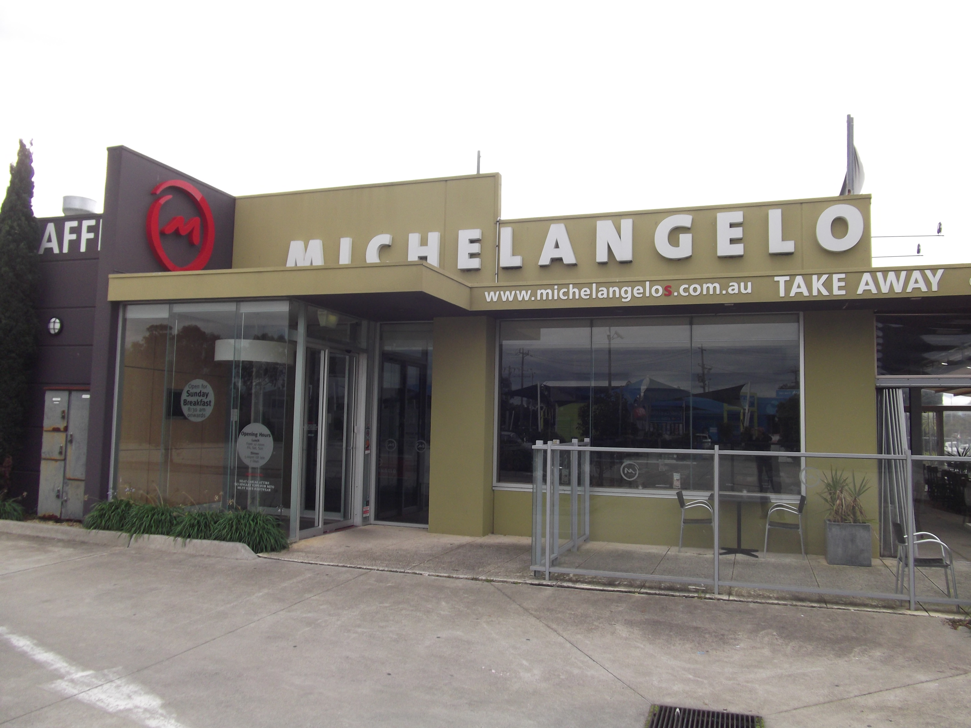





|  |
| --- |
| **CHELMC900016541[1]EA**  **CRUISE & TRAVEL**   * + - PERSONAL SERVICE     - CORPORATE & HOLIDAY TRAVEL     - CRUISING SPECIALISTS     - INTERNATIONAL & DOMESTIC TRAVEL     - TRAVEL VOUCHERS, BRIDAL / GIFT   REGISTRY   * + - WE SELL LUGGAGE & TRAVEL   PRODUCTS  **Phone 9773 1900**  396 Nepean Highway  Chelsea Vic 3196  Email: travel@chelsea-travel.com.au |

***ASPENDALE GARDENS***

***CHARCOAL CHICKENS***

The succulent chickens come with a great range of delicious salads, which are freshly prepared each day.

Gluten free mayonnaise is used. Phone 9588 1616

***Aspendale Gardens Charcoal Chicken*** is a valued sponsor of Edithvale Bowling Club. Please make yourself known to the staff. They look forward to serving you. Phone 9588 1616

[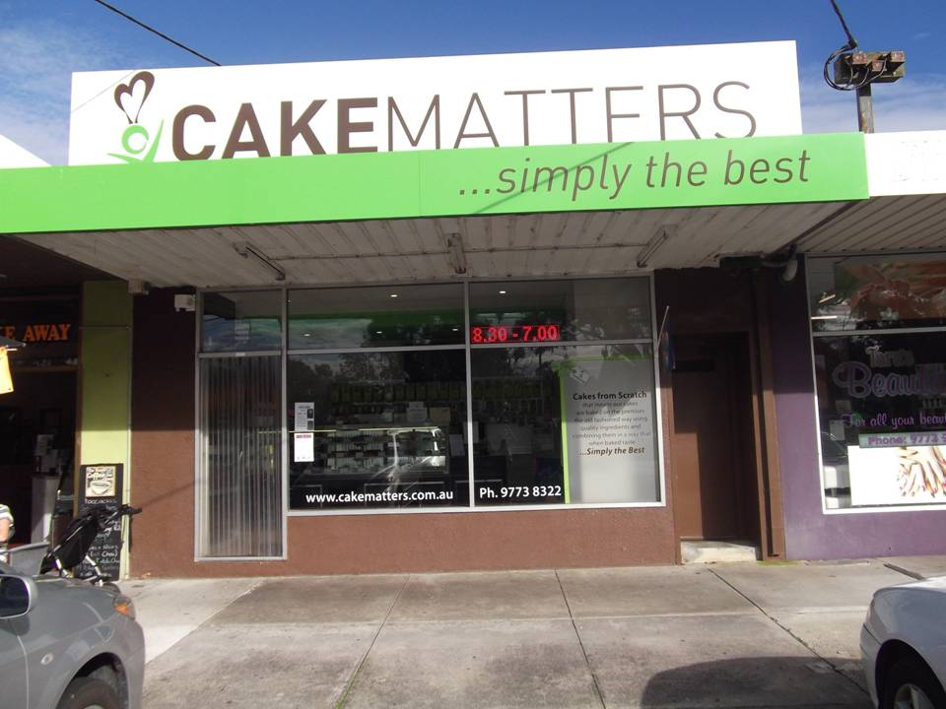](http://www.edithvale.bowls.com.au/sponsors/index.cfm?fuseaction=display_main&SponsorID=9965&OrgID=18279)

Support your Sponsors please

and

don't be shy to tell them

you are from Edithvale

