Two West Aussies go to Kazan

The FINA World Masters Championships were held in Kazan, Republic of Tatarstan, Russia from August 7th to the 16th, 2015.

Lynne Duncan and I, Ken Phillips, responded to applications to attend as International Technical Officials and were accepted. There were twelve internationals; two each from Nigeria, Senegal, Hungary, Australia, three from Ukraine and one from Costa Rica. And of course, a lot of Russians.

Kazan is a very pleasant city of about 1.2 million people 800km west of Moscow. It has a lot of modern sporting facilities and an athlete’s village. In 2009 it was chosen as the Sporting Capital of Russia. The swimming complex consists of two 50 m pools end to end and a diving pool under the one timber beam cantilevered roof. You would have seen this on TV if you had watched the World Championships the week before the Master’s.

The organisation was to be admired. We flew via Doha to Moscow where there were red shirted guides who took us through customs and to the check-in for the one hour flight to Kazan. More guides met us there to escort us to a bus and to our hotel accommodation. No athlete’s village for us, we stayed with the FINA committee in a very comfortable hotel. Interestingly, at Kazan airport the chief of the greeting party insisted we hand over our boarding passes, all the passes from Perth to Kazan. She was very upset when Lynne explained she’d tossed her earlier passes away.

Disappointingly the number of competitors was well down from previous World Masters Championships, about 2650 total of which 2060 were pool swimmers, the others being diving and water polo. Only one pool was required for competition for two sessions each day.

The Open Water Swim was our first event, 3000m across and back the Kazanka River near the confluence with the Volga River. The twelve Internationals were the only officials required and we were largely left to organise ourselves as to the officiating positions.

The pool competition was very different, however, thoroughly well organised. The Russians dominated the referee and starting positions. My first job was Chief IOT at the finish end of the pool. I was alarmed when the first heat of the 800m Free began that there weren’t any IOT’s! Quickly I tried to judge second turn of ten lanes then went to the Referee to ask where are the IOT’s. He pointed to the Timekeepers and said there they are. This surprised me since despite automatic timing they all had a back-up button, a stopwatch and were manually recording the split times. Enough for anyone to do. However, they later proved to be very competent particularly when it came to the form strokes.

We saw some very good swimming. A few Australians won medals in the OWS and pool events. Results were announced as ‘official’ within one or two minutes of each heat swum. If we saw an infringement we had to be very quick to notify the Referee. We didn’t hear if any records were set.

The next FINA World Masters will be held in Budapest, Hungary in 2017.

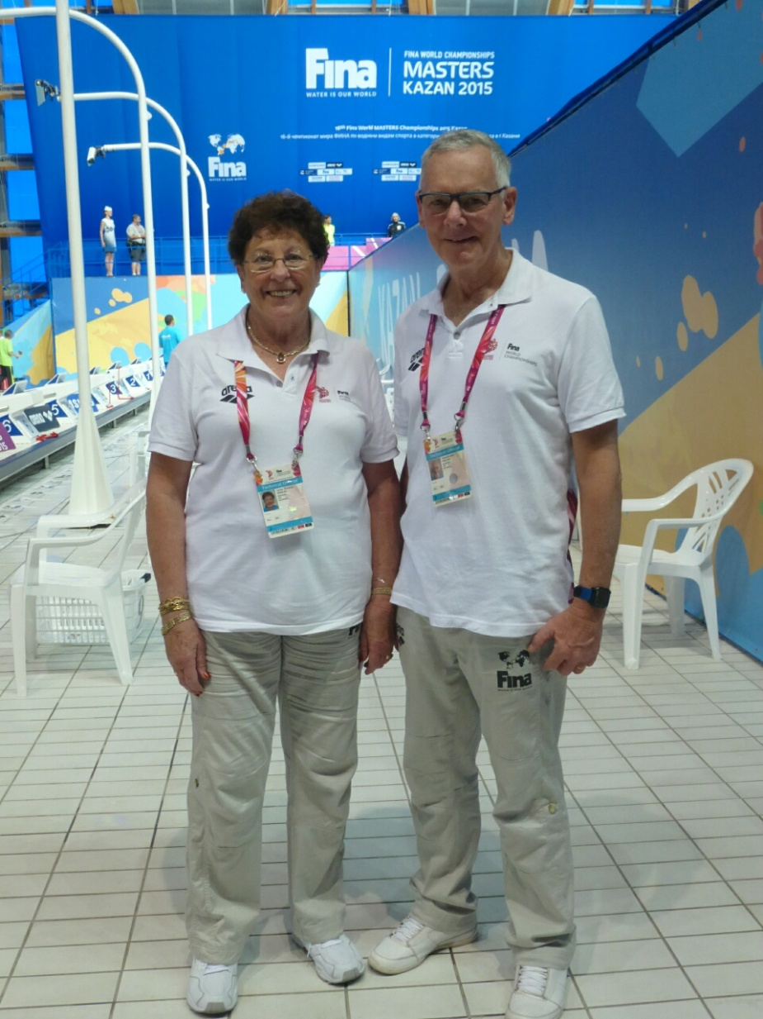

Lynne Duncan and Ken Phillips from MSWA ready to begin officiating

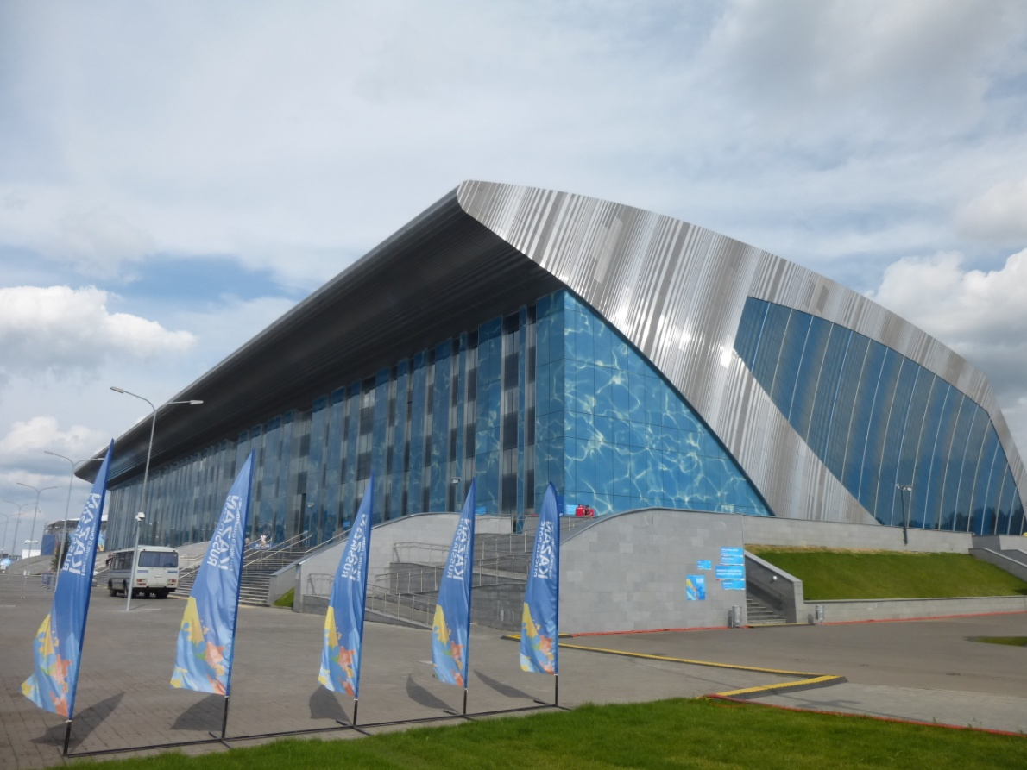

The Water Palace

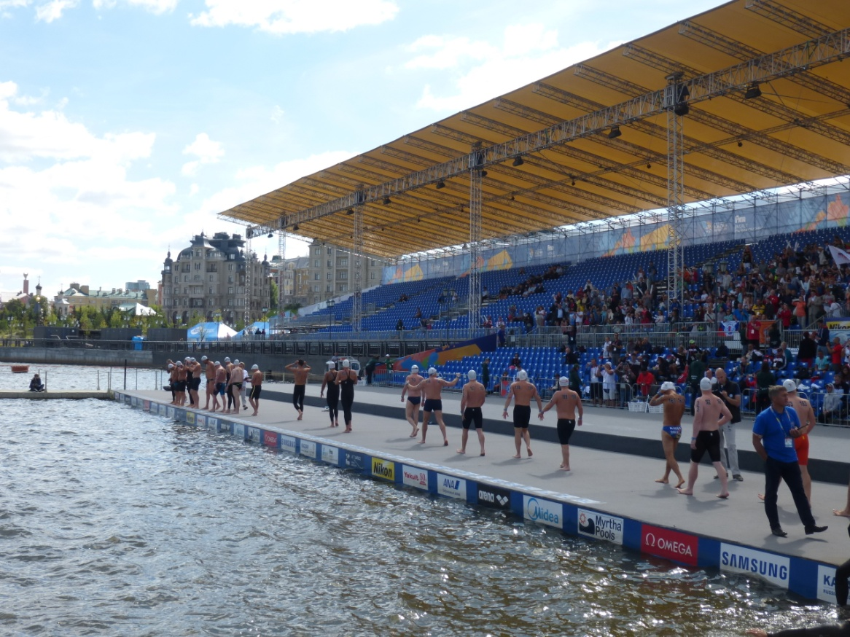

Clerk of Course leading a heat to the start of the OWS (in water start, not a dive)

