Westcoast Masters Winter Report 2015
We started the quarter with a fantastic turn out at the State Open Water Swim at Coogee. These numbers helped the club win the Team Participation Award, we also had age group winners in Kieran Lawrenson, Frank van Rooyen, Mike Kerman, Viki Shelver and Carrol Wannell. Unfortunately, we didn’t get the same number of entries for the All Club Challenge.
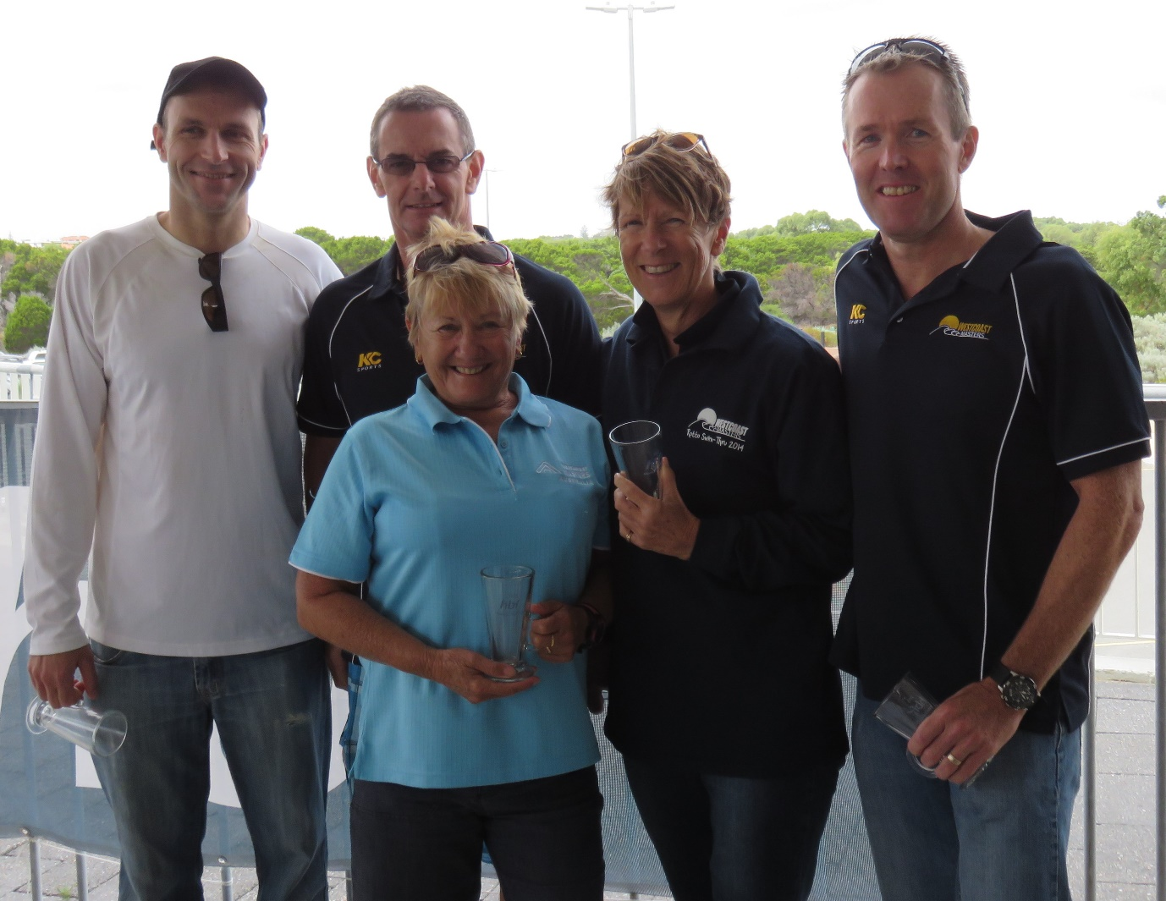
Westcoast hosted their LLCC in March, this was held in the late afternoon at Craigie Leisure Centre outdoor pool. The new format was well received, even with the rather rushed ending. A big thank you to all those who joined us as competitors and especially to those who assisted with the officiating.
Socially, our calendar remains pretty well filled. We have had drinks and dinners out, bowling and dining, kayaking and picnics. Our social committee has many more exciting events lined up. The club has also adopted the first Saturday of each month to be social morning tea time, with members bringing a plate to share and taking time to celebrate anything that might have happened over the past month.
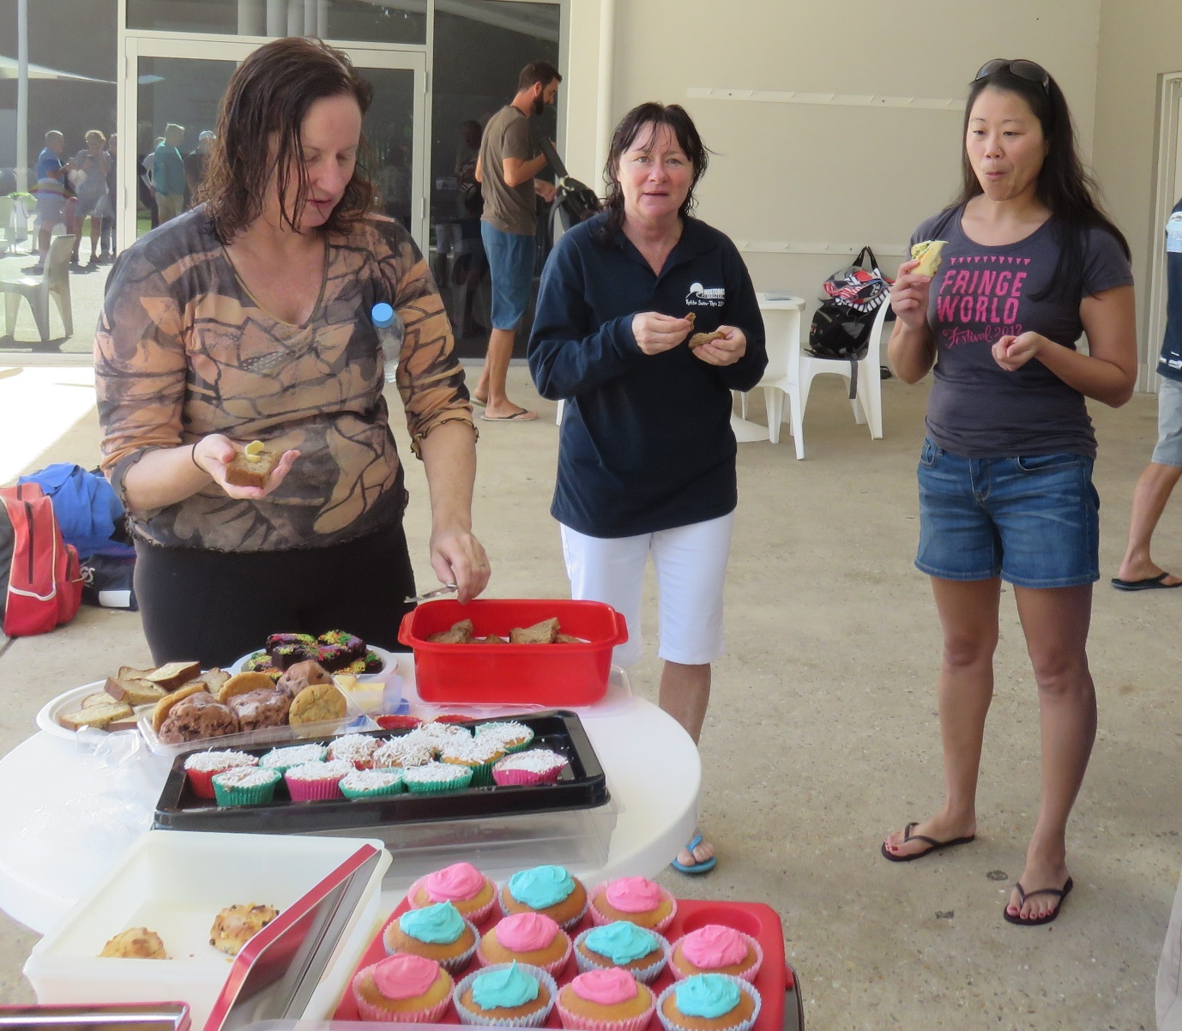
Our swimmers have had the opportunity to attend a stretching workshop, run by Caryn Kiellor. Caryn is a physio, life member and coach, with a huge depth of knowledge and experience. It was a well-attended workshop with lots of people reminded of how important it is to work on flexibility and muscle activation, in order to assist with their workouts. There is an Injury Prevention Workshop scheduled for June.
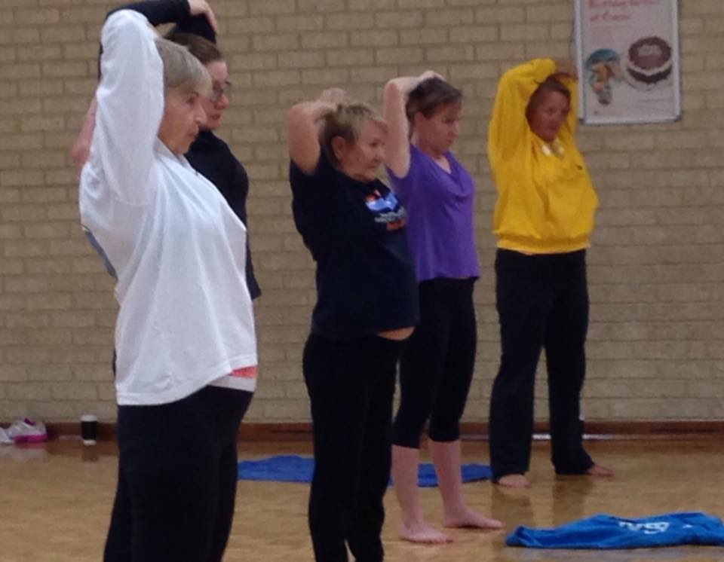
With 124 registered members, we look forward to another busy six months ahead. Although training numbers have dropped slightly, we are still filling four sessions with some keen and active members.

