For E News from Stadium Masters:
We have been delighted to welcome lots of new members this year, most of them in younger age brackets – great for our club which had a big cohort of older members.
For the first time ever, Stadium Masters decided to hold a cake stall recently. And wouldn’t you know it: after a run of 11 days of balmy warm, dry weather, the day of our cake stall dawned cold, wet and windy. It rained for the whole five hours so most of the passersby sailed past our table huddled behind umbrellas. Luckily, enough took note of our plight and we finished up selling everything and taking away $720, which pleased us immensely, even more so as we had to compete with the prestigious Bindaring Clothing sale on the other side of the tracks. Bunnings had thoughtfully lent us an outdoor gas heater, complete with store advertising. If you stood right next to it you could feel the warmth! However running a cake stall would have been far worse the next day as the rain was heavier and the wind stronger. How lucky we were!

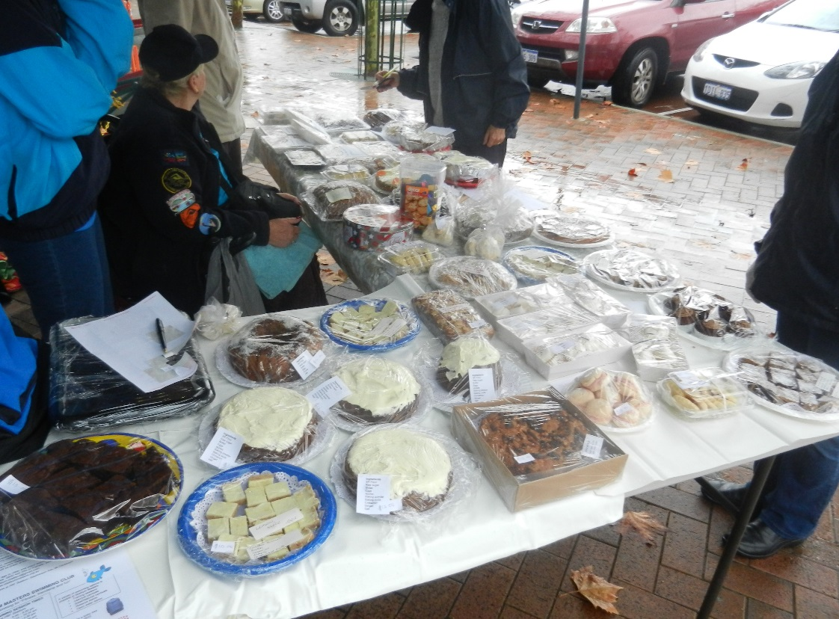

On Sunday 31st May, we’re holding a Swimathon, with all the money we raise going to Alzheimer’s Australia WA. HBF Stadium has helped us out by generously donating two lanes for the event. Our swimmers will use this opportunity to complete some of the longer swims in the Endurance 1000 program, making it a win-win affair.
After knitting poppies for the impressive ANZAC Day display in Melbourne, about eight of us couldn’t put our needles away! Now we’re knitting squares and joining them to make brightly coloured rugs for Wheelchairs for Kids to send overseas with the wheelchairs.
We hope to see you at our 1500 Metre Distance Swim in the HBF Stadium outdoor 8 lane pool. Fortunately this pool has now been restored to its full 50 metres after being reduced to an annoying 40 metres while construction work was underway.
Also, we hope members are flocking to Clubs after the appearance of our gorgeous cover girl, Anne Edmondson, on the Health and Medicine supplement in The West a couple of weeks ago!

