Stadium Masters
Announcing Stadium Masters!
In September we formally changed our club name from Stadium Snappers Masters Swimming Club to Stadium Masters Swimming Club. The idea came from our youngest member, who thought that Stadium Masters portrayed a more “professional” organisation. Since foundation in 1992 our club name has included the name of our training venue, originally the Superdrome, hence our club code was, and still is, WSU. When the venue became known as the Stadium, we changed our name accordingly. Now, in removing our nickname from our official name, we are consistent with other MSWA clubs, except for Bay View Saints and Superfins Masters.
As Christmas draws near, some of us are trying hard to finish our Endurance 1000 swims. Two swimmers were more than halfway through long swims this week when a chlorine gas leak was detected and the entire HBF Stadium was evacuated. The muster point under tall trees was a dubious choice since lightning was flashing and thunder booming at the time!
This year ends for us with our Christmas Picnic and Awards presentation in mid-December and the next year begins with a fresh Committee being elected at our AGM in January.
Inspired by the display of poppies at the Albany Anzac 100 Years commemoration in November, about ten of our members are busily knitting and crocheting poppies to be part of a much bigger display in Federation Square, Melbourne, on Anzac Day next year. Poppies were flowering in the spring of 1915 on the battlefields of Belgium, France and Gallipoli and now the poppy has become a symbol of both great loss in war and hope for those left behind. Anyone interested in contributing to this project can find details and patterns on the internet at 5000 Poppies.
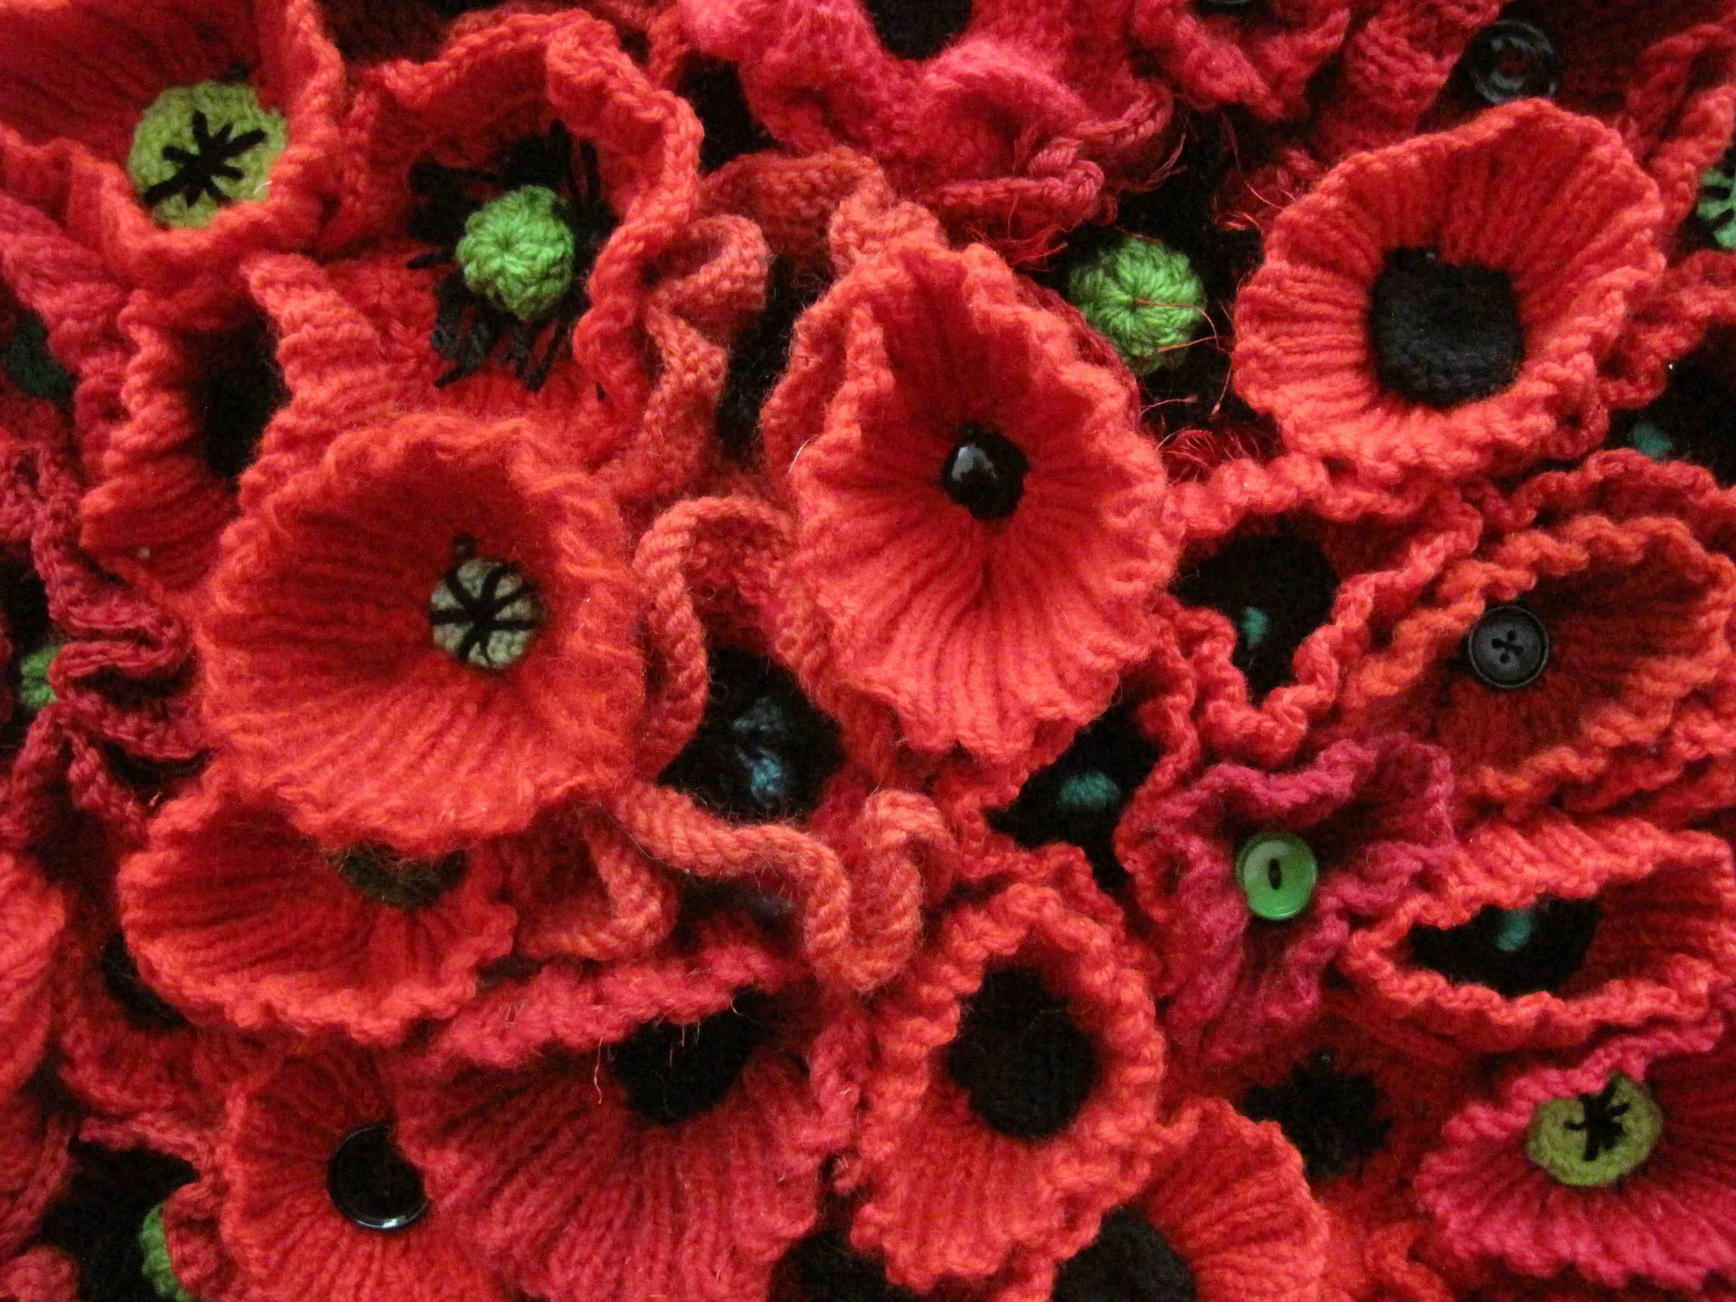

Poppies similar to the ones that Stadium Masters are knitting for a display in Melbourne on Anzac Day 2015

Our thanks to Wendy and Nadine for keeping the wheels turning at MSWA after the devastating fire and doing their best to make sure our swimming activities continue.

