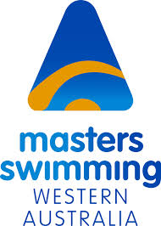

LiveLighter 2014 State Championships
Challenge Stadium, Mt Claremont
24th/25th May 2014
Saturday 24th May - Day 1
9.00am pool open: 10.00am – 4.00pm competition
Event 1 200m Backstroke
Event 2 100m Butterfly
Event 3 200m Freestyle
Event 4 100m Breaststroke
Event 5 200m Individual Medley
Event 6 50m Freestyle
Event 7 50m Backstroke
Event 8 4 x 50m Freestyle Relay – Women
Event 9 4 x 50m Freestyle Relay – Men
Event 10 4 x 50m Medley Relay – Mixed

Sunday 25th May - Day 2
8.00am pool open: 9.00am – 2.00pm competition
Event 11 200m Butterfly
Event 12 100m Freestyle
Event 13 200m Breaststroke
Event 14 100m Backstroke
Event 15 50m Butterfly
Event 16 50m Breaststroke
Event 17 4 x 50m Freestyle Relay – Mixed
Event 18 4 x 50m Medley Relay – Women
Event 19 4 x 50m Medley Relay – Men

Presentations to follow in Lecture Theatre – cash bar available






