


2014 HBF Masters
STATE OPEN WATER SWIM ENTRY FORM

SATURDAY 22nd March 2014 at Coogee Beach (at NEW Coogee Beach Surf Life Saving Club, Poore Grove) 8.45 am Race Start

- ENTRY via CLUB CAPTAINS (for Team Manager bulk entry)
- For Masters Swimming WA members ONLY & NO LATE ENTRIES

EVENT DETAILS:

1000m | Non-Championship event
2000m | This is the 2014 HBF State Masters Open Water Swimming Championship event
Conducted by | Somerset Masters Club on behalf of Masters Swimming WA
Insurance | The event is sanctioned by Masters Swimming WA and Masters Swimming members are covered by personal accident insurance
Course Details | Will be available at Swimmers Briefing (visual & verbal) at 8.30 am and are dependent on weather and conditions on the day
Event Safety | Will be provided by Coogee Beach Surf Life Saving Club. The Masters Swimming WA Referee will have the ultimate and final authority regarding the conduct of the event and can remove any swimmer from the water judged incapable of safely finishing the swim
Cut off time | 10.15 am (1.5 hours after start). Participants not finished at that time will be asked to leave the water by the Referee
Entries Close | With payment to Club Captains by Monday 10th March 2014 - NO LATE ENTRIES ACCEPTED
Team Manager Entries Close | Clubs to email the TM file By 5.00 pm Friday 14th March 2014 to MSWA Director of Recording Sandra Mutch sandra.mutch@worleyparsons.com - NO LATE ENTRIES ACCEPTED
Entry Fees  (subsidised by HBF sponsorship) | 2000m championship event $25.00  1000m non-championship event $20.00  Breakfast provided by Coogee Beach Surf Life Saving Club (3 options): $12.00 each  (B) bacon & egg roll; OR (S) sausage in bun; OR (M) mushroom/tomato in bun with Tea/Coffee/Juice)
Payment to MSWA | Clubs to send copy of completed Summary Sheet by 5.00 pm Friday 14th March 2014 either  (1) by post with cheque (to MSWA PO Box 57 Claremont 6910) OR  (2) via email after payment by bank transfer (to CBA Claremont BSB 066 103 A/c # 1000 4275)

-----------------------------------------------------------------------------------------------------------------

2014 HBF Masters State OWS ENTRY FORM (members to complete & hand to Club Captain with payment)

NAME: Male/Female: (please circle)
Given Name Family Name

AGE (as at 31.12.2014): Date of Birth: PHONE NO:

EMAIL: MSWA CLUB & Rego #:

Event (please circle one): 1000m OR 2000m If entering 2000m please provide estimated time: minutes

ENTRY FEE (circle): $20.00 or $25.00 BREAKFAST (number): (B)…… (S)…… (M/T)…… @ $12.00ea Total Breakfasts: $……

TOTAL PAYMENT ENCLOSED $……… (Make Cheques/money orders payable to YOUR CLUB for bulk payment to MSWA)

Event Waiver for Masters Swimming WA (the “Organiser”) and Coogee Beach Surf Life Saving Club (the “Club”) & their directors, officers, members, servants, agents, & volunteers.
Warning: Participation in this event can be inherently dangerous. Serious accidents can & do occur which may result in me being injured or killed. I have voluntarily read & understood this warning & accept & assume the inherent risks in participating in the Event.
Exclusion of Liability: Except where provided by law & such cannot be excluded, I agree that it is a condition of entry to the Event that the Event Organizer & the Club are absolved from all liability arising from injury or damage whether fatal or otherwise however caused including from negligence of the Event Organizer or the Club arising out of participation in the Event.
Release & Indemnity. On acceptance of entry into the Event I:
- release & forever discharge the Event Organizer and the Club from all claims that I may have or have had but for this release arising from or in conjunction with my participation in this event;
- indemnify & hold harmless the Event Organizer & the Club to the extent permitted by law in respect of any claim by any person including but not only another participant in the event arising as a result of or in connection with my participation in this event.
I have read, understood, acknowledge & agree to the above declaration including the warning, exclusion of liability, release & indemnity.

SIGNATURE: DATE:

2014 HBF Masters
STATE OPEN WATER SWIM

Rules & Conditions
Eligibility | Swimmers must be registered members of Masters Swimming WA
Governing Rules | Masters Swimming Australia Open Water Swim rules of June 2012 will apply, ie.  OWS4.12 When out of water electronic timing is used, swimmers should be put in order of finish at a defined ‘in-water’ finish line, to walk to the timer in order of swim finish – KEEP IN LINE. Obstructing, interfering with or making intentional contact with another swimmer shall, if deemed by the Referee "unsporting interference", lead to disqualification
Registration 7:30 to 8:15am | Will be open from 7:30 to 8:15am for both events & will be located at Coogee Beach Surf Club – NO LATE ENTRIES
Race caps | Issued race caps must be worn by all swimmers throughout the event(s)
Swimwear | 2000m event: According to FINA Masters rules. Wetsuits may be worn but wearers will only be eligible for spot prizes, will not have times recorded and cannot contribute to either of the Club Team Trophies. Rash Vests maybe worn but swimmers must have Referee approval before the event. 1000m event: all eligible for Spot Prizes and times recorded regardless of swimwear worn
Watches & Sharp Jewellery | Swimmers cannot wear watches or heavy or sharp jewellery as they may pose a risk to other swimmers
Race Briefing 8.30 am | All swimmers must attend the race briefing to be held on the beach at 8:30 am SHARP on the day – swimmers will not be able to participate if not at race briefing
Breakfast | Breakfast (by pre-order only) to be served immediately following event finish – please support Coogee Beach SLSC as they are a great support to MSWA
Presentations | Will follow the breakfast at the Coogee Beach Surf Club
Blue Chip Timing Bands | Please be advised that loss/damage of a timing chip (chip + Velcro strap) will cost participants $25.00 and loss/damage of just the velcro timing strap will incur a replacement fee of $10 (this includes where participants decide to cut the strap short)
HBF Masters OWS Series | This event is part of the HBF 2013/14 Masters Swimming WA Open Water Swim Series and members participating in the 2000m championship event will earn double points

Prizes
Individual Prizes
2000m Overall Prizes | Fastest Male & Female overall
2000m Age Group Prizes | 18-24; 25-29; 30-34; 35-39; 40-44; 45-49; 50-54; 55-59; 60-64; 65-69; 70-74; 75-79; 80-84; 85-89; etc
1000m participants and Swimmers wearing wet suits: | Will only be eligible for spot prizes
Top Club Trophy 2000m | Confirmed criteria from August 2013 Council of Clubs meeting: The top Club team award is presented to the Club with the smallest place numbers with a minimum of 2 males and 2 females in the team of six
Club Performance Trophy | According to Club member numbers and participant numbers
Additional Spot Prizes | For 2000m participants GNOT (gaining no other trophy)


Masters Swimming WA sincerely thanks the Somerset Masters Club
for once again conducting the event on our behalf

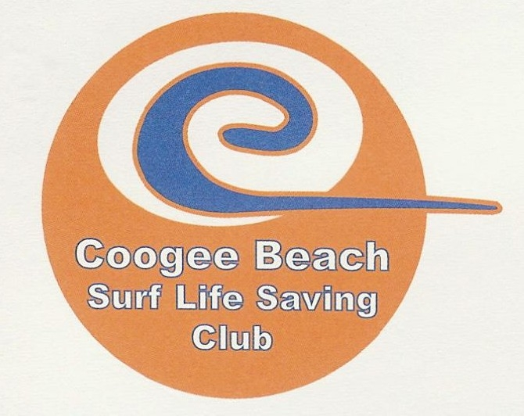
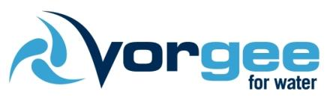
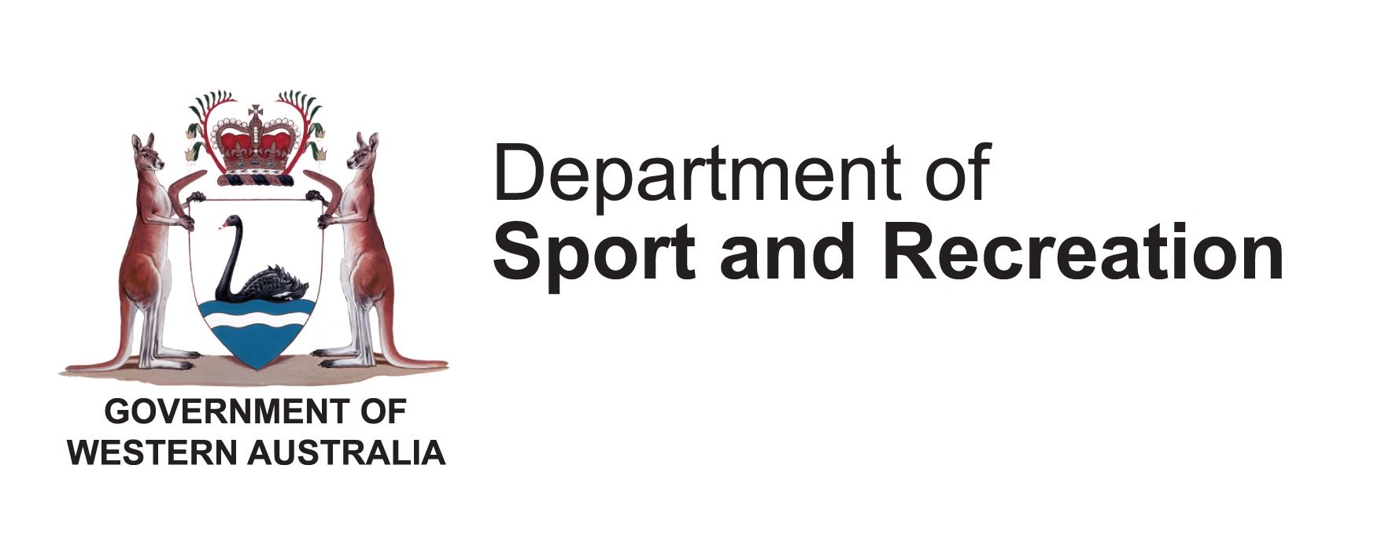


Masters Swimming WA: www.mswa.asn.au or like us on Facebook!

