Club News Summer 2013
Wanneroo Masters
An update from the coach:
The club has the use of 4 lanes and we have a regular core of 8 who meet every Tuesday and numbers for Fridays is about 4. However, last Tuesday I had 12! The group has a mixed bag of skills, ranging from beginner to 2.6km per hour swim (no fins x 25m...getting there!). I have 4 people who are doing triathlon and need swimming skills. Several FIFO workers have inquired and said they will register in December as the registration is low and then a gold coin donation for the lane costs brings them in so they feel like they can come and go as their shifts suit. Let's hope that they do.
Last year the member who received my 'gold star' for effort and improvement is now out of Lane 1 and swimming it up in Lane 2. This year I have a 63yr old who gets the 'gold star' for most improvement - she is amazing and she fronts up twice a week.
So far the members have been involved in one event, swimming with the Bunbury group.
I am hoping to get the group more involved in events in 2014, using the triathlon people to encourage them. I am planning to take them to Arena early next year for one session so they can experience swimming in a 50m pool. Rent for the lanes is reasonable for a one off session and as Arena is in our area, we all can get there easily.
Socially, we have had something every three months, coffee and cake, 10 pin bowling and this Friday, Christmas dinner. They are a very nice group of people and seem to get on well with each other.

Westcoast Masters
The end of our 30 year celebrations draws to a close and we have had some fabulous parties, gatherings and moments of reflection. Our last function was a most enjoyable family picnic at Houghtons Winery. All those who attended definitely had fun and games – giant Jenga, giant snakes and ladders, croquet, quoits and great company.
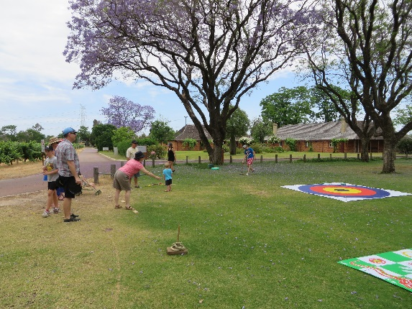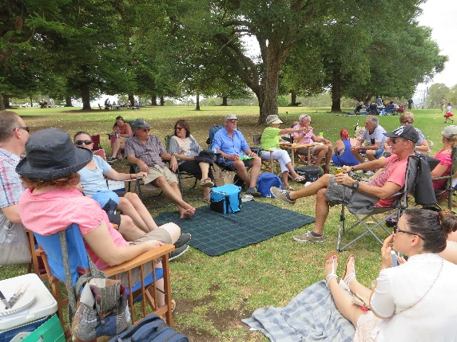
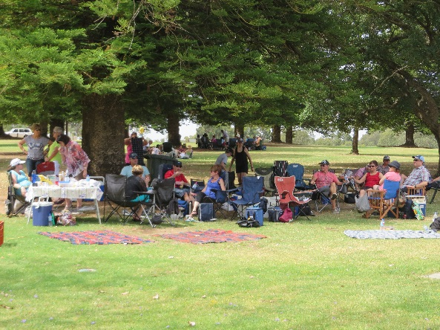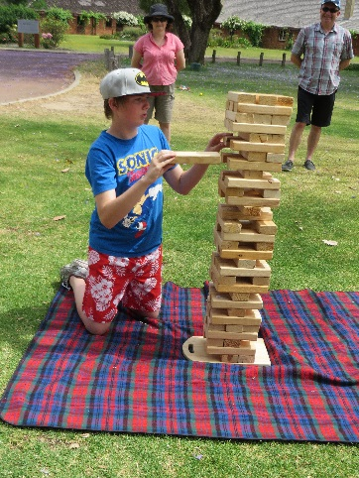
We end the year with a membership of 131. This number is made up of a very active group of regular swimmers joined by a bunch of irregulars. All enjoy the training sessions provided by our excellent team of volunteer coaches, this year lead by Alan Power.
As the weather warms up, the number of ocean swimmers is picking up again. The Sunday morning group is now up to around 30 swimmers. The week day regulars are still at it. We have quite a few members preparing for solo and team involvement in the 2014 Rottnest Channel crossing.
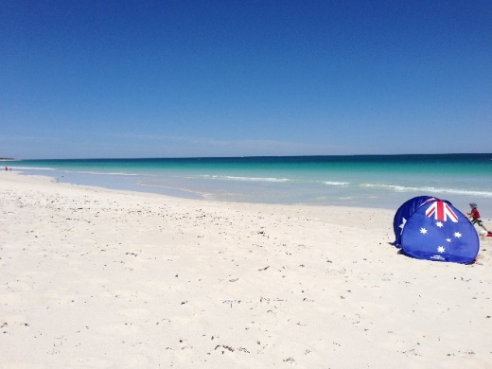
We are looking forward to our annual weekend away at Rottnest, a Christmas breakfast and a very happy and safe festive season.2014.

Superfins
Our annual awards night was held at Royal Perth Golf Club on Saturday 23rd November. Greg Black was named the Superfins Masters Swimmer of the Year. His credentials for the year included 18 Open Water swims, being 1 of only 12 swimmers to complete the Swimming WA Open Water series of 8 swims and also being named Masters Swimming WA’s Open Water Swimmer of the Year for males aged 18 to 24.
Greg’s swims included the Rottnest Channel swim in a team of 4 and a solo swim around the Busselton Jetty.
Greg is currently representing Australia at the inaugural Special Olympics Asia Pacific Games in Newcastle (Dec 1 to 7) in his other favourite sport of 10 pin bowling.
He is a great ambassador for Superfins and swimming and for full participation at a high level in every sport he attempts.

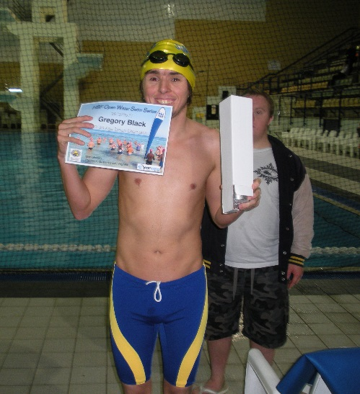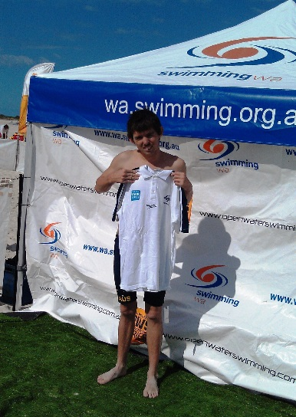

Bay View Saints
The Bay View Saints tried some land training recently at Mosman Park Bowling Club. Swapping a training night for some pre Christmas fun, the group discovered that the best swimmers do not necessarily make the best bowlers! It was great to see the coaches doing some hard work too and not just strolling up and own the pool deck.
