Osborne Park Masters

We wish to thank the organising committee of the 2012 State Championships held in Bunbury in early March 2012. Many of our members commented on the friendly atmosphere created by all the Bunbury Masters members, the MSWA officials and the many volunteers. Well done all!

A huge thank you to our Captains John Musty and Kerensa Allason for organising our great relays and helping our Club to achieve the Top Aggregate Points trophy. Congratulations to Helen Bird the female swimmer of the meet with two State Records and our other age group champions John Fussell and John Lockley. We also wish to thank ALL our coaches who ensured that all our swimmers were in top shape any many came away from the .

Osborne Park Masters were very proud to acknowledge members who achieved 30, 20 and 10 years of ‘fitness, friendship and fun” at our club, at our AGM in February 2012.

30+ years award winners were:
Nancy Cotterell, Roy Collinson, Ken Row, Glad and Norm Clark, Pat Nicholl and Bryce Jones.

20 + years awards:
Richard Lugg, Marg and John Hancock, Jeff and Helen Morris, Nina Epps, Marg Gleghorn, Sue Pow, Alan and Penny Green, Val Elshaw, Jan Hull, Gordon Morris, John Fussell, Didy Whitford, Beryl Paterson, John and Pat Lockley and Evan Jones

10+ years awards
Delise Griffiths, Marion Woolston, Helen Bird, Geoff Scott, Joshua Hofer, Wendy Duperouzel, James Kent, Jon Hronsky, Geraldine Phillips, Liz Grant, Dean Parker, Melissa Peden, Heather Whitehead and Mary Heath

Many of our swimmers have enjoyed Open Water Swims and we had two successful teams in the Rottnest Channel Swim. We also enjoyed the Be Active Club Challenge hosted by Newman Churchlands in February. And congratulations to our State Record breakers in the 320+ 4 x 50m Freestyle relay of Bryce Jones, Judy Limbourn, Gladys Clark and Beryl Paterson.

3 of our swimmers are heading to Adelaide for the Nationals in April.

Social we have enjoyed a picnic at Burswood and the John Ames Trophy swim and Family Fun day at Tuart College with Toni Morris taking home the trophy.

Jeff Morris

30 year award winners left to right are:
Roy Collinson, Ken Row, Norm Clark, Glad Clark,
Nancy Cotterell, Pat Nicholl & Bryce Jones
20 year award winners left to right:
Helen Morris, John Lockley, Pat Lockley, Marg Gleghorn, Nina Epps, Beryl Paterson, Susette Pow, Evan Jones, Margaret Hancock, Alan Green, John Hancock & Penny Green.
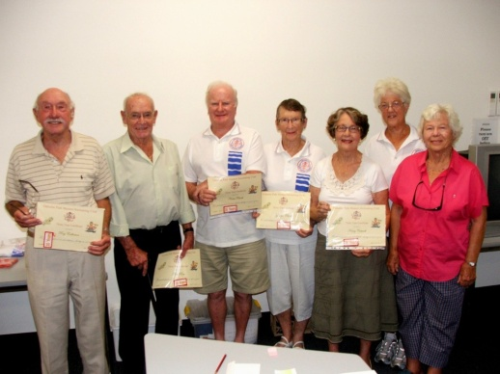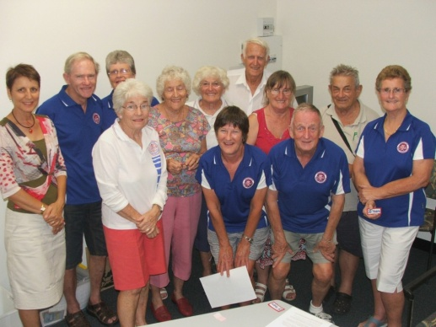

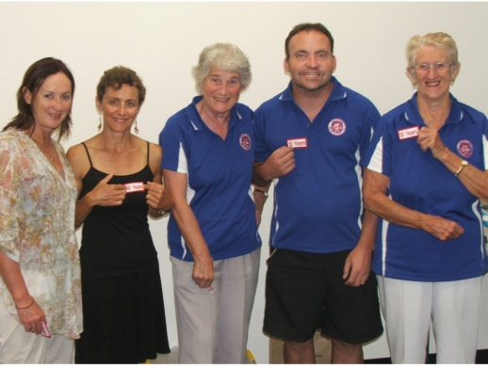
10 year award winners:
Heather Whitehead, Liz Grant, Marion Woolston, Joshua Hofer & Mary Heath.

