Club News for Winter 2012 E News
Osborne Park Masters
We wish to thank West Coast Masters for hosting such a great Be Active Club Challenge on 22 April 2012. It was a well run and friendly meet and our Club were pleased to come in 2nd to the hosts. A huge thankyou to our Captains Alex Gower and Geraldine Phillips for organising the relays and our coaches who ensured that all our swimmers were in top shape.
Osborne Park Masters’ sole representative at the 2012 National Swim in Adelaide was John Fussell, who achieved the fantastic result of 3 first places and 2 second places. We send John off the FINA Masters World swimming Championships in Riccione in June with all our best wishes.
Joanne Kocik was our sole representative in the Busselton Half Ironman on 5 May 2012 and achieved the great result of 6th in the very competitive 30 to 34 age group.
On a sad note, our Treasurer of 4 years Andrew Neal, unfortunately lost his fight with stomach cancer on 3 April 2012 at the age of 46. Andrew was a well respected and valued member of our club and our thoughts are with his wife Julie Matheson and families.
A couple of Andrew’s quotes:
“Making great and lasting relationships is ultimately the only thing that matters and worth working at.”
“If you’re not having fun then you are not trying hard enough”.
On a happier note, we have enjoyed a restaurant night to celebrate Liz Grant’s milestone Birthday and following a successful Bunnings sausage sizzle fundraiser, we celebrated with a night at the Herdsman Hotel on 19th May.
With two new enthusiastic coaches Alecka & Lisl, we have encouraged a good group of swimmers to come along on Saturday afternoons for an extra session at Terry Tyzak Recreation Centre in Inglewood. To keep up the good work, this is often followed by a cuppa or icecream!
Our club continues to train at Bayswater whilst we are waiting for the Beatty Park renovations to be completed and we are looking forward to 2012 Groper State Relay Championships in August.
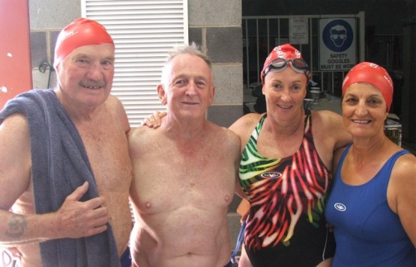
Dave Cuzens, Alan Green, Heather Whitehead and Marina de Leo at 2012 State Swim
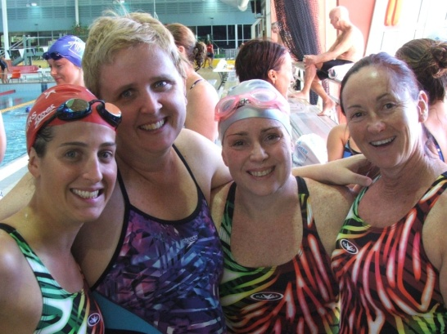
Alecka Patralakis, Kerensa Allason, Lisl McGuire and Heather Whitehead at 2012 State Swim

Riverton Masters
In April, 10 keen Riverton members travelled across to Adelaide to participate in the ‘Nationals’ over 4 days, with some very good swims which included a number of PBs and a WA State Record. Our representatives were Nola Byrne, Mark Davey, Emma Dolby, Damien Eyre, Lee Murphy, Nadine Neethling, Tammy Souster, Hilary Vaughan, Robert Weir and Steve Wills.
Riverton finished in 9th position out of 80 clubs and was the top-scoring WA club. A great result, given the strong competition from other WA clubs and particularly the Eastern States clubs. Overall, it was a terrific performance by all 10 of our swimmers, as each one of them contributed valuable points to the Club’s total. Looks like all the hard training paid off!
Six of our swimmers won a total of 36 medals between them (extraordinary!) and 4 of them – Damien, Robert, Mark and Lee – all won at least one gold medal, meaning they are National Champions. Mark set a WA State record in winning one of his events. In addition, Damien and Robert won their age groups (most points gained over their events), with Mark third in his age group.
The Club fielded 8 relay teams, with 3 of them winning a medal, including a gold!
Well done to all 10 of our swimmers!
Below is a photo of the team with our Mascot Charlie the Crocodile !
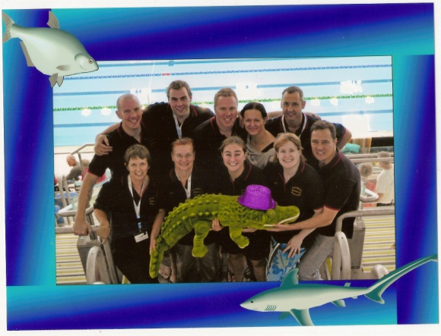

Leeming Masters

Leeming celebrated its 20th year as a Masters swimming club on Saturday, March 24, with the highlight of the evening being the awarding of life membership to club stalwart Kathi Storig.

The event was held at East Fremantle Football Club where about 55 current and past members joined in the occasion. The social committee organised for a mountain of finger food to be served throughout the evening and a good night was enjoyed by all.

Inaugural member and first vice-president Helen Keen addressed the crowd, telling those in attendance how the club came to be set up and reminiscing about the early days at the Leeming Rec pool. After Helen’s speech, club president Doug McIvor acknowledged life members Hazel Clare (awarded in 2004) plus Ceili Mitton (2008) and invited them up to cut the 20th Anniversary cake.
This provided the opportunity to announce that Kathi would be joining their elite group in recognition of her untiring work over many years.

Kathi joined Leeming Aussi Masters in 1997 as almost a non-swimmer and immediately became part of the social committee, along with Hazel and Donna Davies. In her first attendance at an inter-club swim meet, held in Mandurah on 14/09/1997, she competed in the 100m Breast-stroke (2min. 25sec.) and 50m freestyle (1min. 03sec.). In 1999, she started competing in Backstroke events as well as Freestyle and Breast-stroke in inter-club challenges. She was also Leeming’s treasurer that year and contested some open-water swims plus the 1600m Rottnest Swim Thru — doing Breast-stroke all the way. In 2000, Kathi was elected female club captain, a role she held for many years and in those days it involved drawing up programs for Wednesday club nights. She also co-ordinated the ordering of bathers and caps for 43 members. At the Mandurah inter-club swim her time for 50m Freestyle was under the minute for the first time. Along with Hazel she was also responsible for organising trips to Rottnest for the annual Swim Thru, booking chalets and collecting money for the weekend.

2002 marked Leeming Aussi’s 10th anniversary as a Masters club. Unfortunately it also marked the departure of many members to Riverton. Kathi stayed and continued her good work, receiving an Achiever’s Award for her commitment to swimming from WA Aussi Masters. She continued to serve in various roles over the next five years and in 2008 the pool at Leeming Rec was closed and we settled at South Lake Aquatic Centre of a Wednesday night. By then Kathi was the club’s official recorder, a position she still holds, and she was recognised for her contribution to the FINI World Masters Championships in Perth.

Kathi continued her behind-the-scenes efforts which have been of great benefit to Leeming Masters, organising such things as a CPR first-aid course and setting up a club website. Her contribution in 2011 led to Kathi receiving her second President’s Award as best clubperson.
Congratulations Kathi — your life membership is much deserved.

Thornlie Masters
Everything is going well.
We are looking forward to getting the new computer and printer up and running thanks to the grant money we were allocated from Masters WA.
The first Annual Awards Night, since the amalgamation last year, was held in May and it was great that all the Masters Swimmers were invited. They even competed with some of the parents in some of the party games organised for the juniors.
Ron Gray (Masters) was Awarded the Trophy for highest points scored in 2011/ 2012 Summer season (over 16 years) and he also received the Club person of the year award for the combined Clubs.
It is also pleasing to note that Pam Badani has been rewarded for her weekly efforts by receiving the WA Coach of the Year Award. Pam does a great job with the former "Lifestyle Project Swimmers" and the Masters Swimmers who are available on Thursday Mornings.
A fantastic sign that the amalgamation is working correctly is that junior events are being refereed jointly by Masters and SWA Refs on a regular basis and the Club in general all supported the recent 400 Masters swim hosted by Thornlie. There were numerous parents, kids and committee members of the Juniors Club who all helped out with timekeeping on the day and provided some light refreshments after the event. There was also some excellent work done by Murray Davey and Caroline Hickey in the recording area.
Many Thanks to Ken Phillips, Brian Harper and Yvette Ballard for coming to officiate as well as all the swimmers who attended to make it a success.
There are two Masters Members who deserve a mention. Chas Cowland and Wendy Jacobs, both of these people assist with collecting and banking our lane subs on a regular basis and this is very much appreciated as it make things run really smoothly.

Stadium Snappers
State Masters Swim at Bunbury March 2012
Three Snappers were age group winners at the State Swim: Barry Green and Eleanor Parsons both achieved maximum points as well as being age group winners. Pat Sugars was the age group winner for the 80-85 age group, as well as entering the maximum number of events and swimming two relays. The team of eight was well pleased with the efforts of all participants.
Open Water Swim Season 2011-2012
Many enthusiastic Snappers enjoyed the regular Open Water Swims and offer their appreciation both to those clubs who organised the swims and to the officials who marshalled at these events. With the added anxiety of swimming in the ocean during this season, swimmers were a lot more cautious than last year, making safety a priority, as always!

Pamela Walter officiated at some open water swims and will go on to improve her qualifications and supervised experience.

State Open Water Age Group Winners were Julie Crowley and Andrew Wilson with an equal first in their age groups and Theresa Elliott with a first in her age group and 2nd overall. Well done to each and every swimmer.

Rottnest Channel Swim
Snappers were represented in the Rottnest Channel Swim by our solo swimmer Leon Musca who did a PB despite a badly injured shoulder.

The team of four, ERGS Express, made up of Eleanor, Robyn, Gail and Sue, swam well and Andrew Wilson’s team, ‘Happy to Make it’, was good preparation for Andrew’s plan to swim solo soon!

National Masters Swimming Championships in April
Eight Snappers swam in the Nationals in Adelaide and returned with glowing praise for the Adelaide venue. They won enough medals and points to rank Snappers second in the Western Australian list of participating clubs.
20th Anniversary of Stadium Snappers
Stadium Snappers celebrates their 20th Anniversary in June this year and acknowledges the five founding members who are still active members: Hazel and John Christie, Audrey Wren, Nomai Jago and Doris Kimber. Other social events this year have included an evening sailing trip on the Leeuwin and a Golf Day.
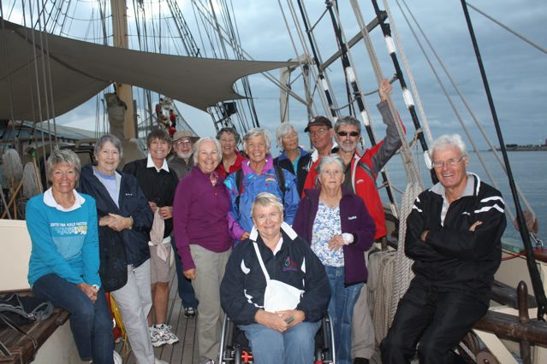
Aerobic Swim Champions for 2011
Stadium Snappers participate generously in the distance swims and are very pleased to be awarded the State Aerobic Trophy for the second consecutive year. We have timers and recorders that give freely and encouragingly of their time as well as swimmers who challenge themselves to do their best in whatever distance they can manage. Snappers came 5th in the National list, a very good outcome for Western Australia.

