Club News Summer Edition 2012

Westcoast Masters
Another great year for Westcoast! We have ended the year with 114 registered members. Lane usage has stayed steady and our swimmers continue to benefit from our excellent training programme. Our coaching roster has drawn from over twenty volunteer coaches, under the guidance of head coach, Alan Power. Although our club is not always in there for the competition, our fitness programme is very successful.
One of our members, Jane Robertson, had the misfortune of having her camper home destroyed by fire, while travelling in Queensland. Fortunately she and her dog, Harley, survived the ordeal with very little physical harm. Club members rallied and put a collection together and we were able to send her a substantial cheque to help her back on her feet. Amazing support for a member in need!
Our last big event for the year was our club weekend on Rottnest for Swim Thru Rottnest. We had over 40 swimmers entered and the same number of members and partners staying over for the weekend. The crossing on Friday was a little hairy after the hectic weather Perth had been experiencing, access to cottages was delayed due to the fact that the schoolies had been stranded for a while and the cleaners hadn’t been able to clean the cottages. Besides all this, we had a wonderful weekend. 2 age group winners and many happy swimmers as a result of the great water conditions. Members have already marked off the date in their calendars for next year’s event.
Lane 1 Ladies all dressed up and ready to go.

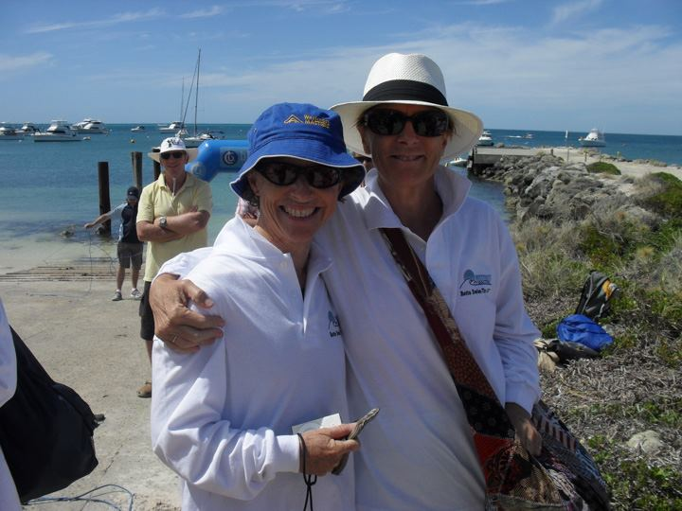
Age group winners – Caryn Kiellor and Viki Shelver
Planning is underway for a year of celebration next year as we enter our 30th year of fitness, fun and friendship, starting at our AGM on the 19 January, when we will celebrate with a birthday tea and cake. We look forward to another bumper year.
To all members of the Masters Swimming Family – committee and members of Westcoast wish you a very safe and happy festive season – and all the very best for 2013.
Leeming Masters

Leeming Masters held their Christmas-themed Wind-Up and Presentation Night on Saturday, December 8, with Greg Thompson and Denise McIvor winning the main awards.

Greg won Greg Bowater’s Coaches Award because of his outstanding year in the pool and one open water swim. He completed 12 endurance swims which gained the club 168 points, he set three State Breastroke distance records in his 35-39 years age group and attended three BACC meetings for a total of 26 points.

Greg was also the joint winner (with Dianne Lee) of the club’s Handicap Award.

When presenting his award, Greg Bowater said Greg Thompson’s attendance at training was excellent and that he was an enthusiastic swimmer and member.

Doug McIvor’s President’s Award for best clubperson went to his wife Denise for her behind-the-scenes work as the club’s longtime treasurer.

She has served in that role for six years, with 2012 being particularly busy because of teething problems with the new online registration system. Denise also sets a budget which includes suggested club fees, provides financial reports for the monthly committee meetings and arranges monies for fundraising projects and social events.

Others awards presented on the night were —

Fastest men’s 400m Freestyle was Kim Smith with a time of 5min. 49.01sec.; fastest women’s 400m Freestyle was Lee Ellis 6min. 19.91sec.; most improved 400m Freestyle swimmer was Nicole Van Blommestein who bettered her time by 25.03sec.; fastest men’s 50m Freestyle was Adrian Young 30.18sec.; and the fastest women’s 50m Freestyle was Dianne Lee 35.23sec.

Following the closure of the Leeming Rec pool and our subsequent move to South Lake Aquatic Centre the club has enjoyed about a 30 per cent increase in membership, highlighted by the number of younger swimmers joining us. To that end we are setting up a Facebook page and updating our website to improve interclub communication and promote more awareness of Leeming Masters’ activities.

This augurs well for the future as we wait in excited anticipation for the establishment of the proposed Cockburn Aquatic and Recreation Community Facility.

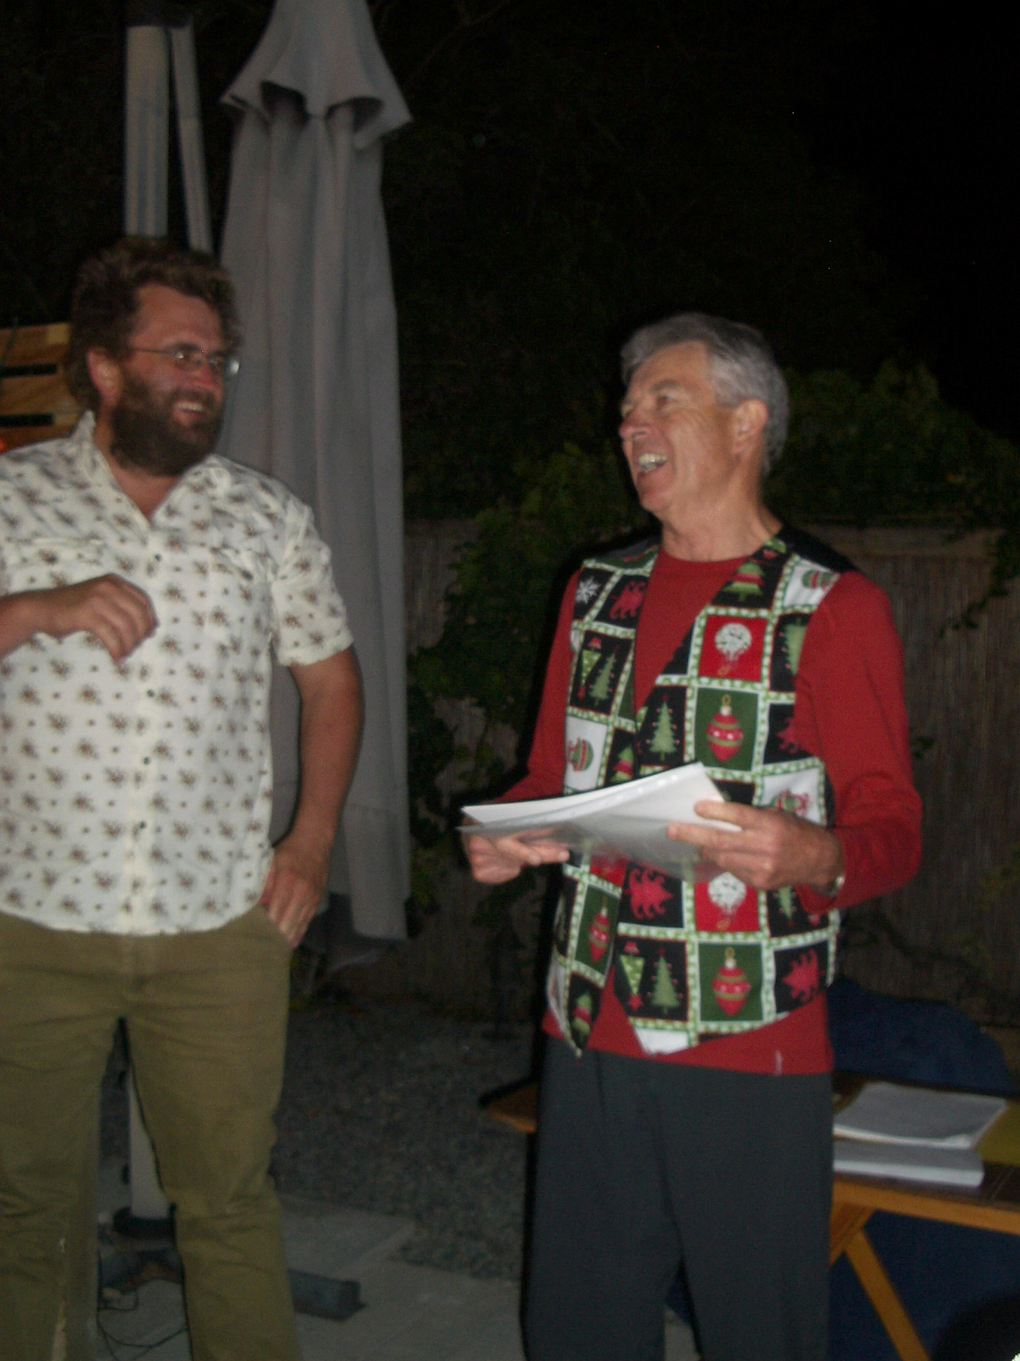
Greg Thompson, left, receives his State record certificates from a “Christmas-attired” club president Doug McIvor.

Belmont Masters
At the AGM of Belmont Masters Swimming Club on 16th December, two of its long time members were awarded Life Memberships. They were Janet Gunn and Hilary Arber,
Janet has been a Club member since 1986 and served on the committee of the Club up until this year. She was Club Secretary for 5 years from 1988 to 1992 and was the newsletter editor for many years.
Hilary joined Belmont Masters in 1988 and has remained a member since that time. Hilary has served on the committee for most of these years and was the newsletter editor for many years as well as having served as publicity officer, Vice President and Secretary and has been our Club technical officer for the past 10 years.
Janet and Hilary have been honoured with Life Memberships in recognition of their contributions to Belmont Masters Swimming Club over many years.
Congratulations to you both.
Vale: Dot Francis 11.06.1931 - 29.11.2012
Dot Francis a member of Belmont Masters for many years passed away on 29.11.2012 aged 81, after a long illness.
Dot joined the Club soon after its inception in 1982 and remained an active member up until her illness debilitated her.
She contributed to the Club both socially and as a swimmer and was always a willing helper.
Dot was the wife our Life Member Norm Francis

Osborne Park Masters
We wish to thank all clubs who participated in our Be Active Club Challenge held at Tuart College on Sunday 25 November 2012. A huge thank you to our Meet Director John Lockley and the Masters Swimming WA officials who helped the meet run smoothly.
A special mention to Sandra Mutch who helped overcome the technical problem of a computer “dying” during the middle of the meet and with the help of our Club Captain Alex Gower and Recorder Fran Howlett, all results were saved and final results still produced on time. Great weather and a delicious Subway lunch and a very enjoyable meet all round.
Open Water Swims
Many Osborne Park members are participating in Open Water swims and so far we’ve had some excellent results.
In the Lake Leschenaultia swim Liz Grant was 1st in her age group and Lisl McGuire was closest to her nominated time and went home with a prize winning towel. In the Swim Thru Rottnest Marg Gleghorn was 1st in her age group and there were some our great results from Pat Nicholl, Penny Green both 2nd and Lisl McGuire 3rd. Well done ladies!
Despite the stingers we still had some great swims from Jon Jessop and Heather Whitehead who were both 2nd in their age group and the newly married Alecka Miles (nee Patralakis) in 4th.
We look forward to more Open Water swims in 2013 with several duos and teams training hard for the Rottnest Channel Swim.
Busselton Ironman 9 December 2012
We wish to congratulate Joanne Kocik from Osborne Park Masters who completed this gruelling event in the great time of
10 hours 25mins 44 Seconds and was 6 in her age group. Anybody who attempts this tough event and finishes within the cut off of 17 Hours deserves or admiration. Well done and we are proud to have you in our club.
Socially, Osborne Park have enjoyed a night out at the Garrick Theatre to see “Calender Girls” and our Annual Christmas Party and Presentation function is to be held at the Marmion Angling & Aquatic Club on Sunday 16 December 2012.
Our club has it last training session at Bayswater Waves on 20 December 2012 followed by a dinner at a local Nepalese restaurant and then after the Christmas break we resume back at our “home “poll Beatty Park on 7 January 2013.
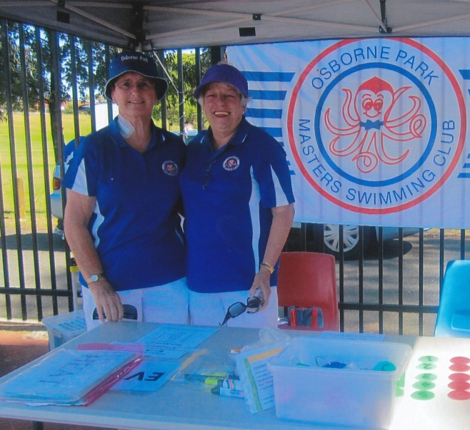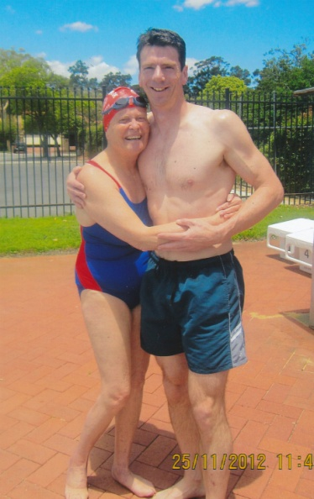
Penny Green and Jan Hull our hard working Marshalls Our Club Captain Alex Gower our BACC on 25 November 2012 being congratulated by Pat Lockley

