Club News Spring 2012

Armadale Masters Swimming Club

The last couple of months attendance has dropped off a little due to illness and some members
having to undergo surgery and also because some members thought they needed a holiday!! We
have been training at St Brigid's College since May of this year and are due back in Armadale early
October. Our morning teas on Saturday at the Melville Rose Gardens are very pleasant with most
enjoying their 'breakfasts' after having put so much into their training!! We have also been fortunate
enough to have had three new members join our ranks during the winter period.

Our Club Championships for the year is going well with everyone participating with a healthy
competitive attitude and determination to do their best times and get that elusive trophy.
Three of our swimmers were successful in the Open Water Series earlier this year with each
winning their age groups.

The BACC Series was also attended with much gusto and we are very pleased with the results
achieved – plenty of PB's which is always pleasing.

Araluen Lunch in July – instead of Christmas in July we decided on lunch. It was a most pleasant
and enjoyable day which started out looking a bit dismal but turned out a lovely, sunny afternoon.
A lovely lunch and an most enjoyable walk through the park with our guide,Liz, who gave us a
history and nature lesson on the way to the dam.

Westcoast Masters

September is here and we are all thinking - where has the year gone?
Again we have attracted a bumper crop of members, currently sitting at 111. Some of these members are very active and some very casual attendees, but all with the same focus of staying fit and having fun.

The past few months we have seen club members hiking in the foothills of the Himalayas, walking the Kokoda trail, relaxing in UK, Europe and Bali - no wonder the lanes have been a little quiet. Hopefully now that spring is here (would you believe it when you look out the window) we will see more members back in the water.

With the recent closure of Arena Joondalup for maintenance, Westcoast’s training schedule has been a bit chaotic. With the known limited water space at peak times we were very lucky to secure lanes at Aquamotion and Craigie. We also introduced a land session of Pilates/Yoga which has been enjoyed by many of our members. However, we will be happy to get back into the old routine.

Again this is a period filled with sadness as we farewell our club member Barbara Logan, who recently passed away unexpectedly. She was a regular in the lanes and at all club events. Barb was the first to have her name on the list for any volunteer work to be done, whether it was timekeeping, catering or working a sausage sizzle. Her smiling face will be missed in the lane and around the coffee table.

Somerset Masters Swimming Club
Melville Be Active Club Challenge 1st April
We fielded a team of 23 swimmers, 1 official, time keepers and supporters for this event at the rejuvenated Melville pool. Overall, the Seahorses came second, with 203 points, losing to Melville with 266 points.
Sausage Sizzle 28th April
We ran a sausage sizzle outside Bunning’s Cannington store as a fund raiser on April 28th. It was an all-day event, staffed by volunteers on 2 hour shifts. We prepared, set up, cooked, served, cleaned up and occasionally ate with enthusiasm, and made a worthwhile profit. The consensus after the event was that this was a fairly easy way to raise necessary funds in a short period of time, and having done it once it would be a lot easier to do it again.

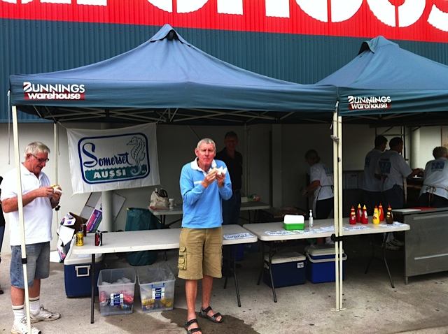

Mandurah Be Active Club Challenge 24th June
Around 25 Somerset Seahorses went down to Mandurah for this Carnival. It was a great competition and Somerset won by a considerable margin. Six state records were also broken by Seahorses.
Somerset Masters 1500m swim 5th August
This was a great event attended by 39 swimmers and numerous other visitors and Seahorses. The swimmers were almost equally divided between Somerset and other clubs. Two state records were broken.
As always, we served everyone with delicious hot soup at the end of the event.
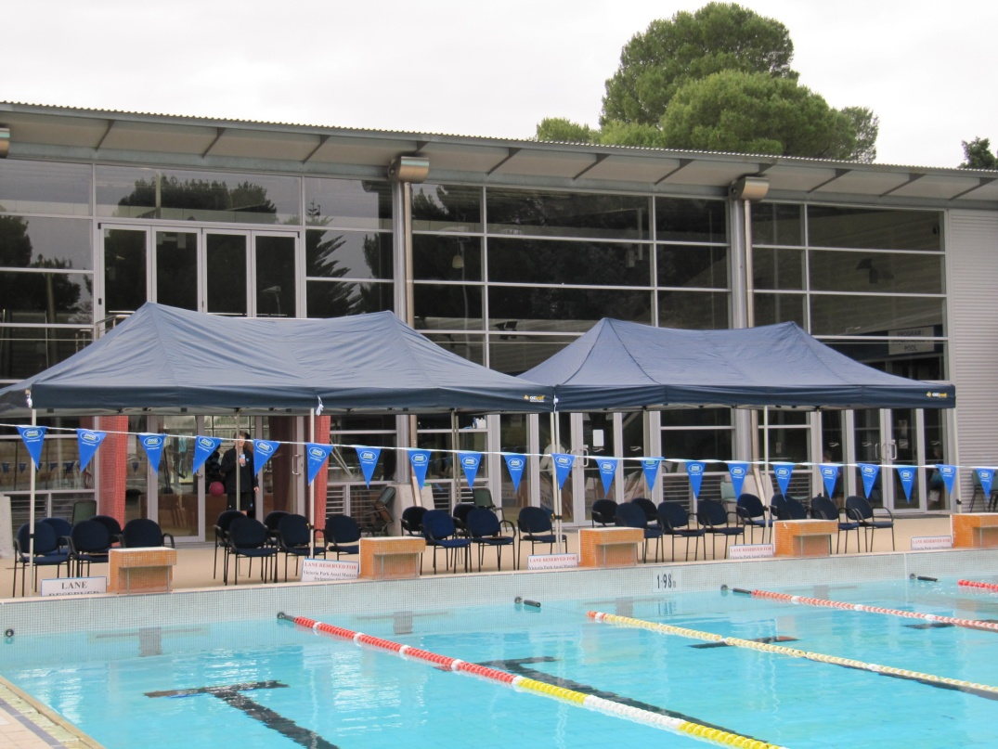
Somerset Aqualife pool, with Masters Swimming Club shelters purchased with grants from Healthway.

Stadium Snappers

20th Anniversary Dinner and Book Launch
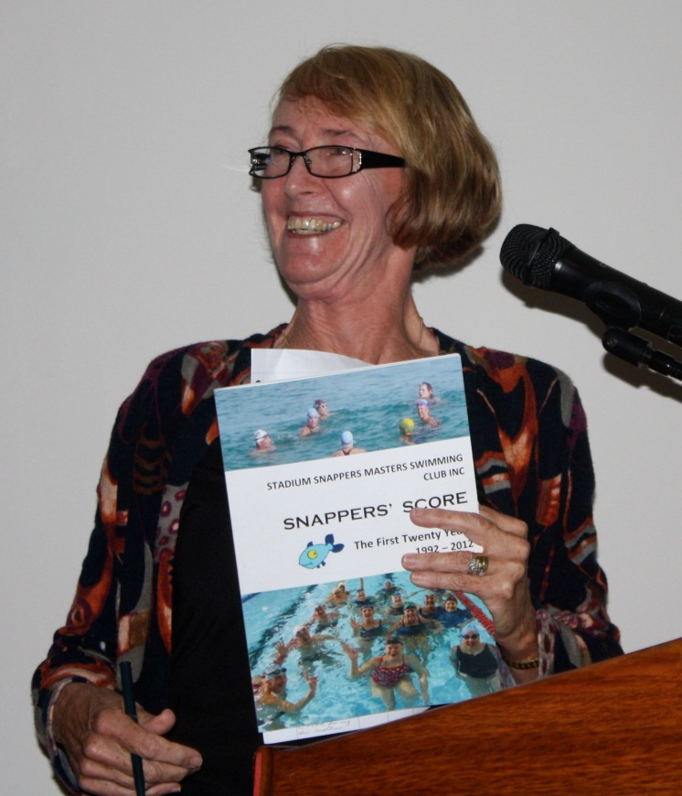
- Stadium Snappers celebrated their 20 Years in June 2012 with the launch of their story, Snappers’ Score: the first twenty years. Lynda Joachim, inaugural President and life member, now living in Queensland, returned for the celebratory dinner and was given the honour of launching Snappers’ Score.
Barry Green had coordinated the writing of the club history which was then edited by Sue Colyer and printed by SNAP with the aid of a generous grant from Masters Swimming WA, negotiated by President Julianne Crowley. Each author focused on a period they had lived through and it is a tribute to the whole team that the book came together in a most interesting, readable and enjoyable format. Congratulations and thanks to all writers and editors. We are currently investigating the possibility of making the book available online in the form of an eBook.

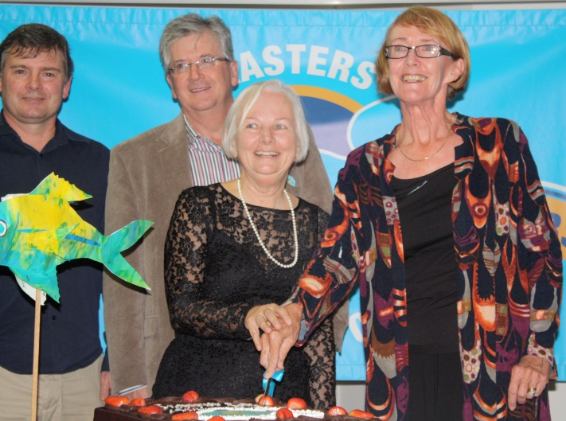
- The Anniversary Dinner saw many early members return to renew acquaintances and enjoy the meal. Glad McGough was recognised as being the early instigator of the formation of the club when she coached the founding members of Snappers under the Swim for a Healthy Lifestyle. She belongs to Maida Vale and is recognised each year with the special trophy she donated called the Founders Award and awarded to a Snapper who has achieved the highest number of Personal Best times and has not won any other award.

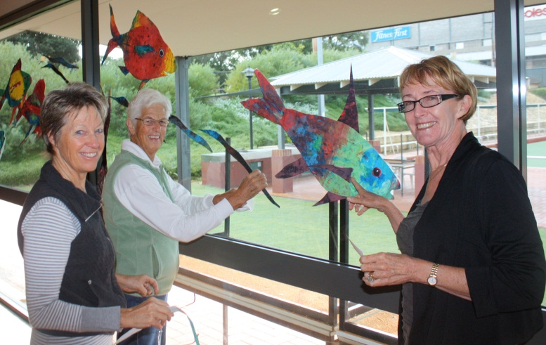
- The hall had a marine theme, decorated with snappers and other imaginative swimming creatures hand-crafted by the members under the direction of our professional club member, Pamela Walter.

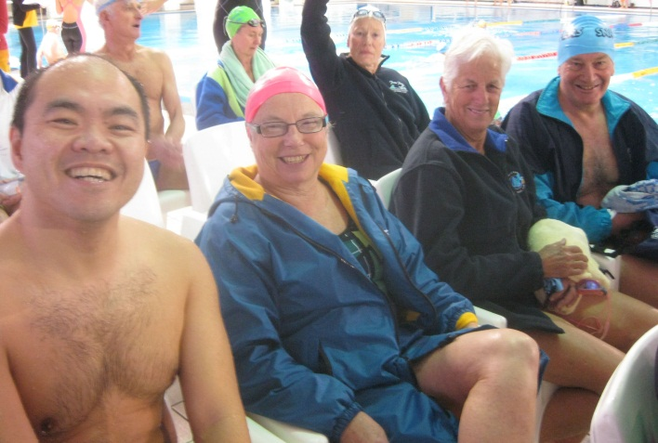
State Short Course Relays
- Snappers successfully fielded a team of Female senior swimmers in the 320+ age group Relay. Hazel Christie, Pat Sugars, Deirdre Stephenson and Margaret Somes swam well but had strong from Osborne Park. Snappers are very proud of their senior swimmers who endeavour to live a healthy lifestyle and train regularly.
- Some of the younger teams set new Short Course records and we are grateful to Claremont for organising and hosting this enjoyable competition.

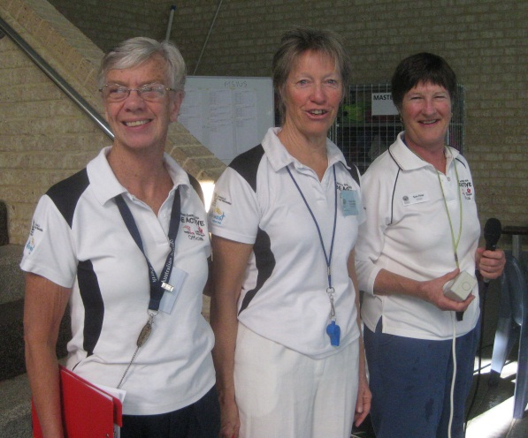
Officials
- Pam Walter and Theresa Elliott are working towards their qualifications as Event Referee and Meet Referee. Sue Pow, who was recognised as Mentor of the Year, is generous with her support and supervision.

Mandurah Mannas
These last few months have moved fast. We are looking forward to the warmer sunshine swims.
For many, many months a very determined team have been training hard for an English Channel Challenge. Winter & Summer in the open ocean & freezing local dams, with 20 brave club members supporting, they all swam 4 or 5 days each week, coached by Barb Pellick. Cold showers & dedication paid off, Ray Reynolds, Deb Bloor, Sue Giles, Ken Phillips & John Reyburn completed their Channel Marathon in 14hrs 44 min on 5th July. Strong tides extended the swim from 34km to 45km around the point from Cape Gris Nez. All club members who supported The Team improved their fittness and are now enthusiastic open water swimmers
Barb Pellick have just returned from competing in a challenging marathon swim in Asia.They really enjoyed the tropical weather.
Pauline & Ivan Wingate flew home from competing in the World Masters Championships in Riccione, Italy. Ivan swam & Officiated. Pauline Scored 4 top 10 swims & came 5th in the O.W.S.
While all these pikers were overseas us "stay-at-homers" organised our BACC Swim in June. Thankyou to all officials & competitors who joined us. We had fun even if Somerset won again.
Thankyou to Claremont for organising a beaut Golden Groper Relay Championship. Our club really enjoys this event
Looking forward to catching up on 9th September at Mandurah Pool for our 1500mt Distance Swim.
C U in the swim
Osborne Park Masters
We wish to thank Claremont Masters for hosting the recent State Relay Carnival on 12 August 2012. It was a well run meet and our Club was pleased to finish 2nd overall. Congratulations to our 320+ team for winning that age group and for the following teams for setting the bar higher in state and national records:
- Mens 320+ 4x50 freestyle – National record 2:49.22
Team of: Evan Jones, Eli Kitay, Dave Cuzens, and John Lockley
Who took 1 second off the previous record.
- Mens 320+ 4x25 medley – National record 1:39.98
Team of: Evan Jones, Eli Kitay, Dave Cuzens, and John Lockley
Who took 4 seconds off the previous record!
- Mixed 320+ 4x50 medley – State record 4:16.55
Team of: Beryl Paterson, Bryce Jones, John Lockley, and Eli Kitay
Who took 20 seconds off the previous state record!
Osborne Park Masters’ sole representative at the 2012 FINA Masters World swimming Championships in June was John Fussell. The club would like to give John a round of applause for his effort in representing the club, state and country and achieving 12th in the 100 m freestyle, 8th in the 50 m backstroke, 9th in the 100 m backstroke, and 10th in the 50 m butterfly, and 11th in the 100 m butterfly. What an effort!
On a social note, the club will be celebrating a combined 100th birthday (Alecka’s 30th and Penny’s 70th) on 4th October. The Thursday night training group will help the celebrations by joining them for dinner.
The club has continued over the winter with a group of swimmers training for an extra session on Saturday afternoons at Terry Tyzak Recreation Centre in Inglewood. To keep up the good work, this group is bound to increase in numbers now spring is arriving!
Our club continues to train at Bayswater Waves during the week whilst we are waiting for the Beatty Park renovations to be completed. We are expecting to move back to the revamped facilities at Beatty Park in January 2013.
Osborne Park Masters will again be holding the BACC at Tuart Hill on 25th November. We look forward to a competitive but fun meet.
Finally, the club would like to acknowledge Geraldine Phillips who is participating in the “Ride to Conquer Cancer” in support of WAIMR - the West Australian Institute for Medical Research. On the weekend of 20/21 October, Geraldine will pull on the lycra and ride 200 km for this cause. At the time of writing this note, Geraldine is 60% of the way to raising the minimum of $2500 sponsorship for eligibility to ride in the event. Please consider making a donation to assist Geraldine achieving the goal while also supporting a great cause. Sponsorship can be made at the following web address:
http://pr12.conquercancer.org.au/site/TR/Events/Perth2012?px=1171883&pg=personal&fr_id=1080
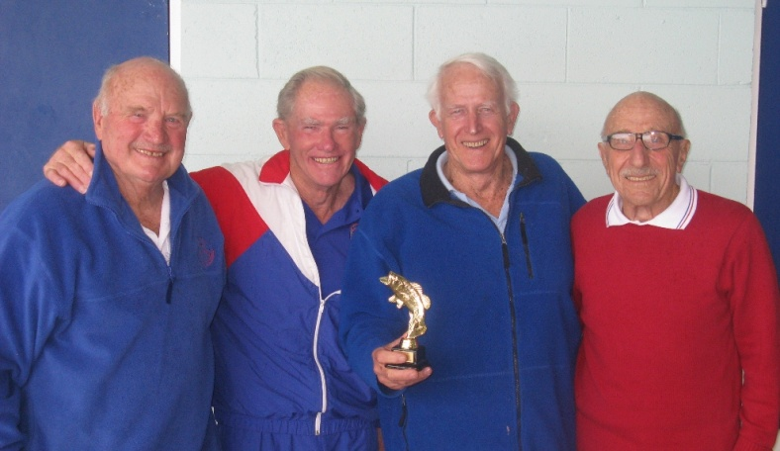
Dave Cuzens, John Lockley, Evan Jones, and Eli Kitay:
All smiles after setting 2 national records at the 2012 State Relay Carnival

Carine Masters
Carine Masters are proud of our two new State record-holders, who between them have amassed 11 State records this season: nine records for Carol-Ann Infante and two for David Laws. Not bad for a small club, but it’s very much in tune with our 35 year history, which we continue to celebrate. At our club dinner in June and a social get-together in August, old and new members shared their stories about the club – and the scrapbooks came out. Ah, nostalgia ... but we are excited too that a number of new and potential members have joined in our training sessions with coach John Burns. PB’s will tumble next season, including among those who have taken to swimming butterfly. Some are improving their skills; others are learning from scratch and looking forward to their first IM swims.

