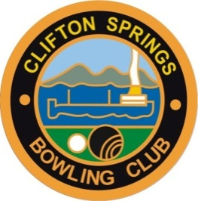

CLIFTON SPRINGS BOWLING CLUB Safe Transport Policy

Rationale
Clifton Springs Bowling Club recognises that:
- It has a duty of care to all members and visitors involved in club-related activities
- Mixing drugs (including prescription medication) with other drugs or alcohol can seriously affect the ability to drive safely
- Driving under the influence of alcohol and drugs is illegal and hazardous to individuals and the wider community
- Drink driving is one of the main causes of road deaths in Australia
- It takes one hour for each standard drink of alcohol consumed to be broken down by the liver
- It takes considerable time until a person can legally and safely drive home if they have consumed over the recommended levels of alcohol.

Accordingly, the following safe transport policy shall apply for all functions undertaken by the club that involve the serving and/or consumption of alcohol.

General
- Where possible, the club will display standard drink posters / cards to help patrons recognise what standard drinks are and the implications on drink driving.
- Telephone calls will be made free of charge to arrange a taxi (where available) or to call a sober person to provide transport from the club.
- Contact telephone numbers for taxi services (where available) will be clearly displayed in the club.

Bar Staff/Servers of alcohol
Bar staff/servers of alcohol shall:
- Encourage members and visitors to make alternate safe transport arrangements if they are considered to be intoxicated or at risk of exceeding .05 blood alcohol concentration (e.g. free call to a taxi/friend/family)
- Promote low alcohol and non-alcoholic drinks to consumers
- Be provided non-alcoholic drinks and bar food free of charge.

Club Functions
- In specific cases, where a designated driver nominated by the club has accepted the responsibility to drive others home safely, the club will provide non alcoholic drinks and/or bar food free of charge (or passengers will be encouraged to pay for these for their driver).

Committee Members, Members, Players and Officials
Those attending club activities where they are planning on drinking alcohol are encouraged to:
- Make alternative transport arrangements to get to and from the activity safely.
- Ride with a driver who hasn’t been drinking alcohol or taking drugs.

Policy Review
This policy will be reviewed annually to ensure it remains relevant to club operations and reflects both community expectations and legal requirements.

Signature
Signed: | ____________________________ | Signed: | ____________________________
 | Club President |  | Club Secretary
Date: | _______________ | Date: | _______________

Next policy review date is _______________________

