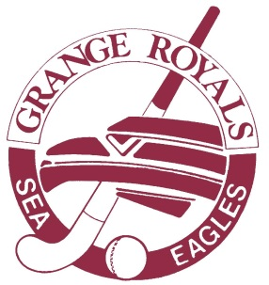

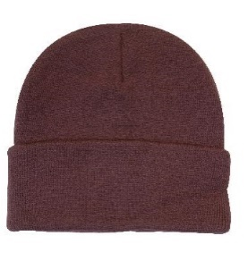**Grange Royals Merchandise**

**Beanie - $17**

Maroon, white **logo** embroidered

100% acrylic

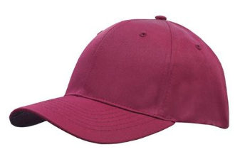

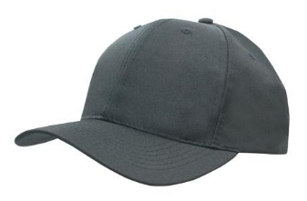**Cap - $17**

Maroon, white **GRANGE ROYALS HOCKEY** embroidered

Grey marle, maroon **GRANGE ROYALS HOCKEY** embroidered

Poly twill

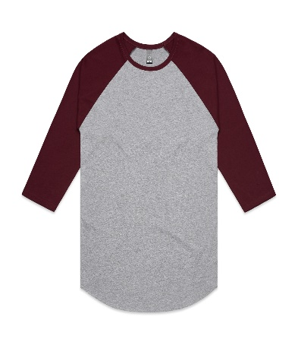

**Raglan - $30**

Grey marle body, maroon ¾ sleeve, maroon **Sea Eagles HOCKEY** screen print

100% cotton polyester

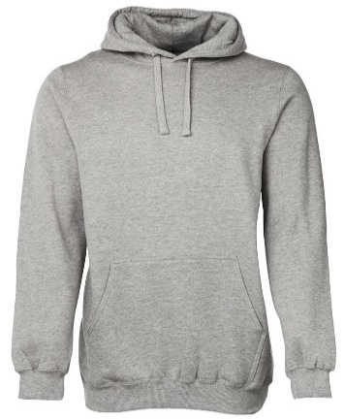**Hoody - $40**

Maroon, white **Sea Eagles HOCKEY** screen print

Grey marle one centred pocket, maroon **GRANGE ROYALS HOCKEY** screen print

80% cotton and 20% poly fleece

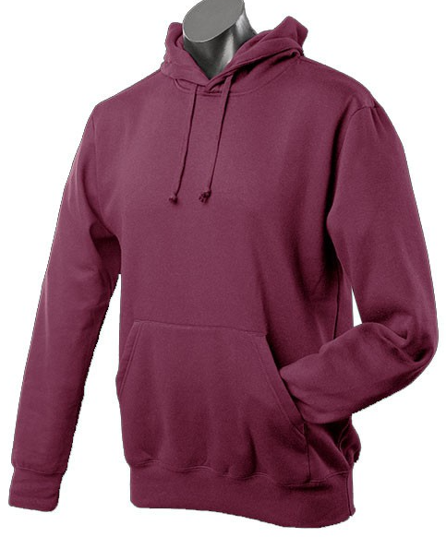



**Polo Shirt – $45**

Maroon white side panels, white **logo** front left chest embroidered

100% DRI-TEX Polyester

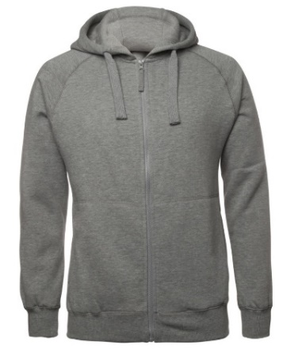**Full Front Zip Hoodie - $50**

Grey marle two side pockets, maroon **logo** front left chest screen print, maroon lower back

**GRANGE ROYALS HOCKEY** screen print

80% cotton and 20% poly fleece

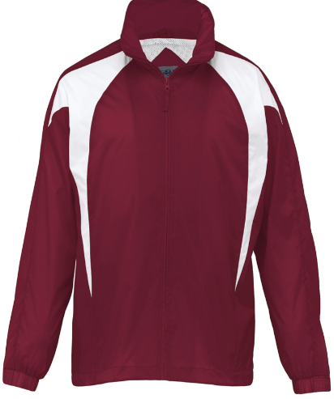

**Spray Jacket - $55**

Maroon white side panels, white **logo** front left chest embroidered

100% nylon tafetta

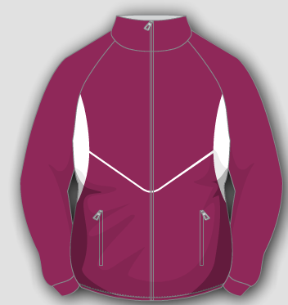

**Fleece Jacket - $100**

Maroon white side panels, white **logo** front left chest embroidered