|  |  |
| --- | --- |
| Club house stretch | Edithvale Bowls News |

**EDITOR – Kevin Breen Winter Edition 2017**

**What’s on**

**New Members** Please make welcome all new members by introducing yourself to them

**From the Executive Director**

The newly elected Board has met twice – in April and May. The focus currently is on membership and the new uniform shirts. Ray White Chelsea, has generously committed to sponsoring the Club for the next 5 years and we have every expectation that it will continue beyond that. The new uniform shirts will carry the new Ray White Chelsea corporate logo on the back, thus promoting the Ray White Chelsea business.

Other major points are:

* The resurfacing of the Frank and Isabel Baguley green is still delayed whilst conditions attached to the recently issued permit are worked through to ensure that the Club takes the necessary steps to comply. As soon as the details are finalised Berry Bowling Systems will be given the go ahead to proceed as soon as practical.

**They were quick!The carpet is already down I have been slow in putting the newsletter out (ED.)** My apologies to the Director (ED)

* The application for grant assistance for the installation of lights over the John Clark green is progressing with the support of the Kingston City Council. It is still hoped that we can hold the first evening of play under lights as a part of the Club’s 50th Anniversary celebrations.
* We have been advised by Bowls Victoria that Scot Nicholson has been appointed to the position of Regional Bowls Manager Eastern and Southern Metropolitan Melbourne / Gippsland. I have had a first meeting with Scot, introducing him to Edithvale.
* The Ken Lee green is closed and undergoing the normal winter treatment for a Bent grass green so that it will be available for the start of the 2017-2018 season if required.
* It is hoped to run a Responsible Service of Alcohol (RSA) course at the club near the start of the 2017-2018 season (possibly in September). We hope to encourage more members to get an RSA Certificate and to serve behind the bar. More details will be available nearer the time but please let me know if you are interested.

Why not bring a friend along to the club, roll a few bowls with them, introduce them to other members and invite them to join. The Club needs **your** help to grow our membership.

Please support your Board members by talking with any one of us if you have ideas or concerns.

***Ian Wilding***

22nd May 2017

**Option A was chosen for our new Shirts.**

**Thank you to the board for all their hard work.**

**ALSO**

**Thank you to our sponsors**

**Ray White, Chelsea**

**Bendigo Bank, Aspendale Gardens**

**Chelsea Travel**

**MENS WELFARE REPORT (Doug RAFTER)**

Doug’s Wife broke her both her wrists, and he, now, has a full-time job attending her needs, but he hopes to be back at bowls soon, after an operation on his leg. We wish & pray they, are both well, onto the way to recovery

Kevin BREEN (ED.)

Margaret Burke

Ladies Welfare Officer

This year has been a worrying time for many women at the club. Some are on the mend while others are coping with treatments. We all wish them well and look forward to their return to bowls. Gail H has returned last week and she rolled a mean bowl - I played against her.

Doug Rafter has his work accounted for looking after his wife Jo who sadly broke both wrists. How awkward for the poor darling. We wish her a speedy recovery.

**VALE**

**I must mention the sad passing of a past member Mick Hogan this month. Mary and Mick were a lovely couple and valued members over many years at Edithvale. Our sincerest condolences to Mary and family.**

We **ALL** join you in those **THOUGHTS** (Ed.)

Keep well and keep bowling.

Regards

**Marg Burke**

Ladies Welfare Officer

Margaret Burke (9772 2720)



HAPPY JUNE BIRTHDAYS TO:

 4/6    Peter Woodbridge

9/6    Robert Davies

10/6    Roger Williams, Robbie Leitch

15/6    John Clark, Geoff Pearce

17/6    Claire Baskett, Andrew Benson

22/6    Tricia Comerford

27/6    Ted Elliott

29/6    Tony Abbott

**Jokes / Stories / Gossip** *by Fibber* 

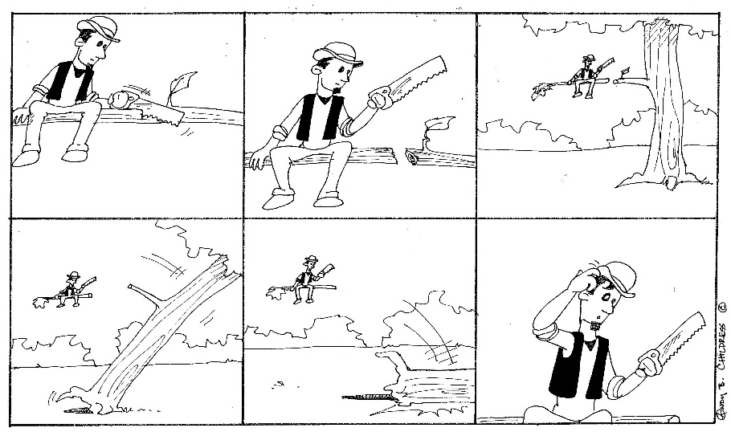

***SPONSORS***

Andrew Tomlinson

Senior Sales Consultant

Ray White, Chelsea

T: 03 9772 6333

M: 0429 234 341

Email: Andrew.tomlinson@raywhite.com

|  |
| --- |
| **CHELMC900016541[1]EA**  **CRUISE & TRAVEL**   * + - PERSONAL SERVICE     - CORPORATE & HOLIDAY TRAVEL     - CRUISING SPECIALISTS     - INTERNATIONAL & DOMESTIC TRAVEL     - TRAVEL VOUCHERS, BRIDAL / GIFT   REGISTRY   * + - WE SELL LUGGAGE & TRAVEL   PRODUCTS  **Phone 9773 1900**  **CHELSEA CRUISE & TRAVEL**  396 Nepean Highway  Chelsea Vic 3196  Email: travel@chelsea-travel.com.au |

***ASPENDALE GARDENS***

***CHARCOAL CHICKENS***

The succulent chickens come with a great range of delicious salads, which are freshly prepared each day.

Gluten free mayonnaise is used. Phone 9588 1616

***Aspendale Gardens Charcoal Chicken*** is a valued sponsor of Edithvale Bowling Club. Please make yourself known to the staff. They look forward to serving you. Phone 9588 1616



MICHAELANGELO”s

* **Address:**
* 4 Springvale Road, Aspendale Gardens
* Victoria 3195

[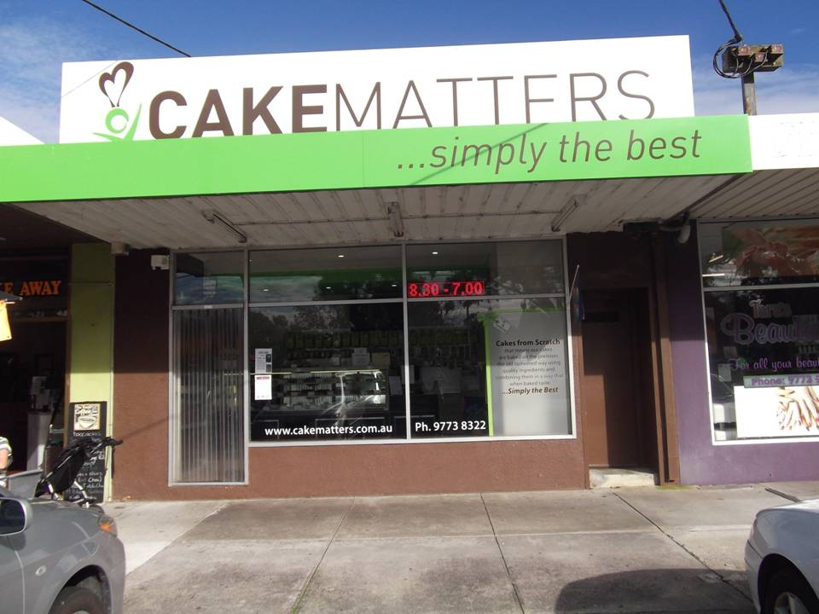](http://www.edithvale.bowls.com.au/sponsors/index.cfm?fuseaction=display_main&SponsorID=9965&OrgID=18279)**Phone:** 03 9772 6999 **Cuisine:** Italian

Cakematters Cake & Pastry Shops

236 Wells Rd, Chelsea Heights, VIC 3196

***Phone 9773 8322***

***LAKEVIEW MEATS at Patterson Lakes. Pop in and see Craig***

* **Address:** Lakeview Shopping Centre Gladesville Blv, Patterson Lakes Victoria 3197 **Phone:** 03 9772 0669