Beatty Park Masters Swimming Club - E-news article

CHRISTMAS IN JULY
Christmas in July function was well attended by 54 members and friends. Four tables of merry makers sparkled and shone, though once again age and experience won out and the “bridal party” won the best decorated table. It was pretty impressive and certainly very colourful. A scrumptious meal was served by a charming, friendly waiter, so all we had to do was sit, chat and eat. Dessert was lovely and the nibbles beforehand kept us sober while we enjoyed a little glass or two of bubbles or the flat stuff. New sleep deprived mums Rebecca and Alecka and almost new mum Narissa all managed to not only stay awake, but to flit around and visit all the tables. It was certainly a fun night and great to catch up with members we’ve not seen for a while.

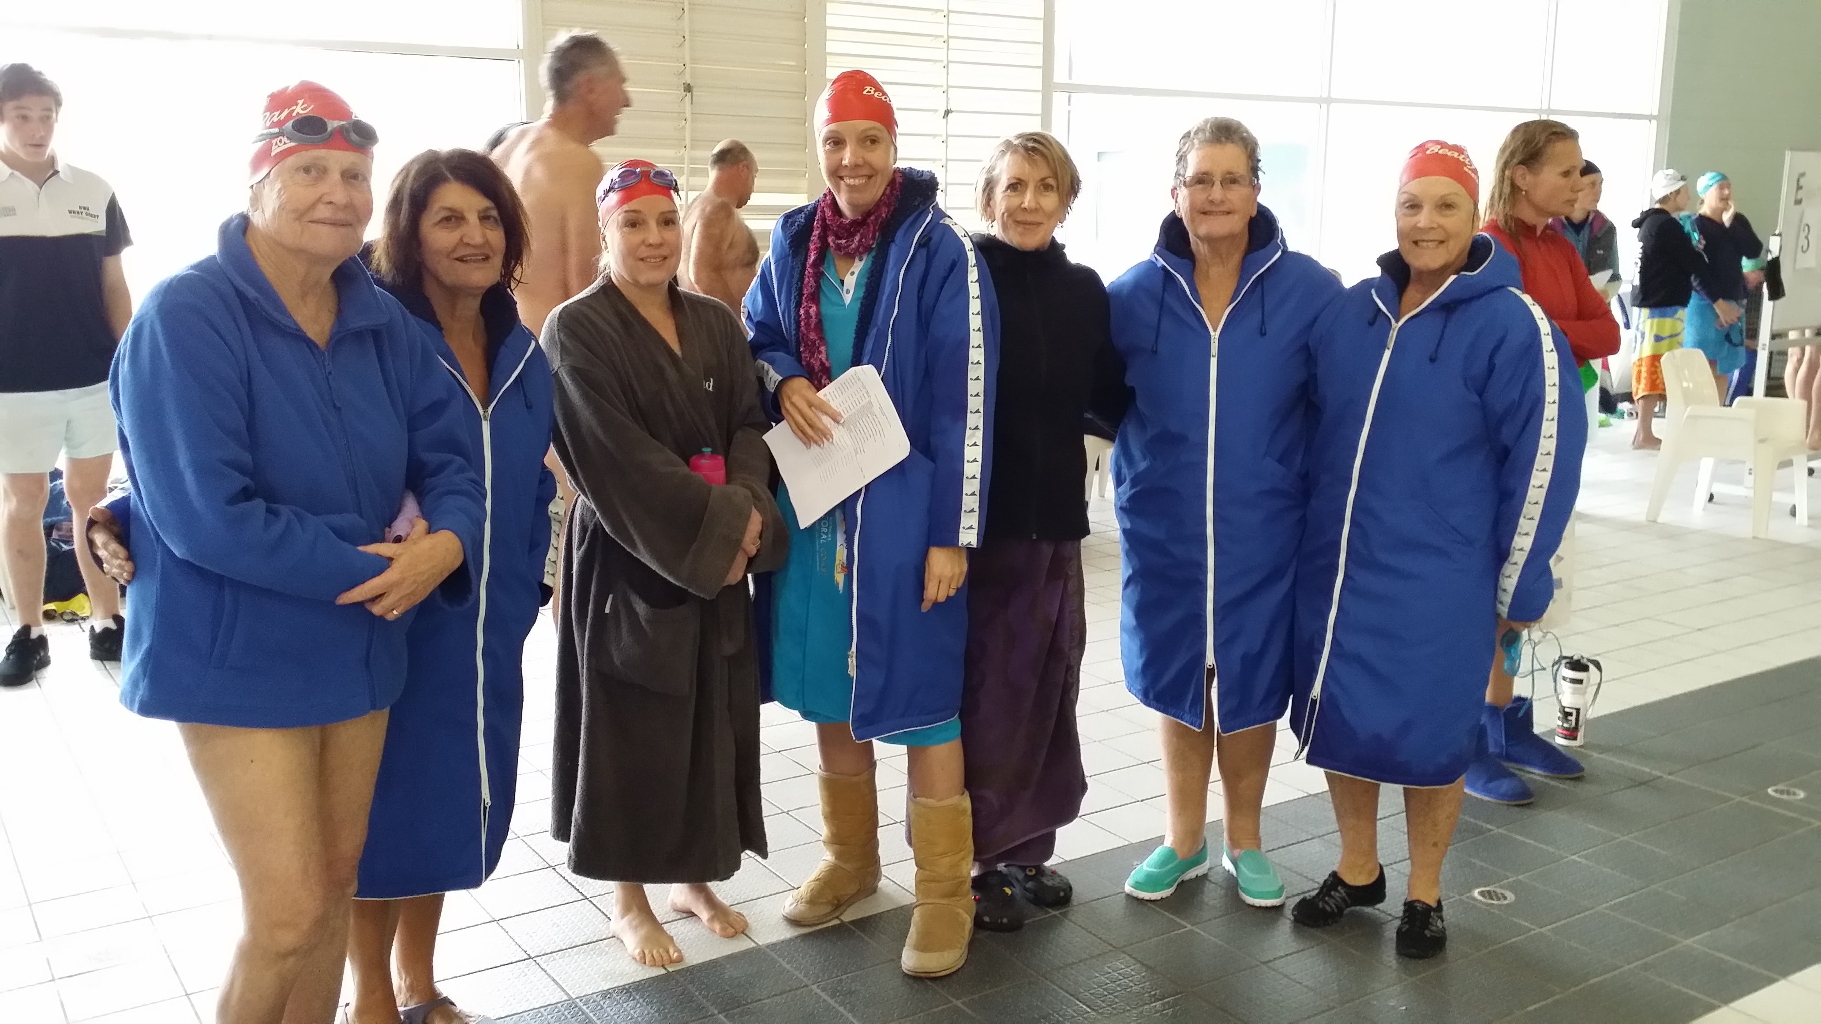
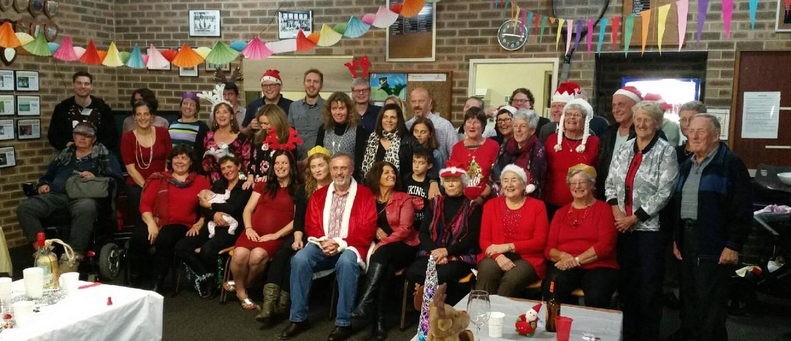

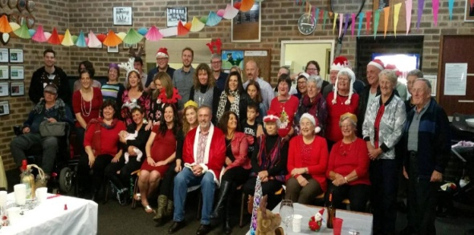

GROPER RELAY CARNIVAL
On Saturday afternoon 23rd July our Club competed in this relay event. With only 32 swimmers we still managed to achieve equal 3rd place with West Coast on 118 points, Mandurah were 2nd with 170 points and Claremont 1st with 184 points. Well done and thank you to our swimmers and helpers.

The Presentation function at the end was good with yummy pizzas and deserts to warm us up and replace the energy that we lost in the pool. Overall a great afternoon was had by all in attendance. Thank you to Claremont club for hosting this well run event.

