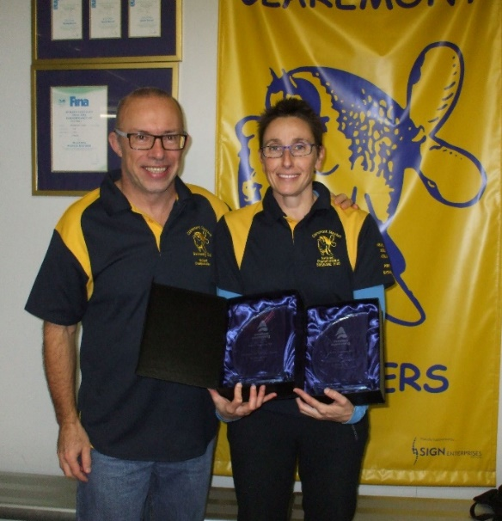
Claremont Masters eNews June 2016
Those of you notice such things will know that Claremont Club and Claremont swimmers individually have won a few awards in the past few months. Rather than dwell on these – which you can find elsewhere, let’s just concentrate on the awards our indefatigable coach / Swim Thru Perth organiser / Golden Groper announcer supreme / general livewire Elena Nesci was recently presented with at the May Council of Clubs. Of course it gives us all a special pride that she won the Perc Edwards Award for Volunteers, but that does not diminish the Award that she won for Service to Masters Swimming WA.
We also congratulate our Vic Paul on being the Overall Male Open Water Swimmer of the season with his 100% score.
There are a few new faces on this year’s club committee and combined with the wiser heads from yore, we are working to make sure the club is a great place to be. Our monthly club nights are not to be missed, and we aim to have a decent turn out at all the swims we get to do throughout the year both in the pool and in the open water.
We are sadly waving off Hannah Rizzuti back to the UK after enjoying her sparkling personality here for two seasons. She arrived here an English swimmer and she is soon to return to London as an Australian one; at least the accent, kind of!
We have over 100 swimmers of all levels. And we hope to see everyone at the Golden Groper State Relay carnival this year on Saturday, 23 July at HBF Stadium.

