Winter e-news Beatty Park Masters

It has been a rough start to the year for Beatty Park Masters after the loss of three long standing members who have made large contributions to the club over many years, Marion Woolston, Nina Epps and John Hancock. Then the recent passing of Ken Row one of our original members. We will miss them!
However we have good news with three of our “girls” Rebecca having a baby boy plus Alecka, and Narissa expecting future Beatty Park swimmers.

2016 NATIONALS IN MELBOURNE
Eight members of Beatty Park Masters descended on Melbourne for the Masters National Championships in April. The weather in Melbourne was unseasonably warm. The pool was lovely and the welcome from Victorian Masters Swimming members was friendly. The competition was well run and all members enjoyed the 4 days of events. There were some amazing swims to watch, the highlight was the final heat of the 50m freestyle where the winner swam 23+ seconds.

Our members swam very well, bringing home one gold, one silver, two bronze and many PB’s.

Several members went to see "Matilda the Musical" whilst in Melbourne and took advantage of being in the AFL heartland to attend one or more of the games held over the Anzac Day weekend.

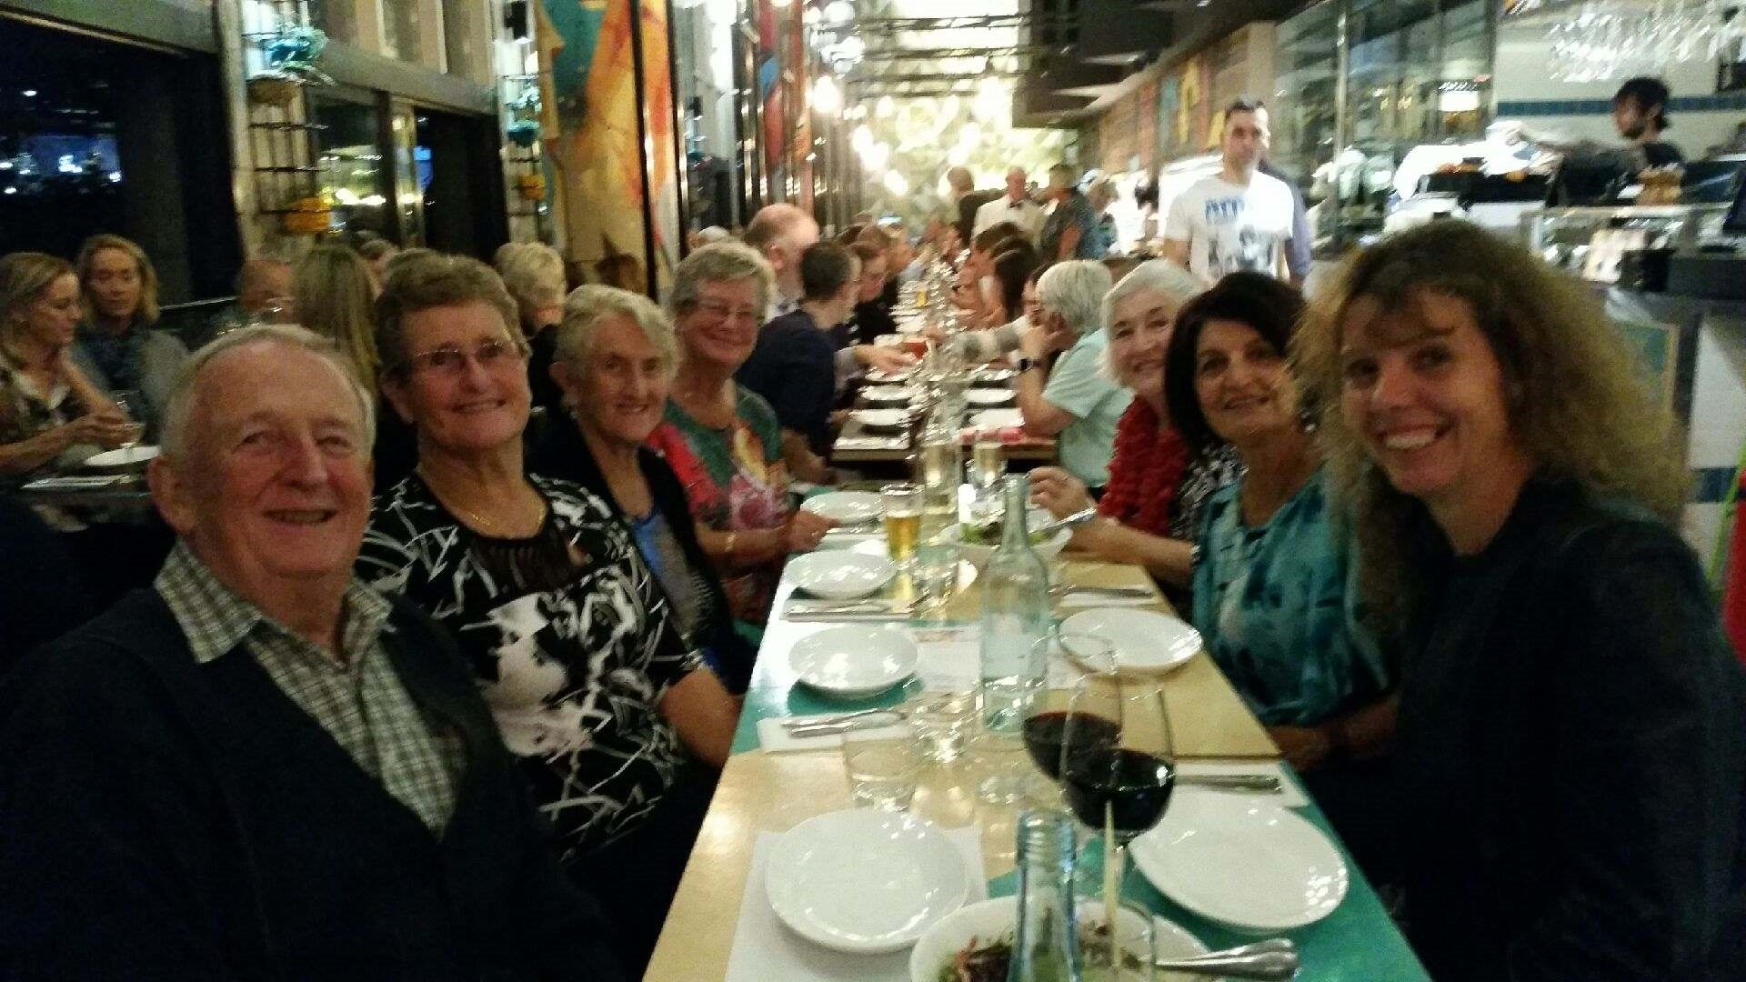
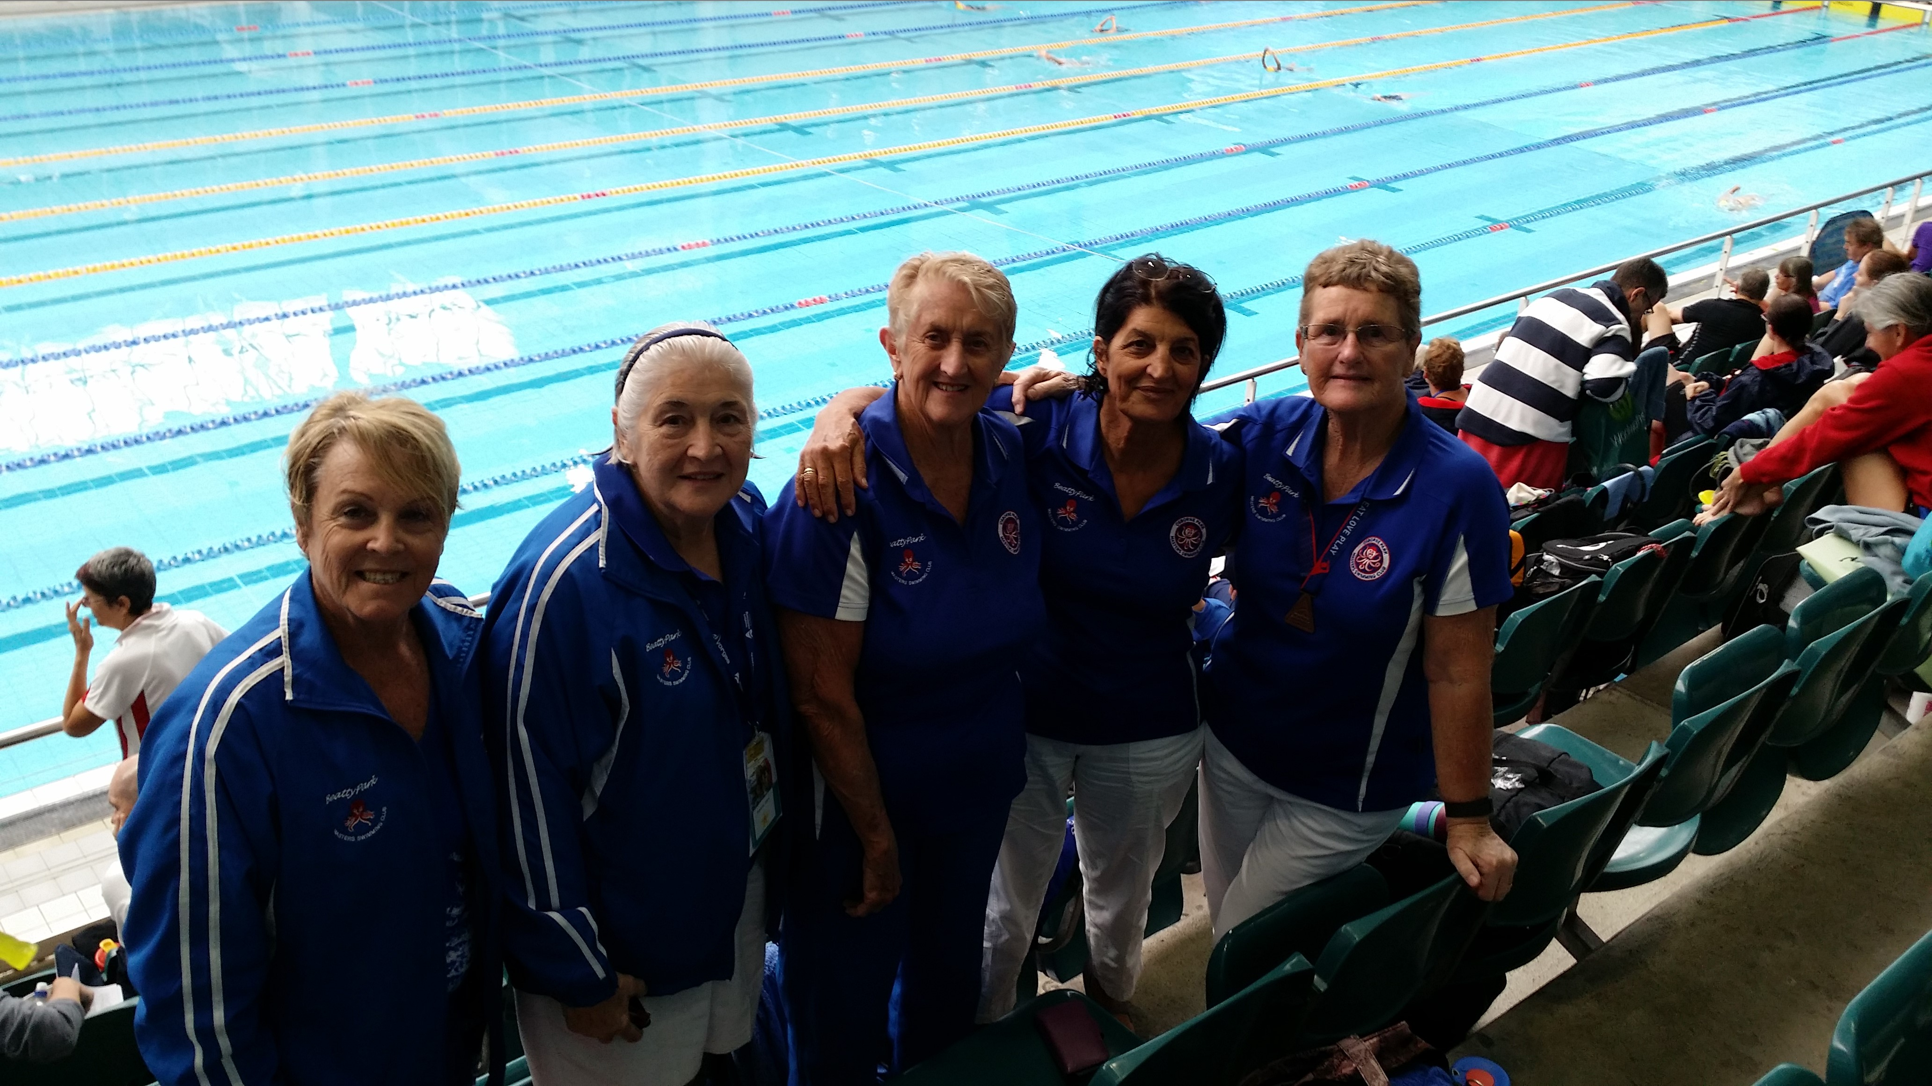

OUR TWILIGHT CARNIVAL 18TH MARCH.
We were fortunate to have good weather that evening with 128 swimmers enjoying the event. This year we finished on time then the Pizzas were late so when they arrived they dissapeared very quickly. The yummy cakes, slices, and fruit provided by our members were popular as usual plus lots of raffle prizes. Thank you swimmers who attended, the MSWA Officials who ran the meet so well and our swimming and non-swimming members who made the night a success. See you all next year.

SAUSAGE SIZZLE
We held a sausage sizzzle at Bunnings Innaloo on Saturday 7th May however it was a cold wet day so there were not as many customers as usual. The volunteers had a good time though and had a night out at La Vela in Scarborough Beach Rd from 5:30pm for a yummy Italian meal.

