Westcoast Masters Winter Report 2016
As we hit the half year mark, membership has reached 130, which is very pleasing. We currently have a new group of swimmers trialling with the club and hope to convert all of these into memberships. A big thank you to all our coaches and club members for making these new swimmers feel welcome and helping to make their experience with us a positive one.

The club went all out recruiting entries for the State Open Water Swim and got a whopping 43 members entered into the event. Unfortunately, 2 had to withdraw on the day, but we still managed to win the Club Participation Award for another year. Also got two age group winners in Kieren Lawrenson and Viki Shelver. A great event, thoroughly enjoyed by all who took part. Although the open water season is over, we still have a group of regular ocean water fanatics hitting Mullaloo every Sunday and some regularly through the week.
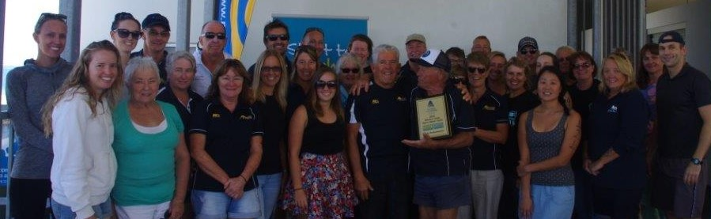

We don’t seem so lucky when trying to attract swimmers to take part in pool events. However, we managed to field a good entry for our home LiveLighter Club Carnival. A very big thank you to all the other clubs that took part and helped to make it the success that it was. Hopefully we will see you all again next year.

Monthly Saturday morning teas and Friday evening burgers have continued to keep up our social opportunities. We are now looking forward to our Winter Gala Event, to be held at the end of July. An opportunity for the ladies to dress up and the gents to show us their dance moves. Look forward to some snappy photos.

Our coaching programme continues to keep our swimmers busy. We have just completed a Motivate in May personal challenge to see how many kilometres could be covered in the month. Next challenge will be an 8 week challenge with 400m time trials to check progress and then a 100 x 100 in October. Lots to look forward to and lots to keep us busy.

