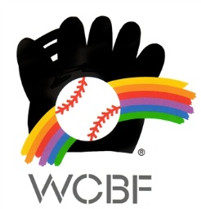
2016 WORLD CHILDREN’S BASEBALL FAIR
PLAYER SELECTION GUIDELINES

- Must be 10 or 11 years of age on the 17th August, 2016
- Current financial member of Baseball Australia
- Currently participating in a Little League program and demonstrate basic baseball skills
- Australian citizen and hold a current Australian passport
- As there will be no contact with families for 9 days the player must be comfortable being away from home, stay in a summer camp environment with shared accommodation (same sex), getting up early, attending clinic and field trips
- Positive character and have the ability to work in group
- Independent and comfortable adapting to a new environment, including Japanese traditional baths
- All expenses from Sydney to the baseball clinics in Japan and back to Sydney will be covered by WCBF including international flights, accommodation, meals, WCBF uniform
- Selected participants will be responsible for any additional expenses including travel to Sydney, any accommodation required in Sydney, travel insurance, BA uniform etc.

