PRESIDENTS MESSAGE
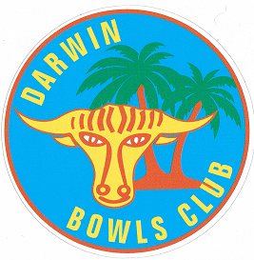
Fellow bowlers,

The Club is well and truly back in full swing after the Christmas and New Year break with 2016 expected to be one of our most challenging.

I would like to take this opportunity in welcoming all the new members to the Club and hope they enjoy the friendly atmosphere that is Darwin Bowls and Social Club.

Club games commence shortly with the handicap pairs and singles so good luck to all especially those who have been dealt with harshly by the handicappers.

The 2016 Calendar is done and should be on the website before the end of the month. Hard copies will also be available on the notice board.

Pennant format for 2016 is still a little up in the air with Bowls NT having their first meeting of the year in February where I am sure all things pennant will be high on the agenda. It will be triples but that’s about all I am sure of. Whilst on pennant, there is talk about having those games played on a Friday evening/night instead of Saturdays. Player comfort is the driving force behind the possible change. If you have thoughts on this proposal please let me know and I will pass it on to Bowls NT.

The State team is not far off being finalised and the club is keen to give the Darwin Bowls Club members who make the team some assistance with the cost of attending the Sides championships. There will be a Trivia night at the Club on 19 Feb with proceeds going to our State reps. We are also running a raffle for a set of Taylor SR Bowls so you should see tickets coming out shortly.

The first Jack Attack tournament will be held in May with games likely scheduled for a Thursday or Friday night. There will be more to follow on this exciting format of the game as we get closer to the event.

Lighting on the Jack Tennant green is being actioned so hopefully within the next couple of weeks some of us sight deficient members will be able to play at night and be able to see a little better.

With a large number of people expected to descend on Darwin for the carnival period to play on our newly renovated greens I am looking for some assistance from our members to form a Carnival committee to ensure that the event runs smoothly and all of our visitors are looked after. If you are interested please let me know.

Finally, Australia Day saw two strong teams from Darwin descend on a lovely wet season day (Not) at Humpty Doo with one of them overcoming some severe adversity to narrowly take out the event with two wins. It seems no matter how experienced you are or how many games you may have played for Australia the little ring still needs to be on the inside.

Harry

Bowls Committee President

28 Jan 16

