|  |  |
| --- | --- |
| Club house stretch | Edithvale Bowls News |

**January 2016**

**EDITOR – Kevin Breen**

(If you have any Items of Interest please E-mail [*kevinbreen1097@gmail.com*](mailto:kevinbreen1097@gmail.com) or

Phone 9772 2824)

**What’s** (been) **on**

**HAPPY NEW YEAR**

**& an enjoyable year of BOWLS**

**New Members**

Welcome to all New Members,

Terry KING & Peter MILLER

**Saturday Section** January 2016

As the final third of the Metropolitan Saturday Pennant competition gets under way we are hopeful that we shall have at least one side playing finals and no relegations. *Go Edithvale!*

At this month's committee meeting coaching was reviewed as Norm Lewis has retired from the position of Coaching Co-Ordinator: the review is ongoing. Members will be advised as soon as new arrangements have been made.

Whilst on the subject of new arrangements it is timely to point out that from the start of the 2016-2017 year – after the Annual General Meeting in April – the 'Saturday Committee' will no longer exist, being replaced by the 'Bowling Committee'. Now is the time for you to consider how you may be able to contribute to the administration of the club – by being a candidate for election to a position on the Bowling Committee. The call for nominations is only a few weeks away.

Entries for our tournaments are 'trickling' in but we need good numbers to ensure that ourtournaments continue to be successful. The best way to promote our tournaments is by personal communications and I encourage all to tell friends and acquaintances, and opponents, at other clubs about tournaments at Edithvale.

**Ian Wilding (President Saturday Section)**

***I named my dog “five miles”. So now I can tell everyone I walk five miles every day.***

**FROM the BOARD – January 2016**

*A Very Happy New Year to all Members and their families!*

**We have a new Greenskeeper**. Daniel resigned in December and we have been extra busy hunting down a top notch replacement before Pennant started. We had 4 applicants of high calibre. The successful applicant was Brendan McCallum. Brendan also has Green’s jobs at Mentone and Hampton and as over 10 years experience. Give him a welcome when you see him.

**John Clark Green** – With Daniel’s unplanned departure we lost 2 weeks of the growing season for the tift dwarf. Rather than put up with the bumps and runs for another year we decided to go ahead with the necessary scarifying, verti-draining and top-soiling. Because we started all this late it means we lose the use of “A” Green for the first 2 or 3 weeks of the after-break Pennant Season. But Brendan has already got the Ken Lee Green (“C”) up and rolling well so it should all just be a slight hiccup... unless the weather turns cold!

**AGM** in April positions becoming vacant are Executive Director, Financial Officer and 1 Director. If you have any management or financial skills or just have a feel for leadership, then think seriously about taking on one of these roles. Important decisions have to be made in regards the running of the Club – both from business and bowls perspectives. If you have some thoughts on running, DON’T LEAVE IT TO THE LAST WEEKS before the AGM – come and talk to one of the current Board Members and talk turkey.

**AND**, the new **Bowling Committee** comes into existence at the AGM. The Mid-week and Saturday Sections will be combined. Positions on the Bowling Committee are by election from the Members. The Bowling Committee will comprise

BOWLING COMMITTEE (9 persons)

--------------

Men’s President (elected by Male members) (1)

Ladies President (elected by Female members) (1)

Secretary (elected by all members) (1)

Treasurer (elected by all members) (1)

Committee Members (elected by all members) (5)

- of these five (5) no more than three (3) may be of the same gender

**--------------------**

**Barefoot Bowls.** Has started. Thank-you to all the volunteers. There is a well stocked Roster so everything is running smoothly. The Barefoot Bowls will go for approx. 8 Fridays (to end of Feb).

**Breakdowns galore** – Cool Room, Kitchen Fridge, Overhead Fan, Hot Water Dispenser.

**Member Survey** – the first scan analysis of the Survey results have been completed. More detailed analysis will assist with our New Membership Program and help prioritise our list of “what needs doing”. There were also some great ideas put forward for improving the Club and our game play.

*Survey Summary:*

* We had 68 responses (just less than half the members) – but this is a good result for surveys;
* Just over 1 in 3 Members joined because the Club is close to home. 70% of members live within 10 mins of Club (by car). 70% of respondents had been with the Club for more than 10 years;
* Overall satisfaction with EBC was 54% Very Satisfied; 39% Somewhat satisfied; 3% Somewhat Dissatisfied.
* Just over a half of members joined for competitive reasons (rather than recreational)
* You gave a satisfaction rating of between 70% and 90% for the Greens overall.
* The Games Days were all rated Very Good to Excellent. Although Wednesdays got a lower rating.
* The Website was visited “often” by 70% of those surveyed and received high accolades all round.
* When asked about a future Fee increase, 75% of those surveyed supported an increase of $20, if necessary ($30 and $40 increases were not supported overall);
* Some interesting and helpful comments were provided. Overall the Kitchen renovation was a prime concern. There were a few plugs for an outdoors toilet. The narrowness of the Edi Rd. Car spaces was an issue. Ideas included having an end-of-season game against a Regional Country Club. A few people saw great value in having a Mentor assigned to new Members to assist in things like Club etiquette, where things are stored, how to sign up for games, introductions to other members etc. There were many more, including a request to have cabana with the cheese and biscuits.
* **New Members** – we have a few new members out there, so make them welcome. Say Hi to Terry King and Peter Miller. And we have a few new members from the Barefoot Bowls sessions which I will introduce next month.

Ian Thomas

Executive Director.

*A riddle Difference between a CAT and a COMMA?*

A CAT has – CLAWS at the end of its PAWS

A COMMA has- a PAUSE at the end of its CLAUSE (thanks grand children)

**"Happy" January Birthdays**

23/1 Bev Elly

28/1 Barbara Overson, George Lansdown

Happy Anniversary to:

23/1 Stan and Lyn Holland

**.**

**MENS WELFARE Report January 2016**

**.** Wayne Clarke is still battling an infection and finding it hard to talk. Please no phone calls or visitors until further advised. We are all thinking of you Wayne.

**.** Stan Holland's weekly chemo treatment is producing good readings which are pleasing his oncologist and Stan is very positive about his own progress.

**.** Ian McPherson is making steady improvement after a hospital procedure a month ago. Ian now plans to be back at bowls on 22 Jan and play pennant on 23 Jan.

**.** Norm Lewis has recently stepped down from the position of coaching co-ordinator due to health issues and will undergo an examination later this month. I know you will be well looked after Norm

Good luck to all our pennant bowlers for the remainder of the season. If I have left out anyone missing bowls due to ill health, please call me on 9774 2997.

**Doug Rafter –(MENS WELFARE)**

***The other day I went to the Doctor and I asked him if he had anything for WIND. He said YES and gave me a KITE***

**Ladies Welfare** Report. December 2015

Pat Sheriff as been diagnosed with stage 3 breast cancer.Currently Pat's having treatment once a week at Frankston Hospital which she seems to be coping with OK. We all wish Pat best wishes and look forward to seeing her around the club soon.

**Rae Gibbs. (Ladies Welfare)**

***A JUMPLEAD walks into a bar. The barman says “I serve you but don’t start anything”***

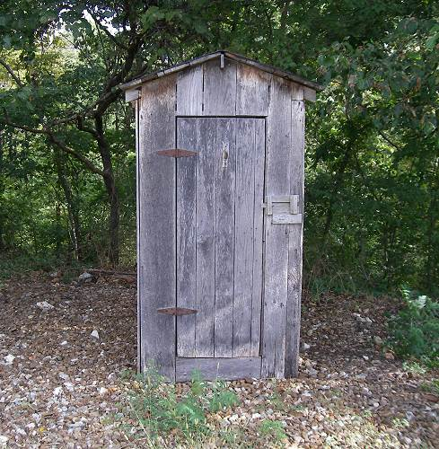**The Dunny**

They were funny looking buildings, that were once a way of life,  
If you couldn't sprint the distance, then you really were in strife.  
They were nailed, they were wired, but were mostly falling down,  
There was one in every yard, in every house, in every town.  
  
They were given many names, some were even funny,  
But to most of us, we knew them as the outhouse or the dunny.  
I've seen some of them all gussied up, with painted doors and all,  
But it really made no difference, they were just a port of call.  
  
Now my old man would take a bet, he'd lay an even pound,  
That you wouldn't make the dunny with them turkeys hangin' round.  
They had so many uses, these buildings out the back,

You could even hide from mother, so you wouldn't get the strap.

That's why we had good cricketers, never mind the bumps, **(Thanks Ian)**

**SPONSORSHIP.**

***LAKEVIEW MEATS*** *at Patterson Lakes. Pop in and see* ***Craig***

***SHARPEDGE Window cleaners*** *Darren has done a lot of work around this area and has 30 years’ experience. Ring him for a quote Phone 0400391211. His prices are very reasonable, an average house $60 - $80”*

**MAKE SURE YOU MENTION THAT YOU”RE FROM EDITHVALE BOWLING CLUB**

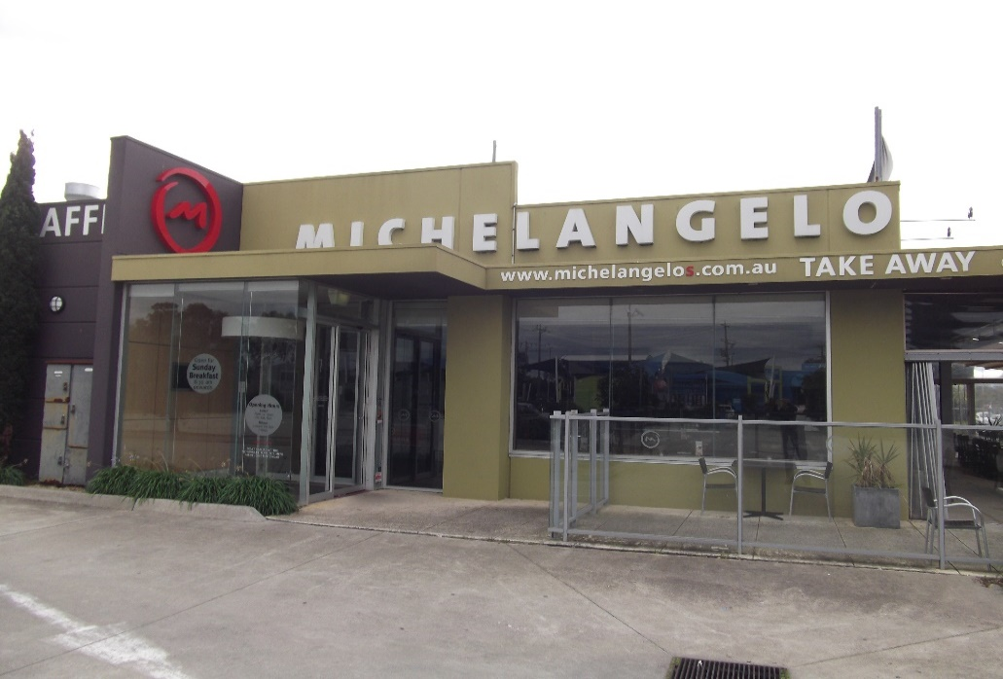

|  |
| --- |
| LastScan.bmp**CHELMC900016541[1]EA**  **CRUISE & TRAVEL**   * + - PERSONAL SERVICE     - CORPORATE & HOLIDAY TRAVEL     - CRUISING SPECIALISTS     - INTERNATIONAL & DOMESTIC TRAVEL     - TRAVEL VOUCHERS, BRIDAL / GIFT   REGISTRY   * + - WE SELL LUGGAGE & TRAVEL   PRODUCTS  **Phone 9773 1900**  396 Nepean Highway  Chelsea Vic 3196  C:\Users\LynRob\Pictures\Bendigo Bank Ad.jpgEmail: travel@chelsea-travel.com.au |

***ASPENDALE GARDENS***

***CHARCOAL CHICKENS***

The succulent chickens come with a great range of delicious salads, which are freshly prepared each day.

[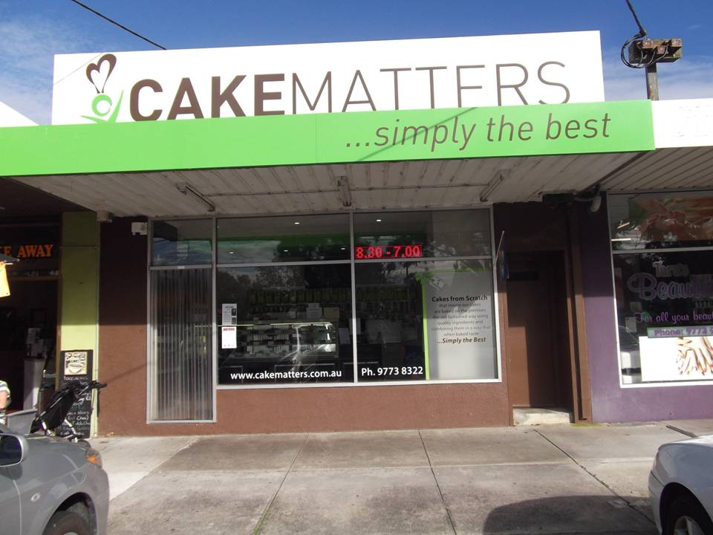](http://www.edithvale.bowls.com.au/sponsors/index.cfm?fuseaction=display_main&SponsorID=9965&OrgID=18279)***Aspendale Gardens Charcoal Chicken*** is a valued sponsor of Edithvale Bowling Club. Please make yourself known to the staff. They look forward to serving you.

Phone 9588 1616

Support your Sponsors please

And d on't be shy to tell them

You are from Edithvale