Westcoast Masters Spring Report
Did someone say Spring! Yes, I think we are looking forward to the warm, sunny days. Membership continues to be in the high 120’s, with new swimmers constantly on the radar.
Training sessions are still very well attended, however there have been a few evening sessions when the weather got the better of many swimmers! But nothing can keep away the die hards! Our training focus is starting to head towards the open water season. Members can look forward to a few open water skill sessions and the challenge of a 100 x 100m or 50 x 100m session.
Since the last report we hosted our LiveLighter Club Carnival and attended the Golden Gropers Relay Carnival. We were very happy with the new format of our carnival and thank all those who attended and assisted. However, we will be reviewing again for next year’s opportunity. Our swimmers rallied together for an amazing attendance (for Westcoast) at the Golden Gropers Carnival, with 29 swimmers taking part on the day. An excellent event, which hopefully we will be able to support next year with as much enthusiasm.
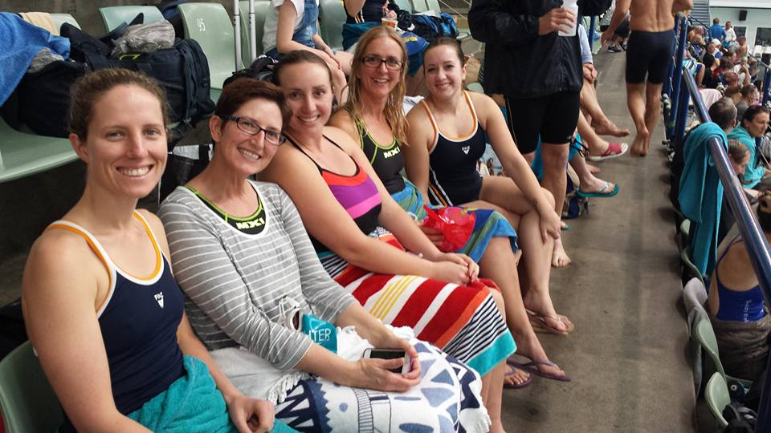
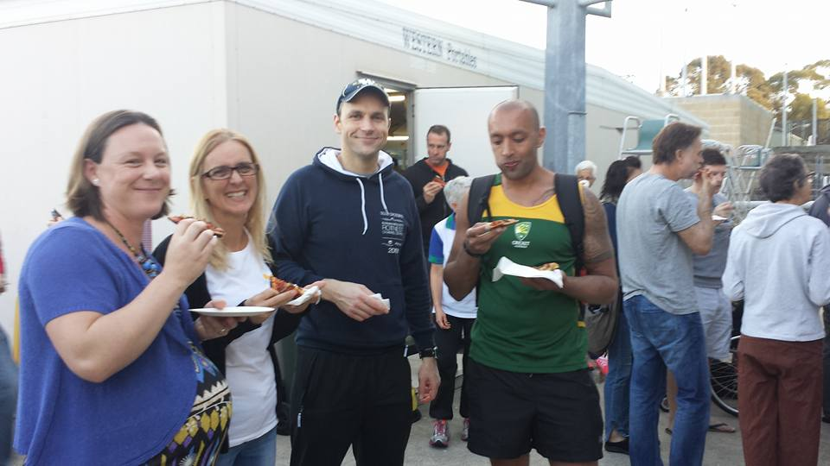
Socially, we have continued with our First Saturday Morning Tea’s poolside at Craigie. It has been a great way to extend our club camaraderie. The Social Committee, under the guidance of Sue Finney, organised a fabulous Christmas in July, hosted at one of our members’ homes – thanks to Debbie and Steve Hart for making their home available. Lots of fun and laughter all round, plus great food provided by an external caterer. A random drinks and dinner date was organised recently, with members popping in the Happy Hours drinks at the Breakwater, followed by dinner at Grill’d. Another great evening!
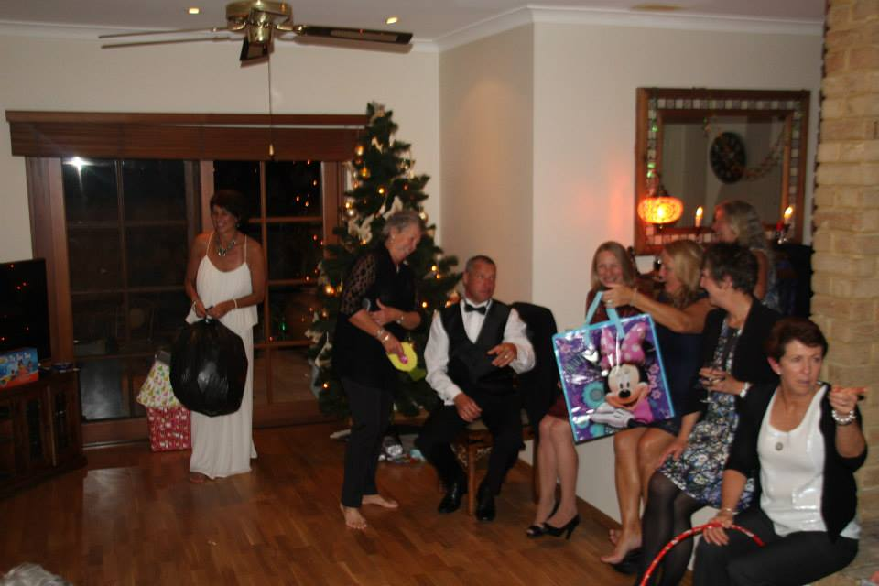
Before we know it, it will be Christmas. Avoid the rush and get in some serious training now!

