For E News August/September from Stadium Masters:
Once again we lucked in with a lovely sunny winter’s day in June for our 1500 Metre Distance Swim in an outdoor pool. This one always seems to be popular with other clubs - could be something to do with it being the first one on the calendar for the year! Lots of State records were broken and some National, too. Well done to all swimmers.
Thanks to Claremont for their amazingly smoothly run Groper Relay Carnival! Finishing equal seventh was a great result for our team of 21, with only five men. Two of our valuable men were new members swimming at a Masters event for the first time and they both performed brilliantly. Our women can be proud, too, coming second overall to Claremont. The highlight of the meet were our 320+ women, who stole the show by winning the 100m Free and the 100m Medley relays as well as a shiny golden Groper for their age group! Of course we didn’t have much opposition because no other club managed to field a team in that age group.
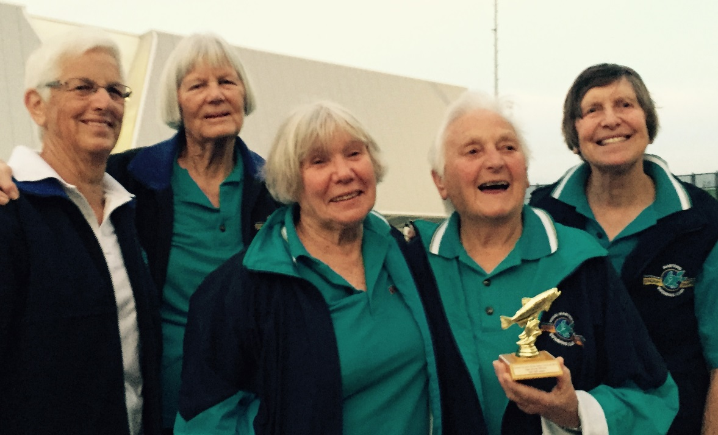
You may remember that we held a Swimathon earlier in the year. When all the proceeds were added up, the total given to Alzheimer’s Australia WA was $5450. Our rug-knitting project resulted in ten brightly-coloured rugs for Wheelchairs for Kids to send overseas with the wheelchairs they make. Now we’ve moved on to knitting beanies for kids in northern India.
