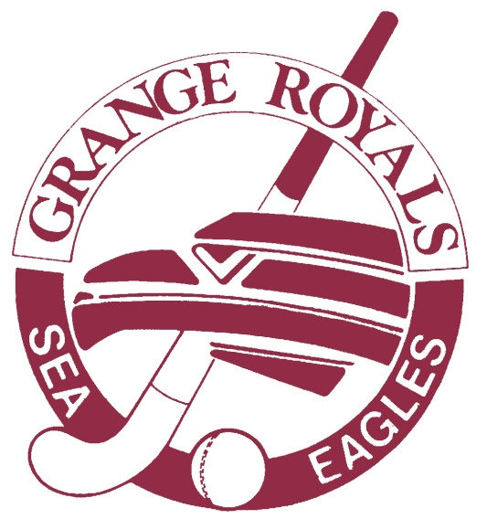

Grange Royals Hockey Club
STRATEGIC PLAN
2019 – 2021

Name of organisation: Grange Royals Hockey Club Inc.
Contact details: Dave Edwards
0402 420 202

Prepared: August / September 2018
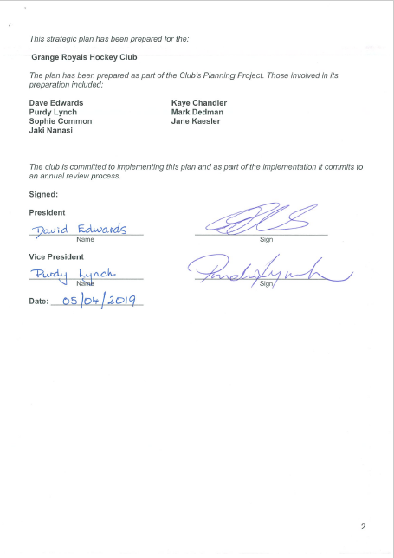
Table of Contents:

List the content of the strategic planning documents and relevant page numbers.

 | Page Number
Cover sheet | 1
Signature page | 2
Table of Contents | 3
Vision and Mission | 4
Overview of Club | 5
Priorities of the club | 6
SWOT analysis | 7
Core Business Areas | 8-10
CLUB VISION and MISSION

OUR VISION:

To be a leading hockey club within the peak competition of South Australia, providing playing opportunities for elite, junior and social players within a community context.

OUR MISSION:

We promote:
- club community, within a family friendly environment
- club success; playing and management
- team achievement
- personal excellence for all members; the development of opportunities for all ages and abilities

OVERVIEW OF CLUB

What the club offers:

Grange Royals Hockey Club is a hockey club in the western suburbs of Adelaide, South Australia.
The Club provides the opportunity for men and women to play in hockey teams, from the youngest age into your later years, within a community focused environment.

We currently field junior teams from Under 9 to 18,
senior teams from Premier League down to Metro 5
and Masters Men and Women.
In addition some of our players choose to play indoor and summer hockey.

The club provides a family orientated environment, based around invitation and community. Our membership is multi-generational, multi-cultural and is inclusive of a broad diversity of community members; based in the city and country areas.
One key element of this is Club Saturday Nights during the season. The Club is open for meals, as well as the weekly raffles and Supporters Club Draw.

The operations and history of our club are listed in the annual reports from each year.

Membership

The membership of Grange Royals is inclusive of senior men and women, masters team members, junior boys and girls, office bearers, parents and supporters.

Future

Development of our club as one with a strong sense of overall community and oneness.

Development of a comprehensive junior program that is inclusive of initial engagement to a junior academy program.

Development of an artificial turf facility that is available to our club during the pre-season and winter season periods of each year.
Ideally this would be located at Grange Reserve, however nearby options would also be considered.

Club operations that are directed by quality and contemporary governance practices, inclusivity and child safe practices, and are supported by a strong volunteer base.

PRIORITIES OF THE CLUB

Key issues facing the organisation

Issues / Priorities

- Provision of a home ground and training facilities and that are of high standard, local and available at required times

- Numbers of new players - attracting them

- Exposure of great numbers of children to hockey at schools

- Maintaining our current player base and volunteer numbers

- Quality coaches for teams

- Management of playing hockey costs – affordable options

- Enhancement of governance and operations practices

S.W.O.T. ANALYSIS

Strengths (internal) | Weaknesses (internal) | Opportunities (external) | Threats (external)
MEMBERSHIP

People/Tradition –  family orientation |  |  | Senior members and supporters getting older
Multi-generational and multi-cultural community

Sense of community - clubhouse, juniors parents playing

Very committed volunteers | Over-asking volunteers
Consistency of governance and structure | Manage transition of volunteer roles
LOCATION

 | Lack of money => No artificial pitch | Redevelopment of the reserve | Lack of access to external funding through ORS grants for artificial surface
16 years on lease |  | Reserve and lease and clubroom
GAME

Coaching numbers and capacity | Lack of club games together | Development of players through HSA programs and flow on clubs | Fixturing at disparate times
 | Retention of playing numbers |  | Costs involved
Cater for all abilities | Keeping number of juniors up |  | Younger generation seem less committed to play every week
Hook into Hockey Program |  | Charles Sturt holiday program | Lack of HSA schools program ( currently addressing)
School clinics program |  |  | Other clubs asking GRRY players to transfer - Poaching of players
Junior Hockey Academy |  |  | Neighbouring clubs encroaching on our area
Umpiring Academy |  | Umpiring Academy
CORE BUSINESS AREAS

MEMBERSHIP

Action | Key Focus | Maintenance Focus | Development Indicator
Attracting new players through targeted recruitment approaches | X
Exposing of greater numbers of children to hockey at schools through a renewed approach – Sporting Schools – in addition to our current program | X
Maintaining our current player base and volunteer numbers |  | X
Promote a sense of positivity, engagement and care amongst members to encourage ongoing membership |  | X
Develop a strong sense of playing for our club as the key connection |  | X
Supporters Club – continue to operate this club to engage with past players, family members and wider community |  | X
Development of a Social Calendar that caters for each demographic |  | X
Develop an Induction Package – who we are, what our club offers, history, information for parents, pathways for players, name the quality of experience they’ll have at Grange Royals Hockey Club |  | X
Strengthen our Club’s presence and operations as an option for local community members | X

HOCKEY PROGRAM

Action | Key Focus | Maintenance Focus | Development Indicator
Development and Retention of Quality Coaches – provision of resources, coaching skill development, coaches’ forums, utilise expertise, target key people | X
Umpire Development – instigate and document pathways for beginning and developing umpires through a Club Academy approach | X
Junior Development – develop an affordable junior development program that caters for the diversity of ability, considers time of year, new player engagement, links to schools and holiday programs, inclusive of our current Academy approach. |  | X
Player Recruitment – continue to utilise networks and personal approaches to attract new senior players | X
Player Retention – utilise a range of strategies to promote ongoing participation; elite player sponsorship, equitable fee levying, provision of equipment, access to facilities, support for individual development |  | X
Fixtures – lobby for a more equitable draw |  | X

FACILITIES

Action | Key Focus | Maintenance Focus | Development Indicator
Artificial Surface - provision of a home ground and training facilities and that are of high standard, local and available at required times  - Work with Reserve Lessees to instigate the development of a Reserve Master Plan | X
Clubrooms - Upgrade of lighting and refrigeration appliances | X

GOVERNANCE & FINANCE

Action | Key Focus | Maintenance Focus | Development Indicator
Budget  Document clear, just and transparent finance processes within the club’s Management and Operations Guidelines  Promote member awareness of key club costs; team nominations, insurance, training etc. | X | X
Management of hockey playing costs – identifying options to support player participation |  | X
Sponsorship – develop a clear strategy to utilise our sponsorship package materials to promote continuation and develop a strong awareness that we are open to new opportunities | X
Finance – identification of new funding sources | X
Enhancement of governance and operations practices  - Review of current roles and responsibilities  - Completion of Star Club accreditation  - Achieve Level 3 Good Sports accreditation | X  X  X

Development Indicators

No progress or very minimal progress achieved

Work is continuing

Work is completed, however for some priorities continuing development and/or action will be undertaken

