Beatty Park Masters Swimming Club E-News December 2016

We’re really pleased to have recently increased our membership to 107, this is the biggest since the Club operated out of the Lyn McClements pool in Osborne Park. Numbers are increasing at training now we have warmer weather and the open water swimmers are getting ready for the ocean events.

For the Rottnest Channel Swim we have two boys attempting their first solos, following successful duos. Two duo teams- two girls who've not swum the channel before and a mixed experienced duo. Two teams of four with a range of experienced to newcomers. 14 participants so the most we've had to date. Five of these have only just joined the club.

LiveLighter All Club Challenge on 15/16 October with only 23 swimmers we finished the carnival in second position with four age champions, Bryce, Heather, Brent and Dave. Congratulations to everyone who competed and supported.
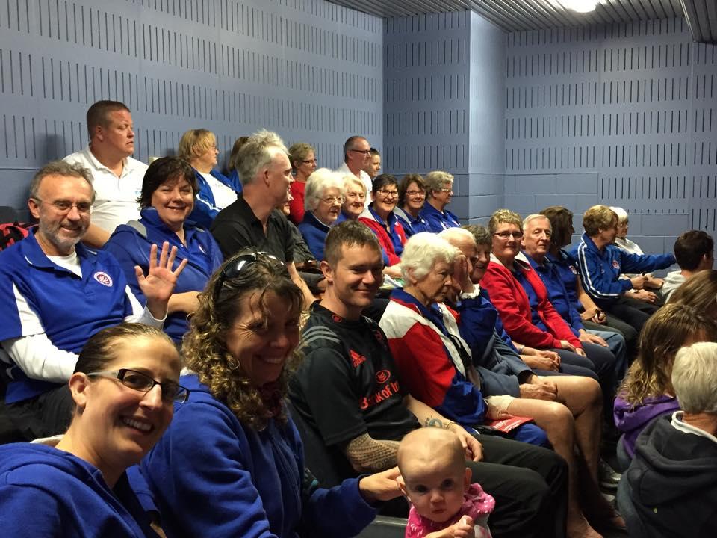

Club members at presentation after LiveLighter All Club Challenge including future member Poppy

On Sunday 27th November we held our Annual Christmas Party at the Marmion Angling and Aquatic Club (MAAC). 55 members and guests attended this event, enjoying yummy food, beautiful view, and spending time with Club mates. A great day was had by all!
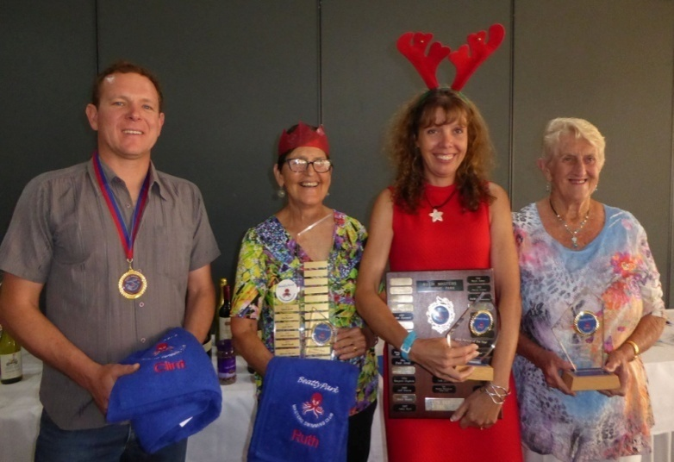

Club Award Winners presented at Christmas Party, Clint, Ruth, Rachel and Mary. Another winner Delise is absent

